Dosbarth Llewelyn – Home Learning - 2020 – Part 6 (Monday 6th July – 13th July)
Literacy | Other Subjects
- I’m running low on story ideas – your first mission is to think of something which has interested you, a book you have enjoyed reading, a film you have like watching, an idea which caught your interest – write me a list to give me some inspiration for our next extended story!  - I thought we would think about poems again as this was the last thing we focused on in Literacy before Lockdown, over 100 days ago now. With things changing all of the time at the moment, I thought it was a good time to reflect and a poem is a lovely way of talking about our feeling and realising that others feel this way too. I would like you to write me a poem this week. It might be slightly different for each of you - for some, you could write me a poem about your feelings about coming back to school. I’ve included a poem called We’re going back to school. I’d like you all to read this and think about it. You could then write your own version of this free verse poem with each stanza starting with “I’m going back to school again…” or some version of this. You can also write a poem about things that you have missed/enjoyed during Lockdown in a similar way and start each stanza with something like “I’m not going out today…” or “I’ve got to keep my distance today…”. I have also included a rainbow template for an acrostic poem. Here you can think about positives and negatives of Lockdown and write a line about them on this template. Remember, each line of an acrostic poem must begin with a word starting with the letter from the word along the edge! I’m really looking forward to reading your poems!  Success Criteria- * Interesting title * Line breaks used * Rhyme * alliteration * Similes * Personification * Repetition * Onomatopoeia * Capital letters at the start of each line *Interesting synonyms used * powerful, vivid images created in readers mind. | Here is a fun way to create a beautiful picture. It can be of anything! I like to do animals or creatures like fairies and monsters. All you need to do is go for a walk with your family and collect some leaves or fallen petals from flowers and let your imagination take over.  I’ve added a link for you to watch and some photographs of ones my family made. You can also get lots of inspiration on Google/Pintrest  I can’t wait to see what you create with leaves and nature!  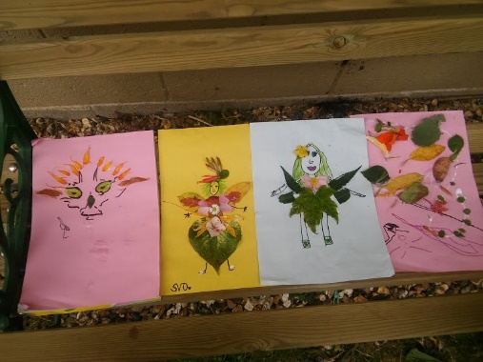  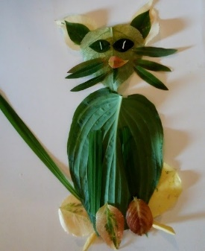  https://www.youtube.com/watch?v=cjQ_k4x2Jpg

Maths
Arithmagic is an exciting and engaging online primary maths game that promotes the regular practice of key fact fluency and mental arithmetic skills covered in the maths national curriculum. The arithmetic practice game includes types of questions often found in arithmetic test and the Multiplication Tables Check. It's designed specially for kids to enjoy while they learn, and proves that maths practice for kids can be fun too. This Arithmagic Maths Practice Game covers addition, subtraction, multiplication (times tables) and division. Have a go!

Search for Twinkl Go Login in a search engine and enter the code - BS8567

Science | Home Reading
Go Green Week. Last week it was ‘Size of Wales’ go green week. They look for ways to create a greener world for us all!  I have set the task for you to design a talking tree poster. Watch the clip that I have attached and then read the information poster.  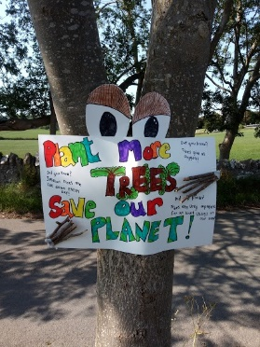  Then get ready and design your own poster, look carefully at the example on the poster to help. I am so looking forward to seeing these! I have included an example that Molly has done for you to see!  https://www.youtube.com/watch?v=5I7u5FMQxHA  You could have a go at this quiz too!  https://howmany.sizeofwales.org.uk/ | Continue to read as often as possible!  Find somethings you enjoy and keep a record in the backs of your Remote Learning books.  You can read anything - Magazines, newspaper, eBook or any other books at home you might have…  As a bonus - Could you write a book review? or maybe make a quiz for others to try based on what you have read?  Lots of lovely reading available online via – https://www.oxfordowl.co.uk/for-home/  You will even find staged books here.

All of the assignments is also available on our Google Classroom. If you haven’t already joined, please check your email for an invitation! Let me know that you have joined by saying ‘Hi’ in the stream. Remember that you can send me your work by attaching it to an email. my email is oldfields@hwbcymru.net.

