Accessing Google Classroom
Firstly login into your Hwb account by visiting https://hwb.gov.wales/ and using the Hwb email and password provided to you by your class teacher. (Please contact your teacher if you do not have this)

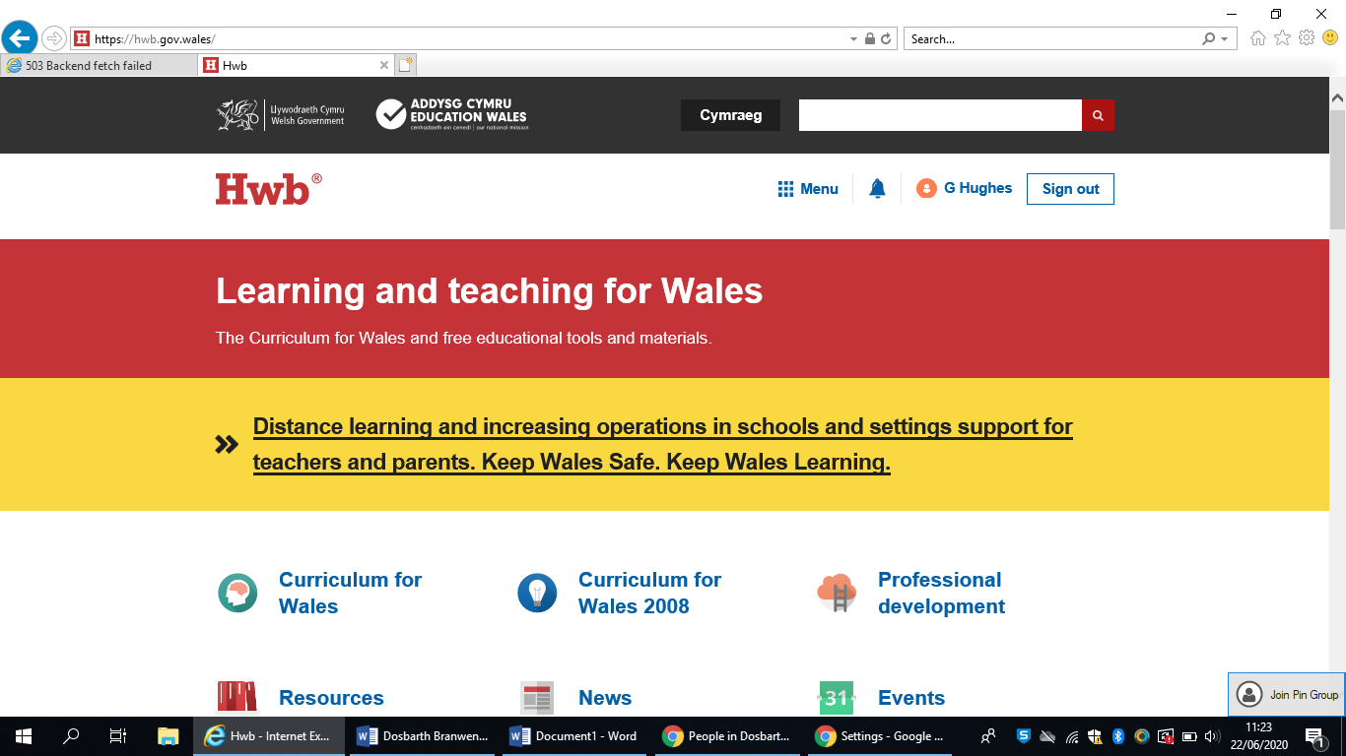
Click on the menu button shown above.

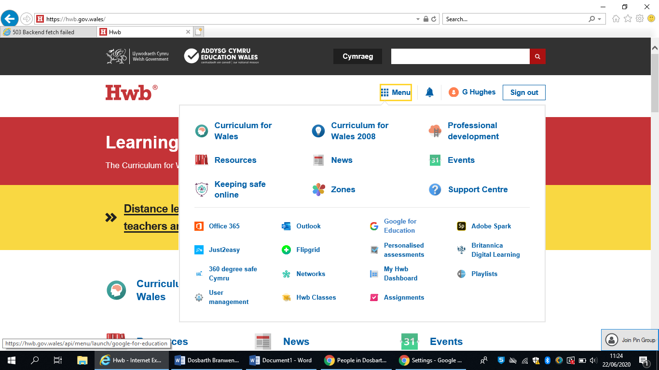
Then select Google for education

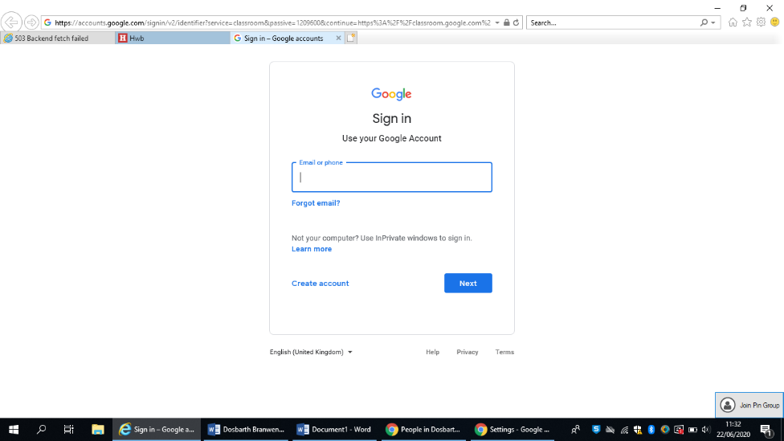
Google will then ask you to enter you Hwb email again.
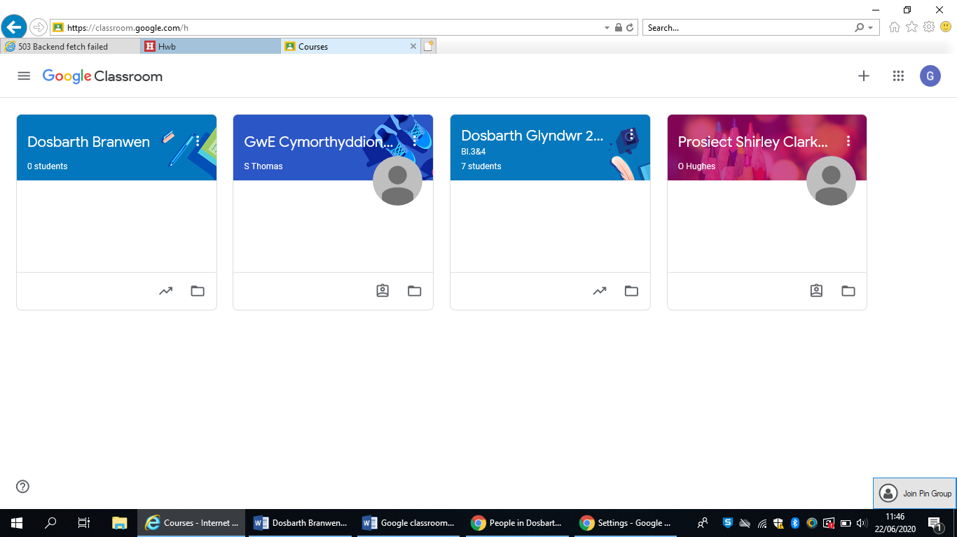
Click the plus (+) icon and Click ‘Join Class’
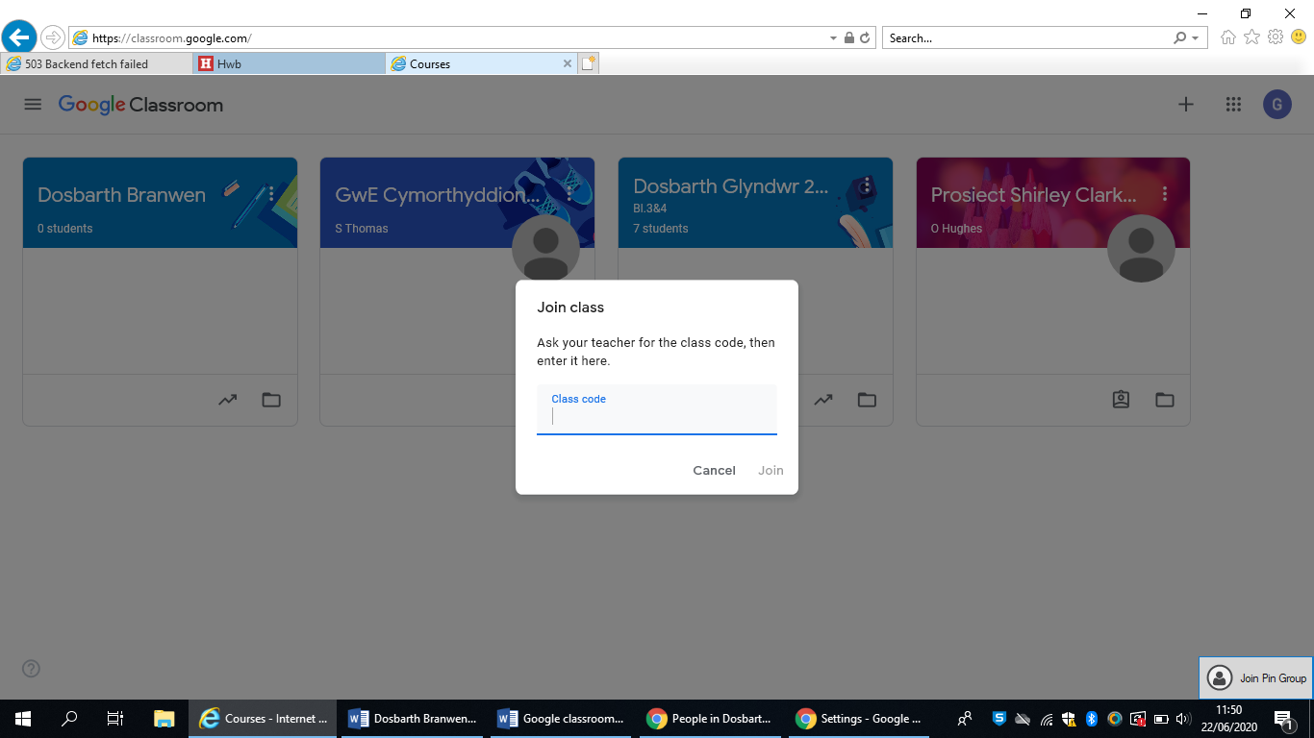
Enter the class code that will be given to you.

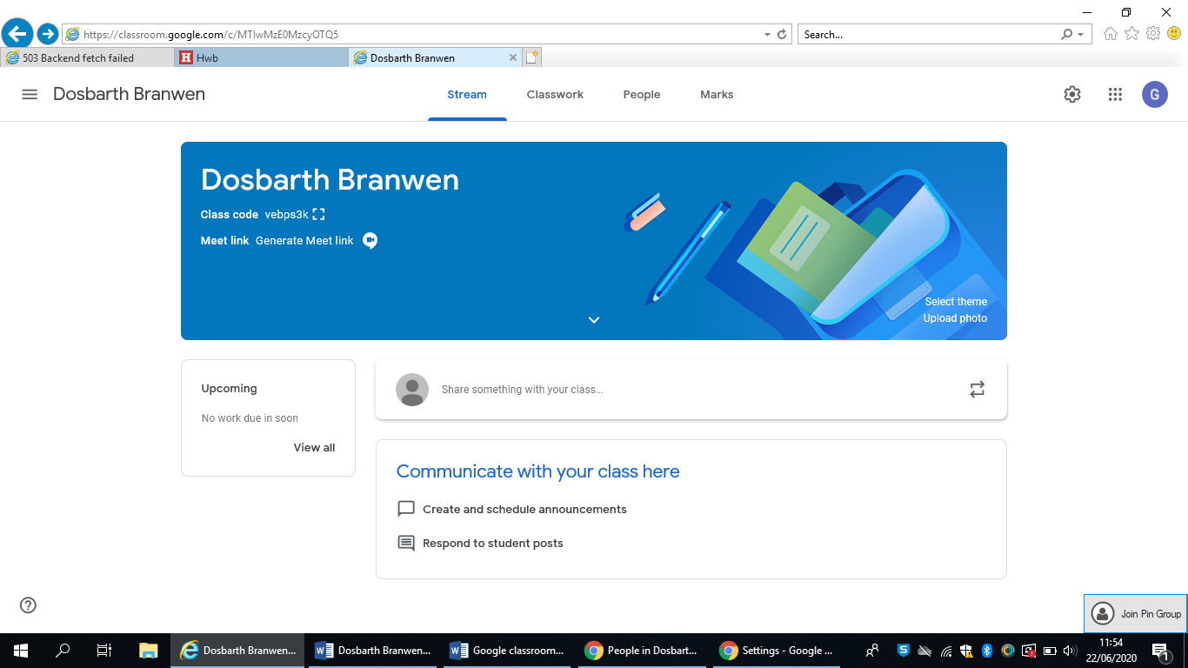
You should then see a page that looks like this. You are ready to go! Check back here regularly for new distance learning and important information.

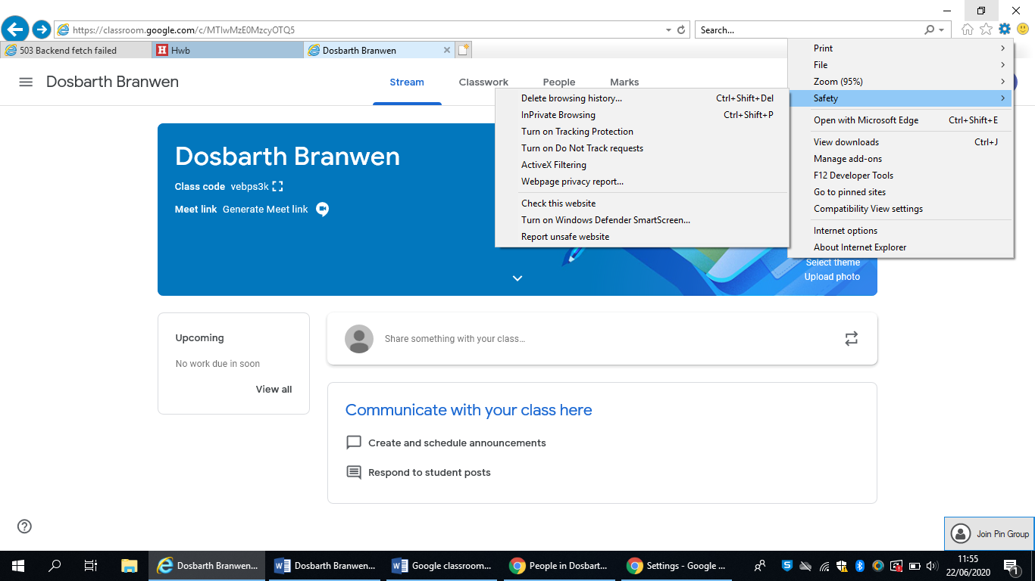
If you are having issues entering the class code;
In Explorer - click the setting cog in the top corner and hover over ‘Safety’ then select ‘InPrivate Browsing’. Now re-enter the class code. This hopefully will sort the any issues joining the classroom.
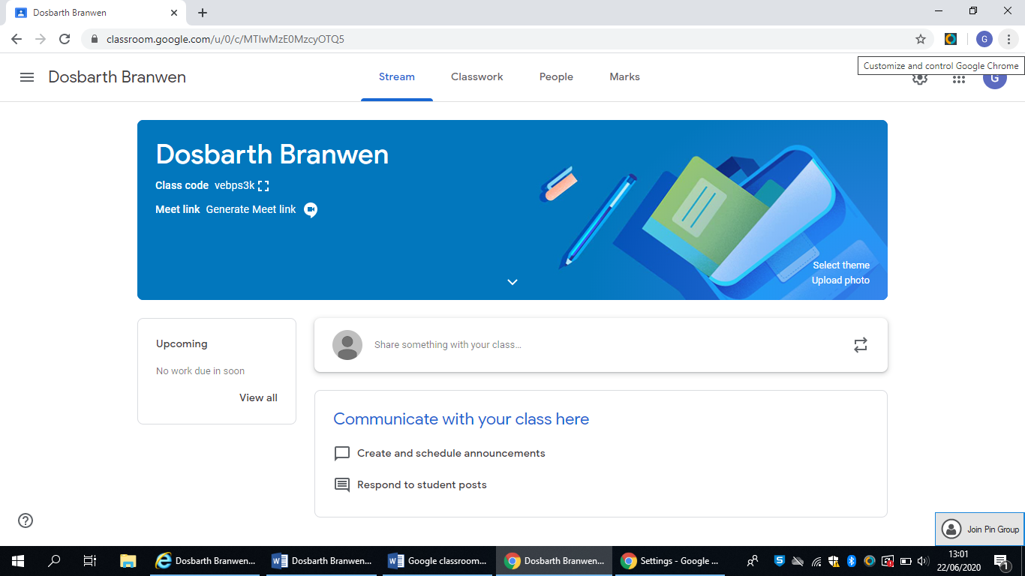
In a chrome browser this is called ‘Incognito browsing’ and the option can be found by pressing the three menu dots usually situated in the top right hand corner of the browser window.
If your class teacher has chosen to invite you to google classroom via email then please check your outlook inbox.
To do this click on the Office 365 icon in the menu
Then click on Outlook to see your emails. Follow the instructions in the email.
