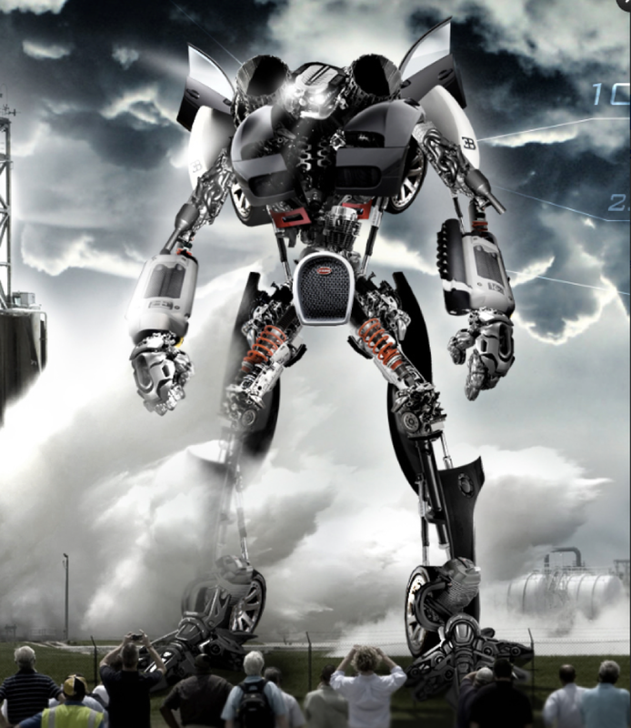

See tasks below!

Choose from these activities (You can do more than one!):
- Complete the grid below.

I can see | I wonder (?)

- Question time!
Who do you think is controlling the robot? Does it have a mind of its own?
Where has the robot come from?.
Are the people in danger?
Can you think of a good name for the robot?
Is there a chance that robots will become part of our society in the future?

3. Sick sentences
These sentences are ‘sick’ and need help to get better. Can you help? Think about using better adjectives, alliteration, adverbs or similes.
The robot stood in front of the people. His hands and feet were big, and his body was really big.

4. Perfect picture
Imagine your job is to design a robot. Draw or describe what your robot would look like, and what it could do.

