Describe a Scene 2

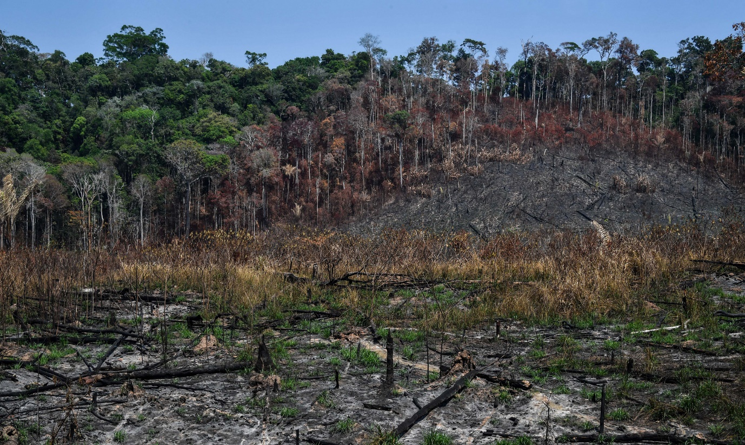

This is an image of a rainforest where deforestation has occurred.
Now have a go and describing this one.
Again describe what you see.
Do you think it would sound the same?
Smell the same?
Feel the same?

