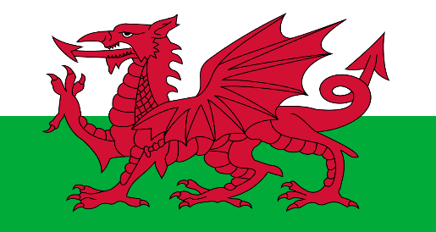

**App/Gwefan yr Wythnos – App/Website of the Week**

**Gair yr Wythnos – Word of the Week**

**Teulu**

is the welsh word for family

<https://flipgrid.com/d2f06e85>

Cwestiwn: **Ga i… os gwelwch yn dda? /** Can I have … please?

Ateb: **Cei / Na chei** - Yes / No

Example: Ga i pensil os gwelwch yn dda?

Can I have a pensil please?

<https://flipgrid.com/052ef28c>

**Cân yr Wythnos – Song of the Week**

**Aderyn Melyn –**

[**https://www.youtube.com/watch?v=I52fbzsfTxY**](https://www.youtube.com/watch?v=I52fbzsfTxY)

**Patrwm yr Wythnos – Pattern of the Week**

**Cyfnod Allweddol 2 / KS2:**

<https://www.learn-welsh.net/welshvocabulary?topic=Colours&level=primary>

**Cyfnod Sylfaen / Foundation Phase:**

<http://www.s4c.cymru/en/learn-and-play/>

**Wythnos 2 – Week 2**