Task Menu 😊
Please complete the following tasks. We would love to see your work. Maybe you could take a photo and upload it to your Hwb for us to see. We can then send you a message 😊
Can you make a list of insects you can find in your garden?  Challenge: include how many of each insect you have found.  How many did you find altogether? | Make a marble run out of junk materials.  Challenge: can you add a scoring system?  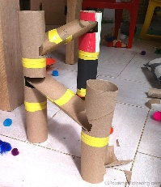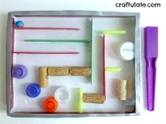 | Play bingo with your family. Use the numbers 1-20 (or 1-100)  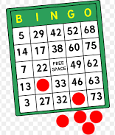 | *Find small squares of paper  *On each piece of paper write the numbers 1-10 (or 1-20)  *Place the numbers face down  *Take in turns to turn over a number – how many more do you need to make 10? 20?  *If your answer is correct you keep the card! 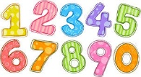
Can you make snap cards? You could use cvc words. Eg cat, dog, pop or tricky words!  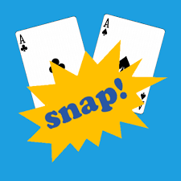 | Can you find out about the life cycle of a butterfly? Can you draw pictures to show each stage?  Challenge: Can you write some sentences about it? | The lost kangaroo in school is missing you. Can you write him a letter? Remember to tell him what you have been doing.  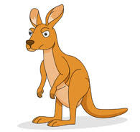 | Can you make a special card for a family member?
Practice your Maths skills. Write your answers down and then check if you are correct.  https://www.topmarks.co.uk/maths-games/daily10 | Draw a picture of your favorite animal.  Can you label it?  Challenge: can you write facts about your animal? | Can you make a mask of your favorite animal? | A naughty puppy has buried a bone in your garden. Can you draw a map to show me where he could have buried it? 😊

