ICT menu Rainbows and Rockets
Hope you are all well and keeping safe. We can see that you have been working hard and hopefully having fun during your time at home. We would like to hear all about what you have been doing, what your favourite activity is, what sort of things you have been doing to keep fit and healthy, what your favourite meal is. So, here is a menu of activities that we would like you to do. Ask a grown up for help and have fun doing the activities together.
Main Task
We are really missing you and would love to hear about what you have been up to. We miss seeing your smiling faces every morning, hearing about your weekend, we miss checking how you are feeling and what’s making you happy or sad. We would love to hear from you and so the main task over the next two weeks is to email us and tell us how you are getting on. What’s keeping you busy? What’s making you happy? What’s been your favourite activity? What's been your favourite meal? Is there anything you don’t like doing? Ask a grown up, brother or sister to help you. We cannot wait to hear from you. Our email addresses are:
BarrowJ15@hwbcymru.net (Mrs Barrow)
GamstonR@hwbcymru.net (Miss Gamston)
ThomasE564@hwbcymru.net (Mrs Price)
Now choose as many of these as you would like …
Login to your HWB account and click onto Just2easy. Click on Jit5. Here we want you to draw a picture of your favourite toy, activity, meal or anything else you want to share with us. Can you write a sentence telling us about what you have drawn? Save your work. Call it ‘My favourite thing’. | Pictogram- what can you find around your house? You might want to collect information on how many squares, circles, rectangles and triangles you can find or collect information on how many doors, windows, rooms you have in the house. Once you have that information you can make a graph. Login to HWB – Justtoeasy- J2Data- pictogram  Have a go – Good luck! | Interview/ vlog – why not record a video of you talking about your time at home? Talk about the best bits, the fun bits, the not so fun bits and anything else you want to tell us about. You could also film someone else in your house. Ask them some questions about how they are feeling, what they like doing, what they don’t like. We can’t wait to see your clips.
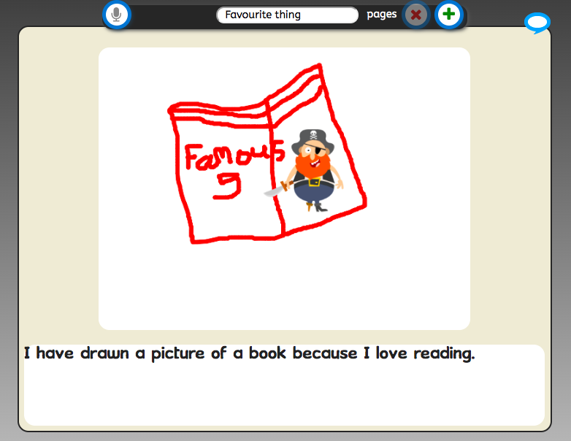 | 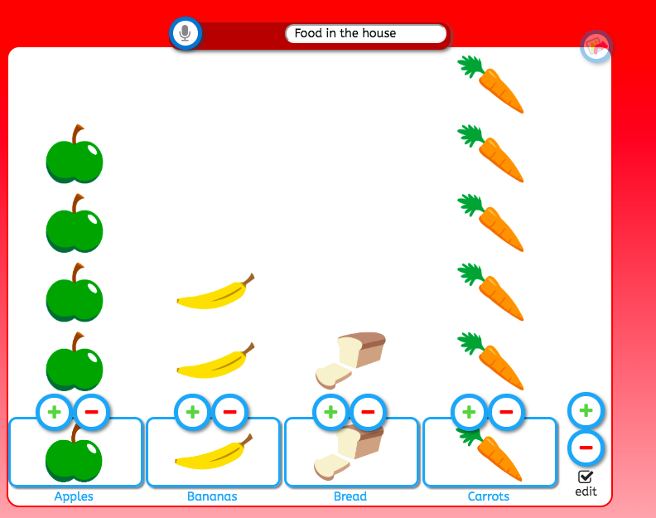
You can add photos/ videos to your work by accessing HWB – Just2easy- my files – bottom left ‘drop files here’ or you can email your work to us 😊

