Homework for Saturn | Given out | To be completed by
Maths /Language Task | Every Friday | The following Friday
Spelling | Monday | Test on the Friday
Menu Topic Related | First week of each half term  (4-5 weeks to complete) | See Date on Homework menu.
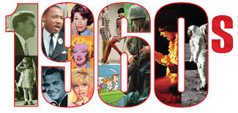
Ticket to Ride!
Spring Term 2—Year 5&6
We are excited to launch our new 1960’s theme this term. Pupils will be learning about the life and times of the era. Pupils will discuss and research about the significant people from the decade and will use major events from the time to write newspaper reports and to plan and prepare a documentary as an oracy task. Pupils will use statistics from the era to analyse and compare prices from the 1960’s to today and to develop pie charts and graphs to present findings. As part of the health and well-being area of the curriculum, pupils will learn about the effects of smoking and the statistics related to this. During rich tasks and missions, pupils will use their knowledge about the era to plan a 1960’s themed event.
You can help your child by:
Discussing how life was different in the 1960’s. Talk about how the world has changed for different groups of people. Help with research e.g. visit a library. Provide resources, information, photos, albums, clothing etc. to bring into school.
General Reminders:
Homework: Maths/Literacy tasks will be set weekly in addition to a weekly spelling list. A homework choice menu will also be set every half term.

Physical Education: It is important that your child has PE kit in school everyday and that they are fully prepared to take part in physical activities safely. PE kit should include: Shorts, T-shirt, Jumper for cold weather and trainers. Pupils are not permitted to wear jewellery.
The

