Pentre’r Graig Primary
School

“Learning, Caring, Having fun!”
“Dysgu, Caru, yn cael Hwyl!”

Policy for
More Able and Talented Children

The United Nations Convention on the Rights of the Child (CRC) is at the heart of our school’s planning, policies, practice and ethos. As a rights-respecting school we not only teach about children’s rights but also model rights and respect in all relationships – Linked to Articles 3, 29 (CRC)

Introduction
In Pentre’r Graig primary School we aim to provide a curriculum that is appropriate to the needs and abilities of all our children. We plan our teaching and learning in such a way that we enable each child to reach for the highest level of personal achievement. This policy helps to ensure that we recognise and support the needs of those children in our school who have been identified as 'more able' and 'talented'. We respect the right of all children in our school, irrespective of differences in ability, to access a number of areas of learning, and to develop the knowledge, skills, understanding and attitudes that are necessary for their self-fulfilment and eventual development into active and responsible adults. The aims of our school include valuing the success of all our children and make reference to using a variety of methods of teaching and learning to provide equal opportunities for all. They also identify the commitment to giving all our children every opportunity to achieve the highest of standards.

Definition
In Wales, we will use the term ‘more able and talented’ to describe learners who require opportunities for enrichment and extension that go beyond those provided for the general cohort of learners. More able learners, given extended opportunities, will not only discover but also develop their talents. The term ‘more able and talented’ encompasses learners who are more able across the curriculum as well as those who show talent in one or more specific areas. The identification of more able and talented learners is linked to context and in every school there will be a group of learners who require extended educational opportunities, regardless of how they compare to more able and talented learners in other schools.

As a school, we decided to define possible MAT categories that pupils may fall under to aid our clarity and understanding for our provision.
The terminology our school uses to define our higher achieving learners is:

“More Able and Talented”:
• More able learners and Talented are those identified as being above the core of the class in any area (including the curriculum areas plus leadership creative etc.) These are the 20% or 6 learners in every class of 30 (approximate as each cohort will differ). These learners may be very good in one or more areas of the curriculum.

“Most Able and Talented”:
• Most Able learners are those who have the ability to excel in one or more area. We describe this as the top 5% across the year group (although not necessarily present in every year group).

We will strive to identify those more able and talented learners who have the potential to achieve, but do not regularly demonstrate high achievement and we will seek to identify barriers to that achievement and help the pupil overcome them.

Aims and objectives
Through this policy we aim to:
- ensure that we recognise and support the needs of our children;
- enable children to develop to their full potential;
- offer children opportunities to generate their own learning;
- ensure that we challenge and extend the children through the work that we set them;
- encourage children to think and work independently.
- Use appropriate assessment of children’s abilities and needs
- Link with other agencies that may help the development of identified children.

Identification of More Able and Talented pupils
Identification of more able and talented learners should include use of;
- Results of statutory tasks & tests
- Results of Whole School assessment procedures
- Teacher Identification
- Discussion with colleagues
- Self / Peer Identification
- Links with parents (e.g. questionnaires)

The school makes sure the identification process is rigorous, transparent and fair. We do not discriminate against any group of children and include learners who arrive after Reception and are late developers. Where attainment is not high but there are indications of potential high ability, the school strives to identify that potential and nurture it. Our aim is to build a comprehensive picture of each child’s ability.

Our identification criteria:

The grid below can be used as a guide for identifying pupils to be included on the more able and talented register. More able pupils will be those pupils within the top 20% of their year group, whereas the most able pupils will be within the top 5%.
Test scores must be taken with caution, and consider the fact that they are a “one-off” judgement of that pupil’s ability. We are aiming for an all - round judgment with a strong evidence-base.

Area | More able (Top 20%) | Most able (Top 5%)
Reading | + 18 months | +24 months
Spelling | +18 months | +24 months
National literacy standardised score | 120+ | 125+
National numeracy standardised score | 120+ | 125+
National curriculum current sub-level (in specified subject) | 1 whole level above expected level for that age group | 5 sub-levels or above for that age group
Sport | County / district level  Development centre | National level  Centre of excellence
Music | Grade 1/2 | Grade 3+
Creative / Artistic | Teacher recommendation | Teacher recommendation
Other subject area i.e. technology, science | Teacher recommendation | Teacher recommendation
Leadership | Teacher recommendation | Teacher recommendation

The names of learners identified as More Able and Talented are recorded on our More Able and Talented list so that their progress can be specifically tracked. Learners may be identified at any time, as talents may become apparent as the year progresses or as learning opportunities evolve.

Once identified learners will remain on the list unless they cease to meet the criteria for nomination. When they will be transferred to a shadow list, we never delete completely any pupil as they may be experiencing a period of consolidation or plateau. The list is updated and reviewed by staff three times a year.

Teaching and learning style
Teachers in our school plan carefully to meet the learning needs of all our children. Pupils are aware of their individual targets and we give all children the opportunity to show what they know, understand and can do, and we achieve this through planning a variety of strategies and challenges to develop children's learning .Differentiated work is planned for to ensure all children have extension activities and the scheme used for mathematics has built in activities to stretch children to their full potential

Classroom strategies
• Helping children to establish what they already know, and what they can learn
• Building on what is known and avoiding unnecessary repetition
• Setting open-ended tasks
• Asking open-ended questions
• Encouraging discussion before recording and writing
• Encouraging imaginative and creative work
• Developing independent learning skills, particularly research, questioning and
thinking skills
• Providing opportunities for independent learning and individualized learning
approaches
• Providing enrichment activities and extension tasks when the previous task is
finished or when the pupil has already learned what is being taught
• Allowing time for some pupils to tackle extended tasks or individual interests
• Using in-class support to provide additional learning opportunities for very able and
gifted pupils
• Varying grouping arrangements: working in ability groups, co-operative and mixed
ability group work, cross-age paired reading and other tutorial support, working with
older pupils
• Valuing and rewarding quality not quantity
• Providing opportunities to experience a range of educational visits that further enrich
and develop learning.
• Providing homework activities linked to the work being undertaken in class

Pupils who have been placed on the More Able and Talented register are each given an individual action and provision plan that has been written in conjunction between the class teacher and MAT Coordinator during the first half of the autumn term (see below). This is then reviewed annually during the summer term, making necessary alterations and having professional discussions prior to transition to the next class.

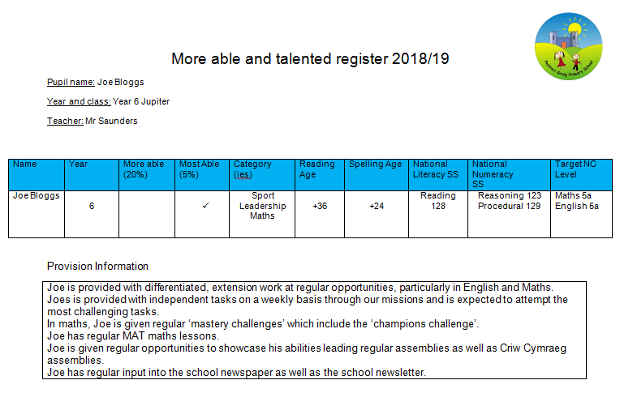

Coordination of school provision
The MAT coordinator is Mr Ben Saunders. He has the overall responsibility, alongside the Senior Leadership Team and class teachers for coordinating the identification, record keeping, policy development, learning and teaching, home/school partnerships, whole school provision, his own continued Professional Development and, discussing these areas with Mrs Allison Davies, the governor who has the Responsibilities for MAT. The coordinator's role also includes:
- running a register of more able and talented pupils, and keeping it up to date;
- monitoring teachers' planning to ensure that suitable tasks and activities are being undertaken across all curriculum areas by the higher achievers;
- regularly reviewing the teaching arrangements for these particular children;
- monitoring their progress through termly discussions with teachers;
- supporting staff in the identification of these children;
- providing advice and support to staff on teaching and learning strategies;

The governing body will be responsible for the maintenance and review of the policy.
If a parent has a concern about any aspect of provision for more able and talented children he or she should first raise the issue with their child's class teacher. If the parent feels that her/his concern has not been addressed appropriately he or she should make an appointment with the Head teacher to discuss the issue further.

Monitoring and review of the policy
This policy will be monitored, through discussions with staff, pupils and parents.

The policy will be reviewed annually The Register will be reviewed regularly by class teachers. Parents of the children will be kept up to date through parent meetings.

