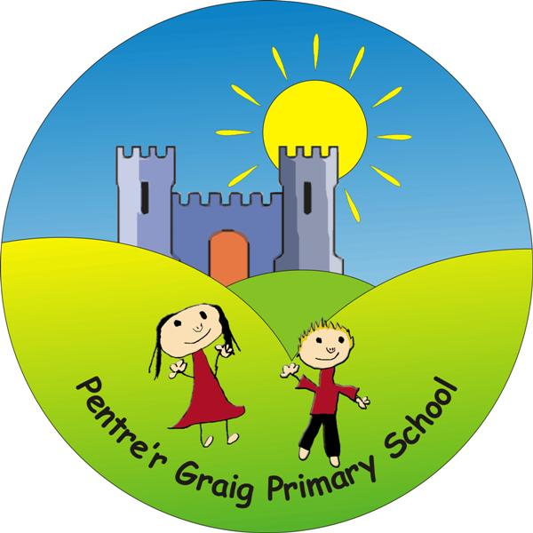
Pentre’r Graig Primary School
School Road
Morriston
SWANSEA
SA6 6HZ
Telephone: 01792 771831

Headteacher: Mrs Allison Davies

Dear Parent / Guardian,
As part of the school’s ‘More Able and Talented’ provision, we are currently trying to track our year 1 – year 6 pupils’ talents. Whilst some of these will be apparent to us through the subjects they study at school, we appreciate that sometimes pupils have talents in other areas which we may not necessarily be aware of. Some examples may include:
• Sporting representation at a district or national level.
• A musical, drama or dance talent.
• Participating in a specific club that may showcase their talents in another area i.e. Astronomy club, Debating society, Cubs, Badgers, Guides etc
If you feel that this may be the case for your child, please could you complete the slip below and return it to me via the school office.
Please give specific details with regards to the club/team they represent, award or grade they have achieved and how regularly they attend training / meetings / competitions.
If you have any questions, please do not hesitate to contact me using the details given above. Thank you for your continued support and cooperation,
Mr Saunders - More Able and Talented Co-ordinator
_________________________________________________________________
Pupil name: _______________________ Year:____________
Details of talent:
_________________________________________________________________
_________________________________________________________________
_________________________________________________________________
_________________________________________________________________
_________________________________________________________________
Signed: ______________________ Date: ________________________

