Welcome to Weekly Wonders.

Each week you’ll be given a creation to look at, listen to, watch, read and explore. Accompanying it, will be a set of prompts or questions which I’d like you to think about and answer. Even though there are no wrong answers, I am expecting you to think openly and to push yourself, thinking as deeply as you can when giving responses. Above all, feel free to explore any of the paintings, artists, compositions, musicians etc. in much more detail, in your own way and time.
Enjoy!

Weekly Wonders
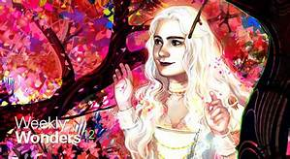
Stimuli to spark your curiosity and expand the mind.
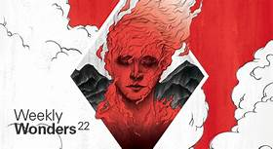
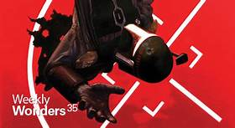
Look, Watch, Listen,
Think, Create, Explore,
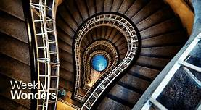
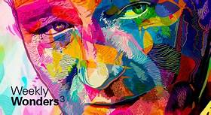

Week 1
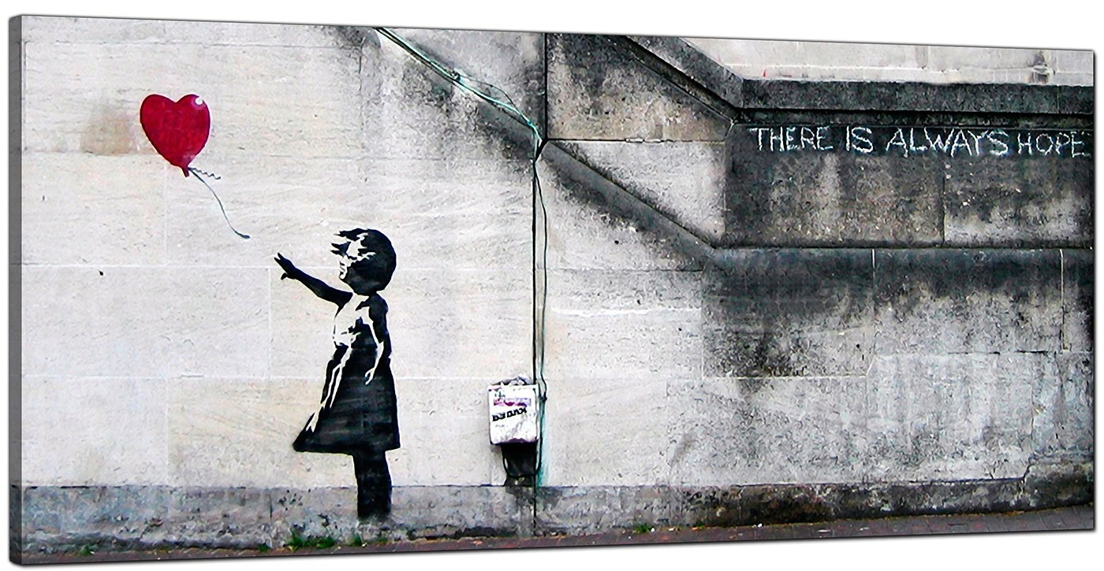

Banksy Girl with the Heart Balloon
- Sit back and look at the picture above. Spend a good while doing this – at least 1 minute. Try not to think about anything and just let your eyes explore the picture.

- Was there a particular part of the picture that drew your eye more than other parts? What was it? Why do you think this was?

- Where do you think this picture is? Who will see it?

- Why did the artist put it there?

- How is the girl in the picture feeling and why?

- Have you ever felt like this? What was the reason?

- The inscription ‘THERE IS ALWAYS HOPE’ was also put there by the artist.
Why do you think he wrote this next to the picture of the girl and the balloon?

- What if Banksy (the artist) was referring to other things to be hopeful about, in the wider world. What sorts of things could he, and the millions of other people who have looked at this picture, be hoping for?

