Tre Uchaf Primary School

Positive, Inclusive, Listening

Information Pack

Contents
Welcome / Admissions Application Details
Hwb Wales
sQuid Payment System
Local Authority No Debt Policy
ICT Acceptable Use Policy
Use of Digital Images / Local Visits
Collection from school
Free School Meals (if applicable)

Please keep this booklet for your records

Tre Uchaf Primary School

Heol Cae Ty Newydd, Loughor, Swansea SA4 6QB
Email: treuchaf.primaryschool@swansea-edunet.gov.uk
Website: http://tre-uchaf-primary-school.j2webby.com/

@treuchafprimary

Croeso!
We would like to welcome your family to Tre Uchaf Primary School and hope you find this admissions booklet useful and informative. You will find lots of information about our school on our website http://tre-uchaf-primary-school.j2webby.com/ and also in our Prospectus. You may also like to take a look at our twitter account which will give you a flavour of our school ethos!
Applying for a School Place through the Local Education Authority (LEA):
You will need to apply for a place in our school through the Local Authority, if you haven’t done so already. You can find a link to the LEA admission form here: admission-form-lea or apply for a place online here https://www.swansea.gov.uk/admissions The LEA will confirm your place with you via letter/email and send a copy to us. This can take up to 14 days, so don’t delay!
Completing our School Admission Pack
Please complete and return the Admission Pack as soon as possible prior to your child starting our school. This will enable us to put your child’s information on to our database. If your child has attended another school we will be able to contact them to obtain any relevant results and assessment information which helps us to ensure we know what your child needs right from the start.
It is important that you ensure any medical information is reported to us in detail in the Admission Pack, particularly if your child has any regular medication e.g. Inhaler, Anti-histamines. Please let us know and we will give you the appropriate forms which need to be filled in. We would also be grateful if you could let us know if your child has any food allergies, not just for school dinners but also for when pupils take part in cooking lessons or food tasting as part of the curriculum.
Data Protection & Information Sharing Tre Uchaf Primary School needs to hold certain personal information about pupils. Information will be held in accordance with the Data Protection Act 1998, GDPR (May2018) and the School Data Protection and Accessing Records Policy. Personal data will be used and shared for a variety of purposes that Tre Uchaf Primary considers to be of benefit to pupils including (but not restricted to) monitoring academic performance, statistical reporting and provision of services. Tre Uchaf Primary complies with the Data Sharing Code of Practice which can be found here;
https://ico.org.uk/media/fororganisations/documents/1068/data_sharing_code_of_practice.pdf
Please see the Data Protection page on our school website, your Admission Pack and www.ico.gov.uk for further information.
PARENTAL PERMISSIONS and CONSENT
School Use of Apps and Programs In the Admissions Pack you are given information about a range of Apps and Programs which the school uses to communicate information and to support your child’s learning. From time to time you will be advised to sign up to these Apps. We only use Apps and systems after viewing and approving the relevant Privacy Policies.

Hwb Platform
The Hwb platform provides all maintained schools in Wales with access to a wide range of centrally-funded, bilingual digital tools and resources to support the digital transformation of classroom practices. The Hwb platform is managed and operated by the Welsh Government.

All pupils in maintained schools in Wales must be provided with a secure log-in to the Hwb platform. This is because mandatory reading and numeracy tests, currently on paper, will be moving online, starting this year, and must be completed by each pupil via the platform. In order to provide your child with a secure log-in, the school will be sending basic information to the Welsh Government. The log-in will allow your child to take the mandatory online assessments, known as ‘personalised assessments’.

For more information about the Hwb platform and how information about your child is used, please see https://hwb.gov.wales/privacy.

For more information about the online personalised assessments, please see
http://learning.gov.wales/resources/collections/national-reading-and-numeracy-tests?lang=en#collection-2

Additional services
If you agree, Welsh Government can also provide your child with access, via the Hwb platform, to a variety of additional services which are provided by other organisations. These include online learning environments such as Hwb Classes, Microsoft Office 365, Google for Education, and other relevant educational tools and resources. Welsh Government is making these additional services available to help your child access educational resources. These additional services are centrally funded and there is no cost for you or for your school to access and use them.

Welsh Government will only provide access to these additional services if you sign the form below to indicate your agreement.

Other programs and apps for which we require your permission are as follows;

App/Program | Information shared | Used For
Class Dojo | Pupil’s name and year group  Photographs | Communication with parents/carers
Time Tables Rock Stars | Pupil’s name and year group  Progress and attainment data | Teaching numeracy skills
EVOLVE | Pupil’s name and year group | Essential Risk Assessments for school trips (required by the LA)
Abacus | Pupil’s name, year group and stage in maths | Maths learning in school (all children), homework and assessment
Incerts/Assessment Foundation | Pupil’s name and date of birth | Tracking and reporting progress in all curriculum areas
sQuid | Parent’s phone numbers | Dinner money payments, communication by text and email
MyConcern | Pupil’s name and date of birth | Sharing safeguarding information about pupil within school

sQuid

Our school, like all other Local Authority schools, uses sQuid online for payments of dinners and for communicating with you by text.

You will receive an activation letter on your child’s first day and this will contain your User name and Password (which you will then be able to alter).
If you already have a sQuid account, please see the section below that details how to add a child to your account.

How to create your own online sQuid account
- Go to the sQuid web page squidcard.com/welcome
- Select the ‘Click here to create a sQuid account’ link
- Enter your details, create a password, choose a security question and answer
- Click the ‘Register’ button to complete your registration
- Confirm your registration by clicking the link in your activation email
- Complete the required additional personal details
- Add your sQuid registration number, security code and assign a display name
Your 16 digit sQuid registration number is: «XX»
Your 3 digit security code is: «CVV»

Already have a sQuid account?
Simply add your child’s sQuid registration number and security code to your account on the ‘Users’ page.

Once you have created and activated your account, you will be able to access and manage your sQuid account online at anytime to:

- Top up your account from your bank account, credit or debit card
- Check your account balance
- View your transactions
- Update your details
- Add further children to your account

Please refer to the sQuid web site for full Terms and Conditions. https://www.squidcard.com/terms-conditions

You can read the sQuid Privacy Policy here https://www.squidcard.com/privacy-policy

sQuid mobile app

The sQuid App is free to download on iOS and Android devices, providing a quicker and more convenient way to access, manage and top up your online sQuid account
Please note you will not able to order a school dinner for your child without a sQuid account.

How to register a sQuid account
Create an account and top up online

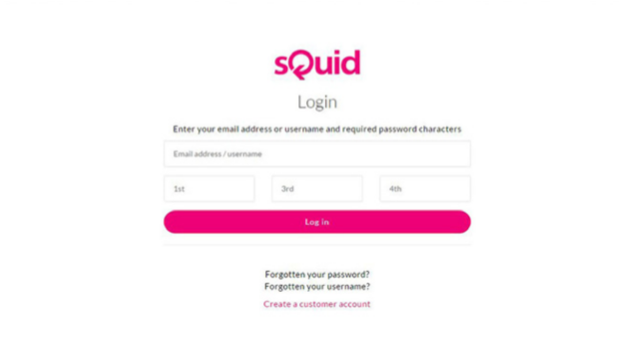
01 Getting started
Go to portal.squidcard.com and click the ‘Create a customer account’ link. You will then be directed through to the sQuid account registration form.

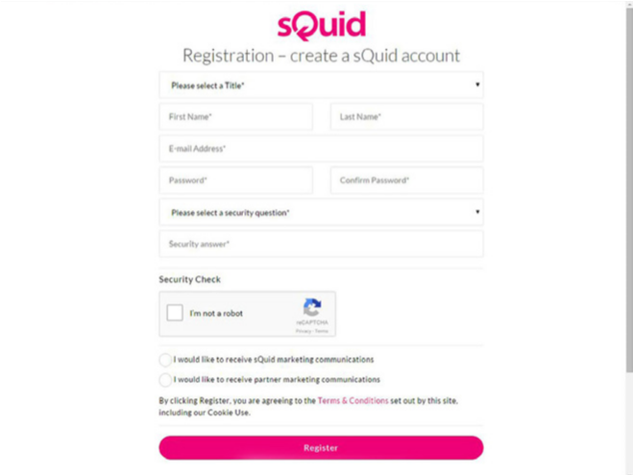
02 Create a sQuid account
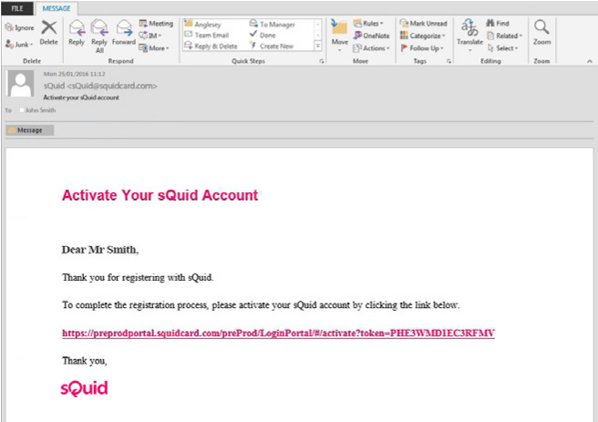
You will need to enter your personal details, create a password and select a security question from the list provided, and enter your answer. Click on the ‘Register’ button to complete your registration.

03 Activate your sQuid account
Once your sQuid account is registered, you will receive an email from sQuid containing an activation link. Click on the activation link to be brought back into the sQuid portal, where you will be asked to complete some additional details.

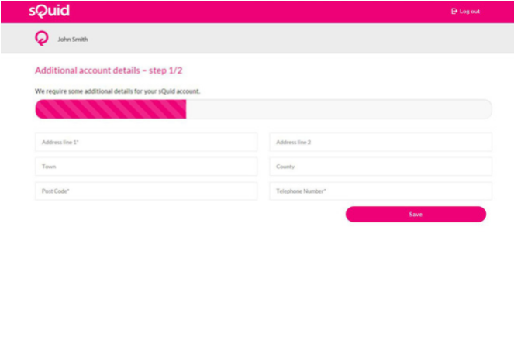
04 Add a sQuid Registration Number (SRN)
Having created your sQuid account, you will be prompted to register your unique sQuid Registation Number. This is the 16 digit number shown on the front of your registration letter, together with your 3 digit security code. You’ll also be able to assign an easy to remember display name on this screen.
To add any additional users to your account after this initial registration process, simply go to the ‘Users’ page and add the user’s sQuid Registration Number and 3 digit security code.

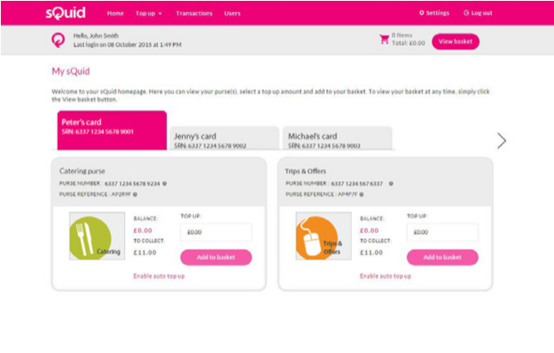
05 Add funds to your sQuid account
You can add money to your account from a bank transfer or a credit or debit card. Click on the ‘Top up’ link at the top of the page, select your preferred payment method and follow the online instructions.
CITY AND COUNTY OF SWANSEA

DINAS A SIR ABERTAWE
To parents/carers of learners Swansea schools
Please ask for:
Gofynnwch am:
Direct Line:
Llinell Uniongyrchol:

E-Mail:
E-Bost:
Our Ref:
Ein Cyf:
Your Ref:
Eich Cyf:
Date:
Dyddiad:
Kelly Small

01792 636686

education@swansea.gov.uk

Dear Parent/Carer,

School Meals – No-Debt Policy

As of 1 September 2017, the City and County of Swansea will adopt a clear no-debt policy relating to the payment and provision of school meals. This is to ensure that, other than where there is an entitlement to free school meals, parents or carers pay for children’s meals.

This will also ensure that school funding is used exclusively for the purpose of providing education to pupils. If debts are incurred then the school budget has to pay for them. This means that money which should be spent on the children’s education is used to pay for debts incurred by parents/carers. In previous years, the local authority has had to cover debts of tens of thousands of pounds. We are no longer able to do this and are seeking your support and cooperation to address this matter.

To help to make payments for meals as easy as possible we are introducing a new online payments system called sQuid in September and you will receive information from your school about how to register.

If you believe that your children may qualify for entitlement to free school meals you can find out more on www.swansea.gov.uk/FSM where you can also make an online application or print off a paper form to send to us in the Civic Centre. If you have any queries about free school meals you can contact 01792 635894 or email FreeSchoolMeals@swansea.gov.uk or visit the contact centre in the Civic Centre.
This allowance is a statutory right and it is important that you use it if you qualify.

EDUCATION DEPARTMENT / ADRAN ADDYSG
CIVIC CENTRE, OYSTERMOUTH ROAD, SWANSEA SA1 3SN
GANOLFAN DDINESIG, FFORDD YSTUMLLWYNARTH, ABERTAWE, SA1 3SN
(01792) 636000 (01792) 636642
education@swansea.gov.uk http://www.swansea.gov.uk
To receive this information in an alternative format please contact Education Support 637400
I dderbyn y wybodaeth hon mewn fformat arall, cysylltwch â Chefnogi Addysg ar 637400

Tre Uchaf Primary
ICT Acceptable Use Agreement for Children (including Hwb+)

The Golden Rule: Think before you click
This is how we stay safe when we use computers:

- I will ask a teacher or another member of school staff if I want to use the computers / tablets
- I will only use activities that a member of staff has told or allowed me to use
- I will take care of the computer and other equipment
- I will ask for help from a member of staff if I am not sure what to do or if I think I have done something wrong
- I will tell a member of staff if I see something that upsets me on the screen
- I will only open/delete my own files.
- I will be polite - don’t upset or bully anyone.
- I will be safe – don’t tell anyone where I live or what my phone number is.
- I will be security smart – keep your username and password safe
- I will only send and open emails if told to by my teacher or if it is part of a lesson.
- I understand that all of my work can be seen by my teacher

I understand that I must follow these rules or I might be in trouble.
I agree with what I have read above and/or what my teachers have told me about using ICT properly.

Name of child: N A M E O F C H I L D Date:

Signature: S I G N A T U R E_____ Class: Class name

Use of Digital / Video Images

The use of digital / video images plays an important part in learning activities. Pupils and members of staff may use digital cameras to record evidence of activities in lessons and out of school. These images may then be used in presentations in subsequent lessons.

Images may also be used to celebrate success through their publication in the school prospectus, newsletters, on the school website, social media (e.g. Twitter) and occasionally in the public media.

The school will comply with the Data Protection Act and request parents’ / carers’ permission before taking images of members of the school. We will also ensure that when images are published that the young people cannot be identified by the use of their names. Parents are requested to give their permission through the online questionnaire to allow the school to take and use images of their children.

Conditions of Use

- We will not use the personal details or names of any child or adult in a photographic image on video, on our website, in our school prospectus or in any of our other printed publications.
- We will not include personal e-mail, postal addresses, or telephone numbers on video, on our website, in our school prospectus or in other printed publications.
- If we use photographs of individual pupils, we will not use the name of that child in the accompanying text or photo caption.
- If we name a pupil in the text, we will not use a photograph of that child to accompany that article and will not give the child’s full name.
- We may include unnamed pictures of pupils and teachers that have been drawn by the pupils.
- We may use group or class photographs or footage with very general labels such as ‘a science lesson’ or ‘making Christmas decorations’.
- We will only use images of pupils who are suitably dressed to reduce the risk of such images being inappropriately used.

Local Visits
At Tre Uchaf Primary we provide opportunities for our children to gain exposure to a range of learning experiences both in and outside the classroom. Class trips to venues in the local area make up a considerable part of outside the classroom learning. Please give consent through the online questionnaire for your child to attend trips to venues in the local area (Loughor and Gorseinon). Some of these venues will include:
- Gorseinon Library
- Loughor Foreshore
- Local parks
- Local Churches and shops
- Penyrheol Comprehensive School
We will inform you of any trips and visits we make in the locality, but will not require additional permission unless the visit also involves transport.

Collection from school

It is important that the school knows who has permission to pick your child up other than yourselves as parents / guardians. Please indicate your permission on the online questionnaire.

We understand that childcare for many parents means that children may be picked up by different people through the week. Please inform your child’s class teacher of the routine for pick up and ensure that the teacher is aware if there is a change to arrangements. We also appreciate that plans may change during the day, so please let us know of any changes to arrangements as early as possible. The office is very busy at the end of the day and it is sometimes difficult to pass on messages to staff if we are notified late in the day.

As your child progresses through school you may decide that they can walk home independently. If you decide that your child is ready for this step please complete the relevant statement on the online form. If you change your mind about this during the school year, please inform your child’s class teacher personally or by letter.

Application for Free School Meals

You can apply for free school meals online at www.swansea.gov.uk/freeschoolmeals

