Dear parent/guardian,
It has been a short week due to the bank holiday and the school closing for polling day on Thursday too. Nevertheless we have still managed to pack in lots of fun activities and learning.
Mrs Osborn’s class have been having a great time with their planting and Jack and the Beanstalk. They have been investigating and measuring how tall their beans are growing depending on where they are planted and also planting sunflowers to see how tall they get too!
Mrs Porter’s class have been designing and now making their very own versions of Clarice Clift pottery. They are in the process of being fired and I can’t wait to see how they turn out. Mr Donovan’s class have been investigating dissolving to see which variables will make a difference and also looking at how light affects the growth of their beans too!
Mrs Adkins class have been doing outdoor work making and following their own algorithms. Following our staff training day we were keen to put things into practice and the children had a great time giving each other instructions and debugging too! Stuart has been busy making their new class planters which are almost finished. We are waiting for the compost to get planting! Have a look below for some photos of all the activities.
So all in a huge amount packed into just 3 days!

Dates for the diary Please note the change of dates!
Date | Activity
Monday June 7th | INSET Day whole school
Tuesday June 8th | INSET Day whole school

Clubs
All clubs are on hold until further notice
Easy fundraising
Thank-you to everyone who has registered and joined easy fundraising to collect donations. We currently have 76 supporters and have raised a total of £2,335.20. So a big thank-you to everyone who is collecting donations and if you are not yet registered then please follow the steps below.
We are raising money for Knelston Primary School – Swansea via easy fundraising.
It’s so simple to get going all you have to do is:
1. Go to http://www.easyfundraising.org.uk/causes/knelstonprimary
2. Sign up for free
3. Get shopping and start raising
No catches, no hidden charges and Knelston Primary School - Swansea will be really grateful for your donations. It would be fantastic if you could join me and really help make a difference.

As always, if you have any questions please be in touch.
Kind regards
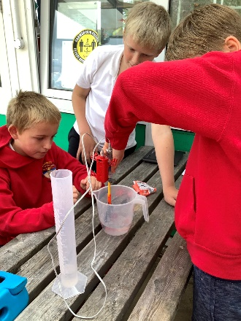
Mr Jenkins
