Knelston Primary School
Governors’ Annual Report to Parents 2019-20
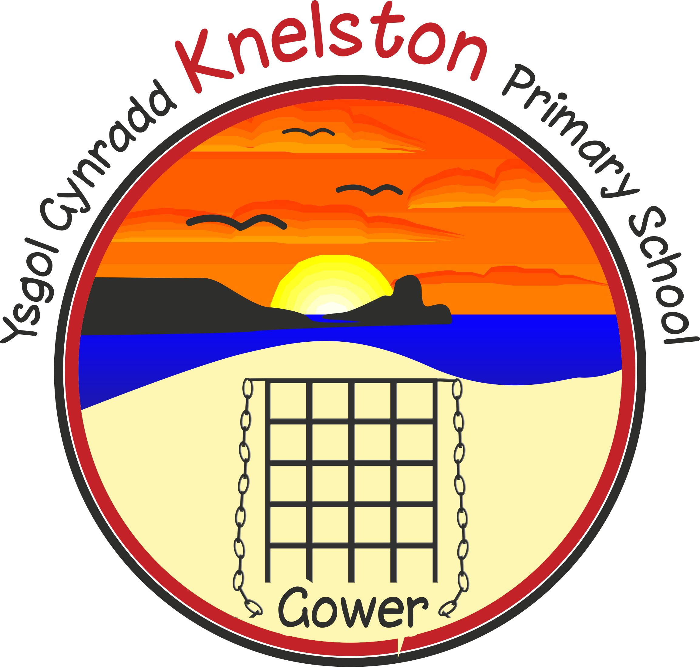 | Address | Knelston Primary School  Reynoldston  Gower  Swansea, SA3 1AR
 | Phone/Fax | 01792 390071
 | Email | Knelston.primary@swansea-edunet.gov.uk

Opening Statement Covid 19 Pandemic.
The pandemic which we have faced since February 2020 has had a huge effect the operation of education and the school. The school was closed to most learners and repurposed from March 20th 2020 and only reopened in a very limited capacity for the last 3 weeks of term. As a result many of the statutory assessment and reporting mechanisms were suspended. This means that this report does not include any performance indicators.
During this period the school staff showed huge dedication and flexibility in how they faced the challenges that the situation threw at all of us. Like many of you they managed to juggle working from home while home schooling their own children and looking after their loved ones. There were a range of new skills to be learnt very quickly to provide remote learning for their classes as well as staffing the emergency childcare facility and looking after vulnerable children.
I would like to take this opportunity to pass on my appreciation for all that they did and for your commitment as parents to help facilitate your child’s learning at home. Since the beginning of the pandemic, the work of our school staff and the wider school community has made me immensely proud. I would like to thank our learners for how they have approached this strange time in their learning and make a promise to them that we will continue to ensure that every one of them has the best possible opportunities with their learning.
Introduction from the Chair of Governors
Dear Parents,
In what has been an extraordinary year, on behalf of the Governing Body of Knelston Primary School I am pleased to present the Annual Report for the academic year 2019-2020.
The year started well and we were delighted to welcome new members to the Governing Body: Parent Governors Oliver Cambell-Kelly and Eve Wakeford and Community Governor Ian Button. We were sincerely sorry to say goodbye to Sheila Fisher who served as Community Governor and Outi Morris who served as a Parent Governor but pleased that Richard Lewis has been appointed as a Local Authority Governor for another term.
We did manage to fit in some highlights this year as well of the year. We started the year with our wonderful celebrations marking the 50th anniversary of the new school. We were joined by pupils and staff from throughout the 50 years for a great day of memories and cakes! We also squeezed in a residential trip to St Madoc Centre and a fabulous showcase for parents and the chief education officer of some amazing working lighthouses. Our children and staff updated our school vision together. It is outlined in the next section. We also worked with local artist Katie Kneath to make a mural of our vision of Gower which is now hanging in Singleton Hospital.
The impact of the pandemic on the school has been unparalleled. During the lockdown we convened a reduced Emergency Governing Body to support the leadership team and I am deeply indebted to Dawn Thomas and Courtney Grove for their valuable input during that time. We are grateful to Mr Jenkins and all the staff for the way in which they responded to the challenges created by the lockdown and for working so hard to ensure that the children continued to have opportunities to learn. We realize how difficult it has been for parents to manage home schooling on top of ensuring the well being of the family and appreciate your support.
We would like to thank the many volunteers and community members who give up their time to support the school and are especially grateful to the PTA for their social and fundraising activities.
As ever you can follow the progress of the school via the newsletters and Twitter. If you have any concerns or questions, please do not hesitate to contact me or any of the governors.

Kathryn David
Chair of Governors

At Knelston Primary School we aim to:

- Create a happy, exciting, safe and caring environment.
- Build the happiness and emotional wellbeing of our school community
- Promote respect for ourselves and value and celebrate diversity
- Inspire, motivate and challenge through a stimulating environment and an inspiring, challenging curriculum
- Raise aspirations, praising and celebrating achievements of all

Governing Body Details
Chair of Governors  Mrs Kathryn David  c/o Knelston Primary School  Reynoldston  Gower  SA3 1AR  Term of office ends: 22/02/2021 | Clerk to Governors  Ms Stef Munday  c/o Knelston Primary School  Reynoldston  Gower  SA3 1AR  Term of office ends: 02/01/2021
Mr Courtney Grove  Vice Chair  Local Education Authority  Term of office ends: 18/10/2022 | Mr Philip Jenkins  Headteacher  Knelston Primary School  Term of office ends: N/A
Mr Kieron Donovan  Teacher representative  Term of office ends 24/9/2023 | Mrs Dawn Latham  Staff Governor  Term of office ends: 23/09/2023
Ms Jane Sinnott  Parent Governor  Term of office ends: 24/10/2021 | Mrs Sarah Frend  Community Governor  Term of office ends 18/07/2022
Mrs Eve Wakeford  Parent Governor  Term of office ends 30/01/2024 | Mr Richard Lewis  Local Education Authority  Term of office ends: 03/08/2024
Dr Nicola Jones  Parent Governor  Term of office ends: 24/10/2022 | Mrs Dawn Thomas  Community Governor  Term of office ends: 09/11/2023
Mr Ian Button  Additional Community Governor  Term of office ends: 01/12/2022 | Mrs Janet Bygate  Community Governor  Term of office ends: 31/01/2022
Mr Oliver Campbell-Kelly
Parent Governor
Term of office ends: 01/12/2022

Financial Details

END OF YEAR STATEMENT 2018/2019
STATEMENT OF ACTUAL EXPENDITURE 2019/20 FINANCIAL YEAR
 | Delegated Expenditure | Non-Delegated Expenditure | Total Net Expenditure
 | £ | £ | £
Teachers Salaries | 293,049 | 2,088 | 295,137
Salaries | 123,953 | 12,442 | 136,395
Other Employee Costs | 1 | 200 | 201
Premises | 17,717 | 0 | 17,717
Transport | 130 | 91,591 | 91,721
Supplies & Services | 36,161 | 0 | 36,161
Recharges | 40,824 | 0 | 40,824
Gross Expenditure | 511,836 | 106,320 | 618,156
Grant Income | -73,034 | 0 | -73,034
Other Income | -19,704 | -71 | -19,776
Gross Income | -92,738 | -71 | -92,810
Net Expenditure | 419,098 | 106,249 | 525,347
RESERVES: |  | £
FINAL FORMULA ALLOCATION: |  | 431,451
TOTAL NET EXPENDITURE: |  | 419,098
TRANSFER TO / (FROM) RESERVES: |  | 12,353
OPENING BALANCE ON RESERVES 01/04/19 |  | 64,719
CLOSING BALANCE ON RESERVES: 31/03/20 |  | 77,072

No members of the Governing Body have claimed any travel, subsistence or other expenses.

Admission Arrangements

The school admission number is currently 19 in each year group. The school follows the Local Authority procedures with regards to admissions. For more information regarding admissions please contact the LA on 01792 636549
The School Development Plan

The School Development Plan has been developed from the key priorities identified through the robust self evaluation processes the school carries out The school has made comprehensive plans to address each of the key priorities and constantly reviews progress with children, staff, governors and other stakeholders.
The following gives an outline of the elements of each focus that we have developed at Knelston over the last academic year. The targets and action points have been developed by teams of staff, governors and pupils and take into account a range of stakeholder input. We will keep stakeholders up to date with actions and outcomes throughout the academic year.
Standards
To ensure all children are challenged to make the best progress

Wellbeing and attitudes to learning
To ensure all children are happy, healthy, safe and enjoy their learning

Provision
Improve independence of learners in applying skills

Care support and guidance
To ensure all children get the best for their needs

Leadership
To improve the strategic leadership of the school.

Curriculum Reform
Improve outcomes and provision developing a new curriculum

School Prospectus

The school prospectus has been updated to reflect changes in staff and policy. It can be accessed via the school website, or by requesting a copy from the office.

Curriculum and Teaching

Curriculum Organisation
The statutory requirement to provide a broad, balanced curriculum is met through the use of whole school termly themes and topics from the curriculum framework as contexts for learning. We have introduced an enrichment day each term to focus on enhancing skills in a range of creative areas. We have developed learning zones in the central area. These zones will encourage children to work independently and interdependently to improve skills in Science, Technology, Expressive Arts, Humanities and Health & Well-being. Wherever possible we engage and motivate the children through first hand learning experiences, which include visits, visitors and outdoor learning opportunities. Each term we have a topic launch day to inspire and enthuse the children in leading their own learning and planning the topic.
Foundation Phase
Children in Foundation Phase follow the six areas of learning described in the document ‘Curriculum for Wales Foundation Phase Framework (Revised 2015)’.
The activities and experiences provided support and promote each child’s individual developmental needs. Within a stimulating environment both indoors and out, the key learning skills such as listening, speaking concentrating, sharing and working cooperatively with others are developed. At this stage, the basic foundations of all future learning are laid and there is a clear emphasis on developing the essential skills of communication, literacy and numeracy.
Key Stage 2
In Key Stage 2, teachers use the National Curriculum Orders as the basis for establishing their topics or themes. Our thematic approach builds on the statutory requirements by identifying combinations of subjects across the curriculum that cover relevant and complementary content and develop a range of skills. Skills progression is built into our planning and is developed within real contexts and whole school themes.

Literacy and Numeracy Framework in Wales (LNF)
The LNF has been developed to support teachers and other practitioners to raise standards in literacy and numeracy. The LNF sets out the skills that the Welsh Government expects learners to develop throughout their time in school and is broken down into year groups. Teachers use the LNF as a planning and assessment tool to ensure that progress and ultimate attainment will be improved.

New Curriculum for Wales
The school continues to work hard to develop and refine its environment and practices to be ready for the new curriculum. We are working alongside other schools in Swansea and Wales to fully implement the curriculum for its inception. This is an exciting time and should help us to keep on developing as a learning organisation.
Admission Arrangements for Disabled Pupils

Pupils with disabilities are subject to the normal admission procedures. Wherever possible, adaptations are made to the school site in order to accommodate pupils with physical disabilities.
Additional Learning Needs

We continue to provide a high standard of support within the framework of the Special Educational Needs Code of Practice for Wales 2002. We consistently operate the Graded Response, as required by Code of Practice. We are currently preparing for the implementation of the new ALN Bill and the changes to practice this will entail.
When a member of the teaching staff has a concern related to the academic progress, emotional development or medical condition of a pupil, they bring their concerns/observations to the attention of the Additional Learning Needs Co-ordinator (ALNCO). The teacher and ALNCO then decide on a course of action and if appropriate, place the pupil on the ALN list. Pupils with a Statement of Educational Needs are also entered onto the ALN Register.
Occasionally referrals are made to Access to Learning, the City and County of Swansea’s ALN support team, asking for advice from specialist teachers employed by this survey. Pupils referred might already be entered on the ALN list or might be new additions.
All pupils listed on the ALN register are required by the Code of Practice to receive an Individual Education Plan which is written with direct reference to their specific needs. Our IEPs are written and reviewed termly, in accordance with the Code of Practice, and where possible the views of all stake holders are sought.
Mrs K. Porter is the ALNCO at Knelston Primary School. She coordinates all meetings, phone calls, and documentation connected with pupils on the ALN register. Mrs Porter also timetables the work of our Learning Support Assistants who provide help and guidance for pupils individually or in small groups. Mrs Porter is always happy to discuss your child’s progress in relation to special needs, should you wish to do so.
The Code of Practice requires that a member of the governing body is allocated the responsibility of liaising with the ALNCO and Headteacher, in order to maintain a high standard of provision for the children with special needs. Our current ALN support governor at Knelston Primary School is Janet Bygate

Links with the Community

The school continues to enjoy many positive links with the community including the following:
- Members of the community provide Welsh speaking and reading sessions
- We are an Ocean Guardian school and campaign and help to keep our local environment beautiful
- Visits from PC Hadley who supports the PSE curriculum
- Working with the local community police for road safety, e-safety and relevant local issues
- Local artists in residence
- Visits to local beaches, church, exhibitions, village halls.
- Visits from a wide range of partners and experts during our topic launch days
- Mural of Gower painted by the children installed in Singleton Hospital

Welsh Provision and Bilingualism
Knelston is an English medium school that recognises the importance of promoting and embracing the Welsh language and culture. Children throughout the school are encouraged to speak welsh both in and outside of the classroom. All staff, both teaching and non-teaching use incidental Welsh throughout the day and Welsh is integrated into all areas of learning. During our weekly Celebration Assembly, children who have been heard using Welsh outside the classroom are recognised.
The Welsh scheme of work defines the sentence patterns and vocabulary to be introduced and reinforced in each year group. We are also supported by a county advisory teacher, Athrawes Bro, who provides regular visits. This support includes modelling teaching, provision of resources and ADDs sessions to support planning and teaching.
Through our thematic approach to learning and teaching we ensure that the children develop their awareness of our cultural heritage in Wales. This might include visits within the immediate or wider community, visitors into school or research. We also hold an annual Eisteddfod in celebration of St David’s day, to which parents, families and other community members are welcomed.

Sport
The school provides a well-balanced physical development/education curriculum following Foundation Phase guidelines and the curriculum orders. This year children have also:
Ospreys rugby coaching, Didi rugby club
Rugby sessions, Football club, Netball club, multi sports club
Athletics meetings, Cross Country.
Residential activity 2 days for Year 3 and 4 at St Madoc

Premises & Grounds
Outside of school painted

New outdoor learning areas developed in Y4/5/6 classes
A shed has been purchased by the PTA for the Y2 garden to promote and facilitate independent outdoor learning.
New tree seats purchased by community council for use in the Hyfryd area.

Health and Safety
Governing Body and staff undertook child protection training
Governing body undertook a range of relevant training

Transition

We continue to enjoy a very positive relationship with our partner comprehensive school, Bishopston. The usual programme of events was cancelled but the children had an online classroom established which allowed them to have a range of experiences to help with transition. Regular meetings also take place between the Head teachers of Bishopston cluster primary schools and shared initiatives are developed through staff collaboration.

Session Times

Key Stage | a.m. times | p.m. times
Nursery | 9.15-11.45
Foundation Phase | 9.15-12.00 | 12.55-3.30
Key Stage 2 | 9.15-12.15 | 12.55-3.30

Annual Attendance and Absence Figures
Period: 01/09/2019 20/07/2020
Year Group R+1+2+3+4+5+6
Autumn Term 2019 | 97.1%
Spring Term 2020 | N/A
Summer Term 2020 | N/A
Annual average 2019-20 | N/A

Pupils’ attendance has a great impact on their learning. Our target is 96.5% please help us achieve this by not taking holidays in school term time and making sure your child attends school if they are well.

Forthcoming Term Dates 2020-21

School term and holiday dates 2020-21

Term | Term begins | Term ends | Mid-term holiday |  | Term begins | Term ends | Total days
 |  |  | Begins | Ends
Autumn 2020 | Tuesday  1 September | Friday  23 October | Monday  26 October | Friday  30 October | Monday  2 November | Tuesday  22 December | 76
Spring 2021 | Monday  4 January | Friday  12 February | Monday  15 February | Friday  19 February | Monday  22 February | Friday  26 March | 55
Summer 2021 | Monday  12 April | Friday  28 May | Monday  31 May | Friday  4 June | Monday  7 June | Friday  16 July | 64
Total: |  |  |  |  |  |  | 195

Foundation Phase Comparative reports of performance in end of KS assessments

Statutory end of key stage teacher assessments were not completed this year

Key Stage Two Teacher Assessments

Statutory end of key stage teacher assessments were not completed this year

