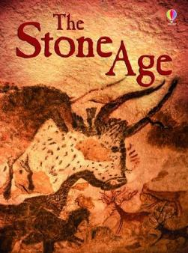

This term our topic is Stone Age “Era de Piedra”, we will learn:
- Stone Age houses .
- Stone Age houses food.
- Role play and songs
- “Me gustaria…”( I would like…)
- Christmas

