Lunes 9 de Noviembre,2020.

L.O: to describe stone age houses. To use verb to live-VIVIR

Donde vives? (where do you live?)
Vivo ...(I live …)
El vive...(he lives…)
Ella vive...(she lives…)

Adjetives

Bonita/to= beautiful
Feo/a= ugly
Grande= big
Pequeno/na= small
Moderno/na= modern
Viejo/ja= old
de piedra= stone
de ladrillos=bricks
con techo de paja= hay roof
de palos = sticks
Use colors: verde,
azul, blanco, negro, gris, amarillo
rojo, naranja, vileta, marron,rosa.

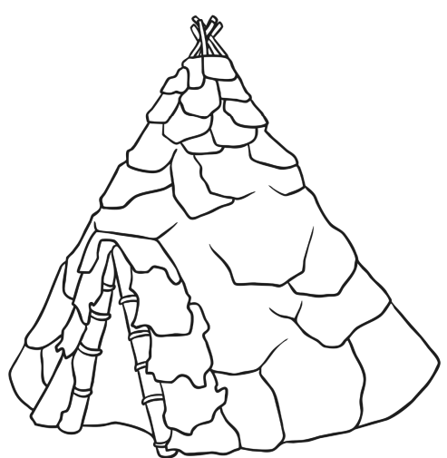en una ruca.
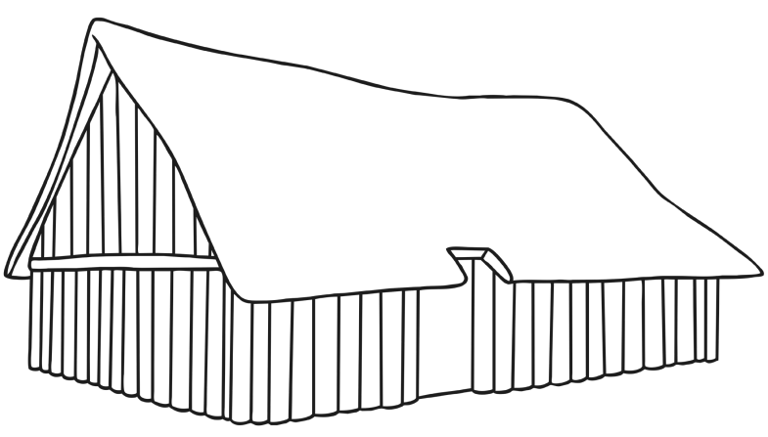en una casa-in a house.

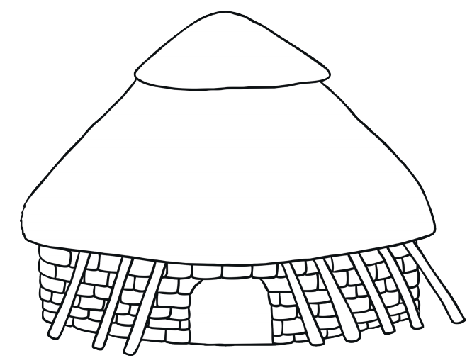
en una casa redonda- in a rounded house.

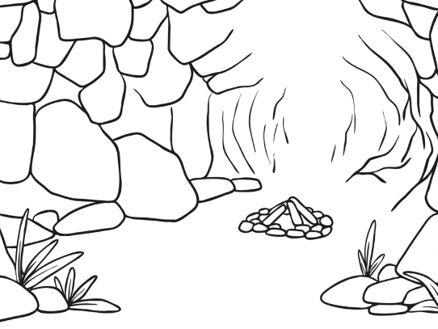 en una cueva- in a cave.

Ask the children to make a dialogue with their learning partners.

Ask children to write their dialogues in their books. Ask them to draw their houses. They must be nice pictures.

“Como te llamas? Me llamo______(names)
Cuantos anos tienes? Tengo__anos.(age)
Que color te gusta? Me gusta_____y_____(favourites colors)
Donde vives? Vivo en Londres, Inglaterra. Vivo en _______(choose a house from the stone age). Es (It is…)____________,_______,_________
Y_________. “ (Use adjectives to describe)

