” Bravery and fear”- Los Sentimientos”

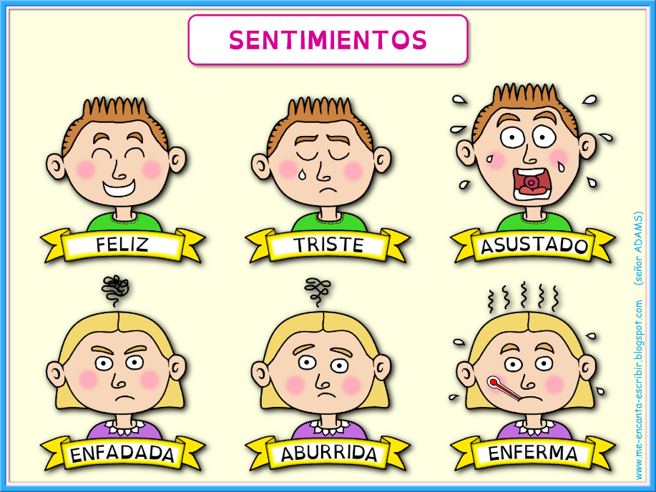
This term our topic in Spanish is “Bravery and Fear”-Los sentimientos. In our Spanish lessons, we are going :
- To identify feelings.
- To express feelings.
- To sing and act.
- To give opinions about food.
- Christmas.

