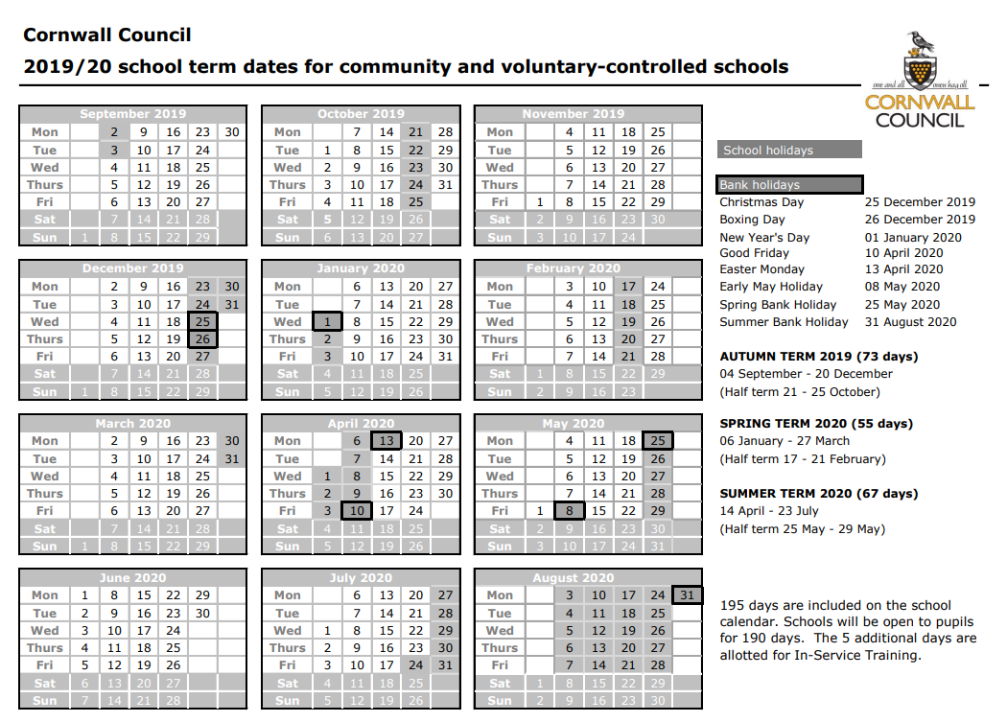

**Perranporth Community Primary School**

**Term Dates and Holidays**

**Below you will see all of the term dates, INSET days and school holidays for the academic year. Holidays will not be authorised during term time. If parents decide to take their child out of school without permission, they will be committing an offence under the Education Act 1996. Absences not authorised by the school may result in issuing a Penalty Notice or prosecution in the Magistrates Court.**

**Please note that we will be having an INSET day on Wednesday 21st February 2018. This day will be used for parent teacher meetings to which children can also attend.**

**Term Dates 2019-20**

**Perranporth School INSET**

**(Non Pupil Days)**

**Wed 4th Sep 2019**

**Mon 28th Oct 2019**

**Fri 20th Dec 2019**

**Wed 26th Feb 2020**

**Thurs 23rd Jul 2020**

**\*Please note the change of Bank Holiday**

**It is now Fri 8th May 2020**