Perranporth School
Pupil Premium Grant Expenditure and Impact Report
2016/17 Academic Year

All schools receive a grant based on the number of pupils in receipt of free school meals (FSM), children in care and children whose parents are in the services. This funding is designed to narrow the gap between the attainment of pupils in receipt of pupil premium and other pupils in the school. Schools are free to use this money in any way they wish, but the aims must be clear - to raise standards for more disadvantaged children. Information on how Perranporth does this is and the impact it has had in this school year is outlined below.

Number of pupils and pupil premium grant received (PPG)
Total number of pupils on roll | 207
Number of pupils benefitting from PPG | 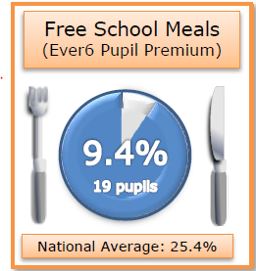
Total amount of PPG received | £ 37, 480

Summary of PPG spending
Objectives
- To close the attainment gap in reading, writing and mathematics
- To increase engagement of families in pupils' learning
- To improve pupils' readiness to learn
- To develop self-esteem and confidence, preparing the children for their future role in British society.
- To broaden experiences and widen opportunities for the children and enrich their curriculum.
- To encourage and promote an enthusiasm for learning (BLP)

Review 2016/2017
A review of our Pupil Premium provision recognises that good practise is taking place across the school, particularly with regard to intervention and to support pupil progress. The Pupil Premium co-ordinator meets termly with the school governor who provides challenge and support to monitor the impact of Pupil Premium spending. Reports and data are also shared at termly governor meetings and included in the head teacher’s report. The school annually provides a summary of the spending and uses data and other qualitative information to ensure best practice. The school has a comprehensive strategy to support disadvantaged pupils, this is informed by research and liaising with other schools to help make informed decisions about how to allocate the funding to address barriers to learning.
Key Stage 2 – Pupil Group Performance 2017
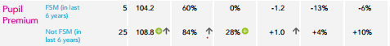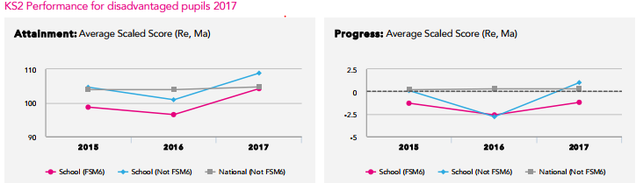

Actions taken so far | Cost |  | Desired impact |  | Impact
Employment of two teaching assistants to deliver bespoke interventions set by the teaching staff for 4x afternoons and 2x before school sessions for PP pupils on a rotation basis. TAs employed in the morning in KS2  Employment of TA to run additional hour before school x 2. | £ 17,725  +£603 | 1. | Targeted pupils feel more confident about their learning. Barriers to learning are addressed rapidly, meeting the pupils’ individual needs and supporting them to overcome barriers to their learning. All pupils make accelerated progress in identified areas. Children are able to talk confidently about their learning. Children are able to respond to feedback and become more critical learners for self improvement. |  | Lesson observation and book scrutiny demonstrated that lower achieving PP pupils are receiving effective feedback which is supporting good progress.  “Mrs A helps me when I am finding things a bit tricky, I understand it more when I go over it again.”  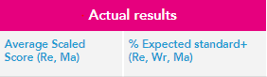  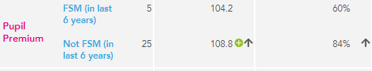
 |  |  |  |  | Book scrutiny demonstrated that through the teaching sequence, pupils were writing at greater length, not only in the small group teaching but this was also evident across the curriculum.
Employment of teaching assistant for in KS1 to deliver bespoke interventions set by the teaching staff, precision teaching and pre-teaching for 3 x afternoons per week to PP pupils on a rotation basis. Intervention has an additional focus on Phonics to ensure that pupils pass the phonics screening test. | £2715 |  | Pupils are able to access a greater range of class-based learning without support.  Class teachers report that pupils are accessing the curriculum with more confidence.  Pupils develop more confidence in reading/ writing and maths. |  | Tailored and bespoke intervention program delivered to meet children’s individual needs meant that they were better equipped to access the curriculum. This has been successful.  Lesson observation and talking to children demonstrates increased independence in class and an increased confidence in a range of subjects across the curriculum.  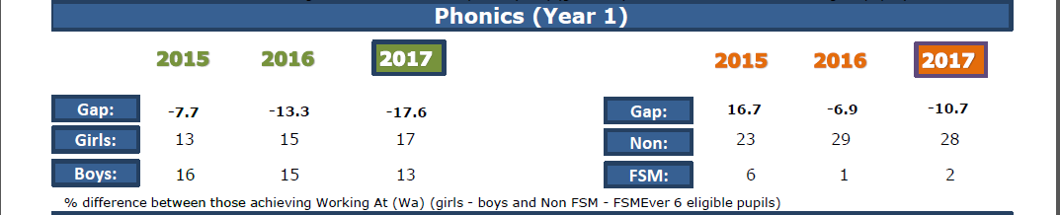

Release time for the Pupils Premium and disadvantaged pupils co-ordinator to monitor PP provision in class and through intervention, provide support for PP intervention staff and Tad ensuring best practice. | £10,950 | Co-ordinator uses the time to identify the learning needs of PP children.  PP and disadvantaged children are identified on the ‘Alert List’ – this is updated termly. Support and training is provided for TAs.  The coordinator will hear children read/ carry put learning walks and book scrutiny to ensure high quality teaching and learning.
Improving classroom practice through focussed observation and peer support to support the progress in Mathematics of disadvantaged pupils. | Time | Teachers improve practice to ensure that all pupil premium pupils achieve their potential, contributing to the accelerated progress of pupil premium pupils in their classes. | In lesson observations there was high quality, wave one teaching.
Mathletics – online maths resource | £ 167 | Increase pupils’ motivation in mathematics. | Children are accessing Mathletics more readily. Pupils in receipt in PP are able to consolidate their learning at home. Anecdotal evidence from parents suggest that pupils enjoy accessing Mathletics.  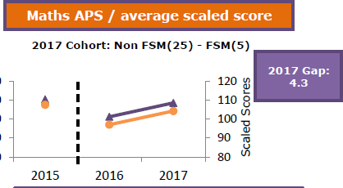
Employment of Emotional and Behavioural specialist. | £2548 | Pupils more ready for learning in school. Increased confidence and self esteem.  Parents feel supported in helping their child. | This is a very successful targeted support for pupils and parents.  Parental feedback has been overwhelmingly positive The impact on the behaviour at home and school of pupils receiving the support has been very positive.  ‘I like working with Ann, she has Rocky Raccoon and the worry monster – he only eats worries.’ (ST)
Fund to offset the cost of trips, additional tuition, residential visits and other enrichment activities: governors agreed in October 2015 to fund the full cost of extra-curricular clubs for pupils in receipt of pupil premium. | £ 2805 | Increased number of pupils on FSM accessing clubs on reduced rates.  Higher take up of residential places.  Pupils experience new activities and it broadens their horizons and raises aspirations. | There has been a dramatic rise in PP pupils accessing a range of clubs including all peripatetic music lessons.  Pupils from disadvantaged backgrounds went on the Y6 school camp.  ‘It was really good fun, I’ve never slept in a tent before and I loved the circus skills.’ (KT)
Fund towards the cost of uniform: governors agreed to support pupils in receipt of PP in purchasing two pieces of uniform. | £355 | Higher uptake of PP (this was necessary after the introduction of free school meals).  Pupils had the correct uniform and felt part of the school community. | All pupils were wearing the correct school uniform. Parent relationship with school improved as they could see that every effort was being made to support their children.  Children in the correct school uniform had an improved attitude to learning and their behaviour improved too.
Total expenditure | £ 37,968

