Perranporth School

E Safety Policy

Reviewed September 2015

Perranporth E Safety Policy
Development / Monitoring / Review of this Policy

This e-safety policy has been developed by Perranporth Primary School safeguarding committee made up of:
- Computing and E safety Coordinator
- Head teacher / Safeguarding Governor
- Health and Safety Officer/ Governor
- Staff – including Teachers, Support Staff, Technical staff
- School Council and Diamond 6 Pupils

Schedule for Development / / Review

This e-safety policy was approved/ Reviewed by the Governors: September 2015
The policy has been reviewed to reflect PREVENT training given to all teaching staff November 2015
The implementation of this e-safety policy will be monitored by the: E-safety Committee , TERMLY
The Governing Body will receive a report on the implementation of the e-safety policy generated by the monitoring group (which will include anonymous details of e-safety incidents) at regular intervals/ when necessary: By L Kelly
The E-Safety Policy will be reviewed annually, or more regularly in the light of any significant new developments in the use of the technologies, new threats to e-safety or incidents that have taken place. The next anticipated review date will be: October 2016 ( J Roberson & L Kelly
Should serious e-safety incidents take place, the following external persons / agencies should be informed: Cornwall Police, CEOP and/or IWF
The school will monitor the impact of the policy using:
- Logs of reported incidents
- Monitoring logs of internet activity (including sites visited)
- Surveys / questionnaires of
-students / pupils
-parents / carers
-staff

Scope of the Policy
This policy applies to all members of the school community (including staff, students / pupils, volunteers, parents / carers, visitors, community users) who have access to and are users of school ICT systems, both in and out of the school.
The Education and Inspections Act 2006 empowers Headteachers to such extent as is reasonable, to regulate the behaviour of students / pupils when they are off the school site and empowers members of staff to impose disciplinary penalties for inappropriate behaviour. This is pertinent to incidents of cyber-bullying, or other e-safety incidents covered by this policy, which may take place outside of the school, but is linked to membership of the school. The 2011 Education Act increased these powers with regard to the searching for and of electronic devices and the deletion of data. In the case of both acts, action can only be taken over issues covered by the published Behaviour Policy.
The school will deal with such incidents within this policy and associated behaviour and anti-bullying policies and will, where known, inform parents / carers of incidents of inappropriate e-safety behaviour that take place out of school.

Roles and Responsibilities
The following section outlines the e-safety roles and responsibilities of individuals and groups within the school:
Governors:
Governors are responsible for the approval of the E-Safety Policy and for reviewing the effectiveness of the policy. This will be carried out by the Governors receiving regular information about e-safety incidents and monitoring reports. A member of the Governing Body (L Kelly & A Johnson) have taken on the role of E-Safety Governor additional to their role as Safeguarding officer.
The role of the E-Safety Governor will include:
- regular meetings with the E-Safety Co-ordinator
- regular monitoring of e-safety incident logs
- reporting to relevant Governors
Headteacher / Principal and Senior Leaders:
- The Headteacher has a duty of care for ensuring the safety (including e-safety) of members of the school community, though the day to day responsibility for e-safety will be delegated to the E-Safety Co-ordinator.
- The Headteacher and the Assistant Head Teacher should be aware of the procedures to be followed in the event of a serious e-safety allegation being made against a member of staff
- The Headteacher is responsible for ensuring that the E-Safety Coordinator and other relevant staff receive suitable training to enable them to carry out their e-safety roles and to train other colleagues, as relevant.
- The Headteacher will ensure that there is a system in place to allow for monitoring and support of those in school who carry out the internal e-safety monitoring role. This is to provide a safety net and also support to those colleagues who take on important monitoring roles
- The Senior Leadership Team will receive regular monitoring reports from the E-Safety Co-ordinator.

E-Safety Coordinator: Jesse Roberson & Linda Kelly
  - leads the e-safety committee
  - takes day to day responsibility for e-safety issues and has a leading role in establishing and reviewing the school e-safety policies / documents
  - ensures that all staff are aware of the procedures that need to be followed in the event of an esafety incident taking place.
  - provides training and advice for staff
  - liaises with the Local Authority / relevant body
  - liaises with school technical staff
  - receives reports of e-safety incidents and creates a log of incidents to inform future e-safety developments
  - meets regularly with E-Safety Governor to discuss current issues, review incident logs and filtering / change control logs
  - reports regularly to Senior Leadership Team

Network Manager: ICT4
The Network Manager is responsible for ensuring:
  - that the school’s technical infrastructure is secure and is not open to misuse or malicious attack
  - that the school meets required e-safety technical requirements and any Local Authority / other relevant body E-Safety Policy / Guidance that may apply.
  - that users may only access the networks and devices through a properly enforced password protection policy, in which passwords are regularly changed (teaching Staff)
  - that they keep up to date with e-safety technical information in order to effectively carry out their esafety role and to inform and update others as relevant
  - that the use of the network / internet / Virtual Learning Environment / remote access / email is regularly monitored in order that any misuse / attempted misuse can be reported to the Headteacher / E-Safety Coordinator / for investigation / action / sanction
  - that monitoring software / systems are implemented and updated as agreed in school policies

Teaching and Support Staff
are responsible for ensuring that:
  - they have an up to date awareness of e-safety matters and of the current school e-safety policy and practices
  - they have read, understood and signed the Staff Acceptable Use Policy / Agreement
  - they report any suspected misuse or problem to the Headteacher; E-Safety Coordinator for investigation / action / sanction
  - all digital communications with students / pupils / parents / carers should be on a professional level and only carried out using official school systems
  - e-safety issues are embedded in all aspects of the curriculum and other activities
  - students / pupils understand and follow the e-safety and acceptable use policies
  - students / pupils have a good understanding of research skills and the need to avoid plagiarism and uphold copyright regulations
  - they monitor the use of digital technologies, mobile devices, cameras etc in lessons and other school activities (where allowed) and implement current policies with regard to these devices
  - in lessons where internet use is pre-planned students / pupils should be guided to sites checked as suitable for their use and that processes are in place for dealing with any unsuitable material that is found in internet searches
  - they have undertaken or are aware of PREVENT training (cascaded if not attended) and know which signs to look out for in cases of radicalisation.

Child Protection / Safeguarding Designated Person / Officer : Mr A Johnson
should be trained in e-safety issues and be aware of the potential for serious child protection / safeguarding issues to arise from:
- sharing of personal data
- access to illegal / inappropriate materials
- inappropriate on-line contact with adults / strangers
- potential or actual incidents of grooming
- cyber-bullying
- any forms of radicalisation

E-Safety Group
The E-Safety Group provides a consultative group that has wide representation from the school community, with responsibility for issues regarding e-safety and the monitoring the e-safety policy including the impact of initiatives. The group will also be responsible for regular reporting to the Governing Body.
Members of the E-safety Group will assist the E-Safety Coordinator with:
- the production / review / monitoring of the school e-safety policy / documents.
- the production / review / monitoring of the school filtering policy (if the school chooses to have one) and requests for filtering changes.
- mapping and reviewing the e-safety curricular provision – ensuring relevance, breadth and progression
- monitoring network / internet / incident logs
- consulting stakeholders – including parents / carers and the students / pupils about the e-safety provision
- monitoring improvement actions identified through use of the 360 degree safe self-review tool

Students / pupils:
- are responsible for using the school digital technology systems in accordance with the Student / Pupil Acceptable Use Policy
- have a good understanding of research skills and the need to avoid plagiarism and uphold copyright regulations
- need to understand the importance of reporting abuse, misuse or access to inappropriate materials and know how to do so
- will be expected to know and understand policies on the use of mobile devices and digital cameras.
- They should also know and understand policies on the taking / use of images and on cyberbullying.
- should understand the importance of adopting good e-safety practice when using digital technologies out of school and realise that the school’s E-Safety Policy covers their actions out of school, if related to their membership of the school.

Parents / Carers
Parents / Carers play a crucial role in ensuring that their children understand the need to use the internet / mobile devices in an appropriate way. The school will take every opportunity to help parents understand these issues through parents’ evenings, newsletters, letters, website and information about national / local e-safety campaigns / literature. Parents and carers will be encouraged to support the school in promoting good e-safety practice and to follow guidelines on the appropriate use of:
- digital and video images taken at school events
- access to parents’ sections of the website and on-line student / pupil records
- their children’s personal devices in the school (where this is allowed)

Policy Statements

Education – students / pupils
Whilst regulation and technical solutions are very important, their use must be balanced by educating students / pupils to take a responsible approach. The education of pupils in e-safety is therefore an essential part of the school’s e-safety provision. Children and young people need the help and support of the school to recognise and avoid e-safety risks and build their resilience. All teaching staff are trained in PREVENT and are responsible for teaching this as part of Promoting Britsh Values and the Computing Curriculum. (The Prevent strategy is the Government’s response to help counter the extreme ideologies that recruit vulnerable people and to offer guidance and support to those who are drawn to them. Much of the work is dominated by the opposing ideologies of far-right extremism (neo-Nazi) and violent Islamists (Al Qaeda, ISIS), although the strategy addresses all forms of extremism.
Local delivery of Prevent is aligned with Community Safety and Safeguarding; all communities are affected by violent extremism and those most vulnerable to the ideologies are the young, particularly through the use of the internet.
E-safety should be a focus in all areas of the curriculum and staff should reinforce e-safety messages across the curriculum. The e-safety curriculum should be broad, relevant and provide progression, with opportunities for creative activities and will be provided in the following ways:
- A planned e-safety curriculum is provided as part of Computing / PHSE / SMSC and PBV other lessons and should be regularly revisited
- Key e-safety messages should be reinforced as part of a planned programme of assemblies and tutorial / pastoral activities
- Students / pupils should be taught in all lessons to be critically aware of the materials / content they access on-line and be guided to validate the accuracy of information.
- Students / pupils should be taught to acknowledge the source of information used and to respect copyright when using material accessed on the internet
- Students / pupils should be helped to understand the need for the student / pupil Acceptable Use Agreement and encouraged to adopt safe and responsible use both within and outside school
- Staff should act as good role models in their use of digital technologies the internet and mobile devices
- in lessons where internet use is pre-planned, it is best practice that students / pupils should be guided to sites checked as suitable for their use and that processes are in place for dealing with any unsuitable material that is found in internet searches.
- Where students / pupils are allowed to freely search the internet, staff should be vigilant in monitoring the content of the websites the young people visit.
- It is accepted that from time to time, for good educational reasons, students may need to research topics (eg racism, drugs, discrimination) that would normally result in internet searches being blocked. In such a situation, staff can request that the Technical Staff (or other relevant designated person) can temporarily remove those sites from the filtered list for the period of study. Any request to do so, should be auditable, with clear reasons for the need.

Education – parents / carers
Many parents and carers have only a limited understanding of e-safety risks and issues, yet they play an essential role in the education of their children and in the monitoring / regulation of the children’s on-line behaviours. Parents may underestimate how often children and young people come across potentially harmful and inappropriate material on the internet and may be unsure about how to respond.
The school will therefore seek to provide information and awareness to parents and carers through:
- Curriculum activities / homework
- Letters, newsletters, web site
- Parents / Carers e safety sessions
- High profile events / campaigns eg Safer Internet Day
- Reference to the relevant web sites / publications eg www.swgfl.org.uk www.saferinternet.org.uk/ http://www.childnet.com/parents-and-carers

Education & Training – Staff / Volunteers
It is essential that all staff receive e-safety training and understand their responsibilities, as outlined in this policy.
Training will be offered as follows:
- A planned programme of formal e-safety training will be made available to staff. This will be regularly updated and reinforced. An audit of the e-safety training needs of all staff will be carried out regularly.
- All new staff should receive e-safety training as part of their induction programme, ensuring that they fully understand the school e-safety policy and Acceptable Use Agreements.
- The E-Safety Coordinator will receive regular updates through attendance at external training events and by reviewing guidance documents released by relevant organisations.
- This E-Safety policy and its updates will be presented to and discussed by staff in staff / team meetings / INSET days.
- The E-Safety Coordinator will provide advice / guidance / training to individuals as required.
- PREVENT Training for all teaching staff (November 15) cascaded to support staff.

Training – Governors / Directors
Governors should take part in e-safety training / awareness sessions, with particular importance for those who are members of any subcommittee / group involved in technology / e-safety / health and safety / child protection. This may be offered in a number of ways:
- Attendance at training provided by the Local Authority
- Participation in school training / information sessions for staff or parents

Technical – infrastructure / equipment, filtering and monitoring
The school will be responsible for ensuring that the school infrastructure / network is as safe and secure as is reasonably possible and that policies and procedures approved within this policy are implemented. It will also need to ensure that the relevant people named in the above sections will be effective in carrying out their esafety responsibilities:
- School technical systems will be managed in ways that ensure that the school meets recommended technical requirements
- There will be regular reviews and audits of the safety and security of school technical systems
- Servers, wireless systems and cabling must be securely located and physical access restricted
- All users will have clearly defined access rights to school technical systems and devices.
- The “master / administrator” passwords for the school ICT system, used by the Network Manager must also be available to the Headteacher / Principal or other nominated senior leader and kept in a secure place (eg school safe)
- Technical Support Assistant is responsible for ensuring that software licence logs are accurate and up to date and that regular checks are made to reconcile the number of licences purchased against the number of software installations
- Internet access is filtered for all users. Illegal content (child sexual abuse images) is filtered by the broadband or filtering provider by actively employing the Internet Watch Foundation CAIC list. Content lists are regularly updated and internet use is logged and regularly monitored. There is a clear process in place to deal with requests for filtering changes.
- The school has provided enhanced / differentiated user-level filtering
- School technical staff regularly monitor and record the activity of users on the school technical systems and users are made aware of this in the Acceptable Use Agreement
- An appropriate system is in place for users to report any actual / potential technical incident / security breach to the relevant person, as agreed).
- Appropriate security measures are in place to protect the servers, firewalls, routers, wireless systems, work stations, mobile devices etc from accidental or malicious attempts which might threaten the security of the school systems and data. These are
tested regularly. The school infrastructure and individual workstations are protected by up to date virus software.
- An agreed policy is in place for the provision of temporary access of “guests” (eg trainee teachers, supply teachers, visitors) onto the school systems.
- An agreed policy is in place regarding the extent of personal use that users (staff / students / pupils / community users) and their family members are allowed on school devices that may be used out of school.
- An agreed policy is in place that allows staff to download executable files and installing programmes on school devices.
- An agreed policy is in regarding the use of removable media (eg memory sticks / CDs / DVDs) by users on school devices. Personal data cannot be sent over the internet or taken off the school site unless safely encrypted or otherwise secured.

Use of digital and video images
The development of digital imaging technologies has created significant benefits to learning, allowing staff and students / pupils instant use of images that they have recorded themselves or downloaded from the internet. However, staff, parents / carers and students / pupils need to be aware of the risks associated with publishing digital images on the internet. Such images may provide avenues for cyberbullying to take place. Digital images may remain available on the internet forever and may cause harm or embarrassment to individuals in the short or longer term. It is common for employers to carry out internet searches for information about potential and existing employees. The school will inform and educate users about these risks and will implement policies to reduce the likelihood of the potential for harm:
- When using digital images, staff should inform and educate students / pupils about the risks associated with the taking, use, sharing, publication and distribution of images. In particular they should recognise the risks attached to publishing their own images on the internet eg on social networking sites.
- In accordance with guidance from the Information Commissioner’s Office, parents / carers are welcome to take videos and digital images of their children at school events for their own personal use (as such use in not covered by the Data Protection Act). To respect everyone’s privacy and in some cases protection, these images should not be published / made publicly available on social networking sites, nor should parents / carers comment on any activities involving other students / pupils in the digital / video images.
- Staff and volunteers are allowed to take digital / video images to support educational aims, but must follow school policies concerning the sharing, distribution and publication of those images. Those images should only be taken on school equipment, the personal equipment of staff should not be used for such purposes.
- Care should be taken when taking digital / video images that students / pupils are appropriately dressed and are not participating in activities that might bring the individuals or the school into disrepute.
- Students / pupils must not take, use, share, publish or distribute images of others without their permission
- Photographs published on the website, or elsewhere that include students / pupils will be selected carefully and will comply with good practice guidance on the use of such images.
- Students’ / Pupils’ full names will not be used anywhere on a website or blog, particularly in association with photographs.
- Written permission from parents or carers will be obtained before photographs of students / pupils are published on the school website
- Student’s / Pupil’s work can only be published with the permission of the student / pupil and parents or carers.

Data Protection
Personal data will be recorded, processed, transferred and made available according to the Data Protection Act 1998 which states that personal data must be:
- Fairly and lawfully processed
- Processed for limited purposes
- Adequate, relevant and not excessive
- Accurate
- Kept no longer than is necessary
- Processed in accordance with the data subject’s rights
- Secure
- Only transferred to others with adequate protection.
The school must ensure that:
- It will hold the minimum personal data necessary to enable it to perform its function and it will not hold it for longer than necessary for the purposes it was collected for.
- Every effort will be made to ensure that data held is accurate, up to date and that inaccuracies are corrected without unnecessary delay.
- All personal data will be fairly obtained in accordance with the “Privacy Notice” and lawfully processed in accordance with the “Conditions for Processing”.
- It has a Data Protection Policy
- It is registered as a Data Controller for the purposes of the Data Protection Act (DPA)
- Responsible persons are appointed / identified - Senior Information Risk Officer (SIRO) and Information Asset Owners (IAOs)
- Risk assessments are carried out
- It has clear and understood arrangements for the security, storage and transfer of personal data
- Data subjects have rights of access and there are clear procedures for this to be obtained
- There are clear and understood policies and routines for the deletion and disposal of data
- There is a policy for reporting, logging, managing and recovering from information risk incidents
- There are clear Data Protection clauses in all contracts where personal data may be passed to third parties
- There are clear policies about the use of cloud storage / cloud computing which ensure that such data storage meets the requirements laid down by the Information Commissioner’s Office.

Staff must ensure that they:
- At all times take care to ensure the safe keeping of personal data, minimising the risk of its loss or misuse.
- Use personal data only on secure password protected computers and other devices, ensuring that they are properly “logged-off” at the end of any session in which they are using personal data.
- Transfer data using encryption and secure password protected devices.

When personal data is stored on any portable computer system, memory stick or any other removable media:
- the data must be encrypted and password protected
- the device must be password protected
- the device must offer approved virus and malware checking software
- the data must be securely deleted from the device, in line with school policy (below) once it has been transferred or its use is complete

Communications
A wide range of rapidly developing communications technologies has the potential to enhance learning. The following table shows how the school currently considers the benefit of using these technologies for education outweighs their risks / disadvantages:

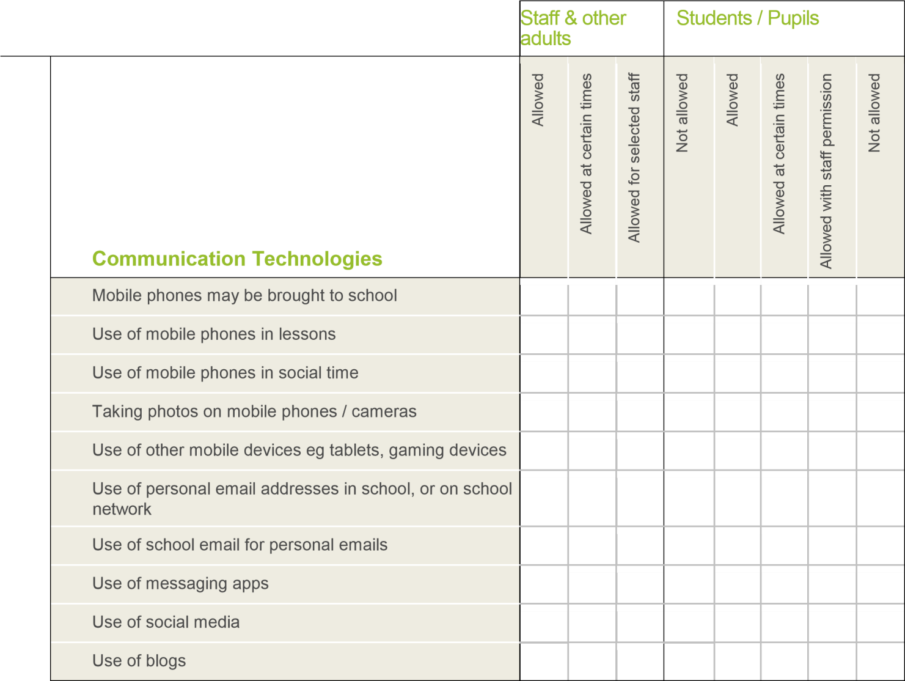

When using communication technologies the school considers the following as good practice:
- The official school email service may be regarded as safe and secure and is monitored. Users should be aware that email communications are monitored.
- Users must immediately report, to the nominated person – in accordance with the school policy, the receipt of any communication that makes them feel uncomfortable, is offensive, discriminatory, threatening or bullying in nature and must not respond to any such communication.
- Any digital communication between staff and students / pupils or parents / carers (email, chat, VLE etc) must be professional in tone and content.
- Whole class / group email addresses may be used at KS1, while students / pupils at KS2 and above will be provided with individual school email addresses for educational use.
- Students / pupils should be taught about e-safety issues, such as the risks attached to the sharing of personal details. They should also be taught strategies to deal with inappropriate communications and be reminded of the need to communicate appropriately when using digital technologies.
- Personal information should not be posted on the school website and only official email addresses should be used to identify members of staff.

Social Media - Protecting Professional Identity

All schools have a duty of care to provide a safe learning environment for pupils and staff. Schools and local authorities could be held responsible, indirectly for acts of their employees in the course of their employment. Staff members who harass, cyberbully, discriminate on the grounds of sex, race or disability or who defame a third party may render the school or local authority liable to the injured party. Reasonable steps to prevent predictable harm must be in place.

The school provides the following measures to ensure reasonable steps are in place to minimise risk of harm to pupils, staff and the school through limiting access to personal information:
- Training to include: acceptable use; social media risks; checking of settings; data protection; reporting issues.
- Clear reporting guidance, including responsibilities, procedures and sanctions Risk assessment, including legal risk School staff should ensure that:
- No reference should be made in social media to students / pupils, parents / carers or school staff
- They do not engage in online discussion on personal matters relating to members of the school community
- Personal opinions should not be attributed to the school /academy or local authority
- Security settings on personal social media profiles are regularly checked to minimise risk of loss of personal information.

The school’s use of social media for professional purposes will be checked regularly by the senior risk
officer and e-safety committee to ensure compliance with the Social Media, Data Protection, Communications, Digital Image and Video Policies.

Unsuitable / inappropriate activities
The school believes that the activities referred to in the following section would be inappropriate in a school context and that users, as defined below, should not engage in these activities in school or outside school when

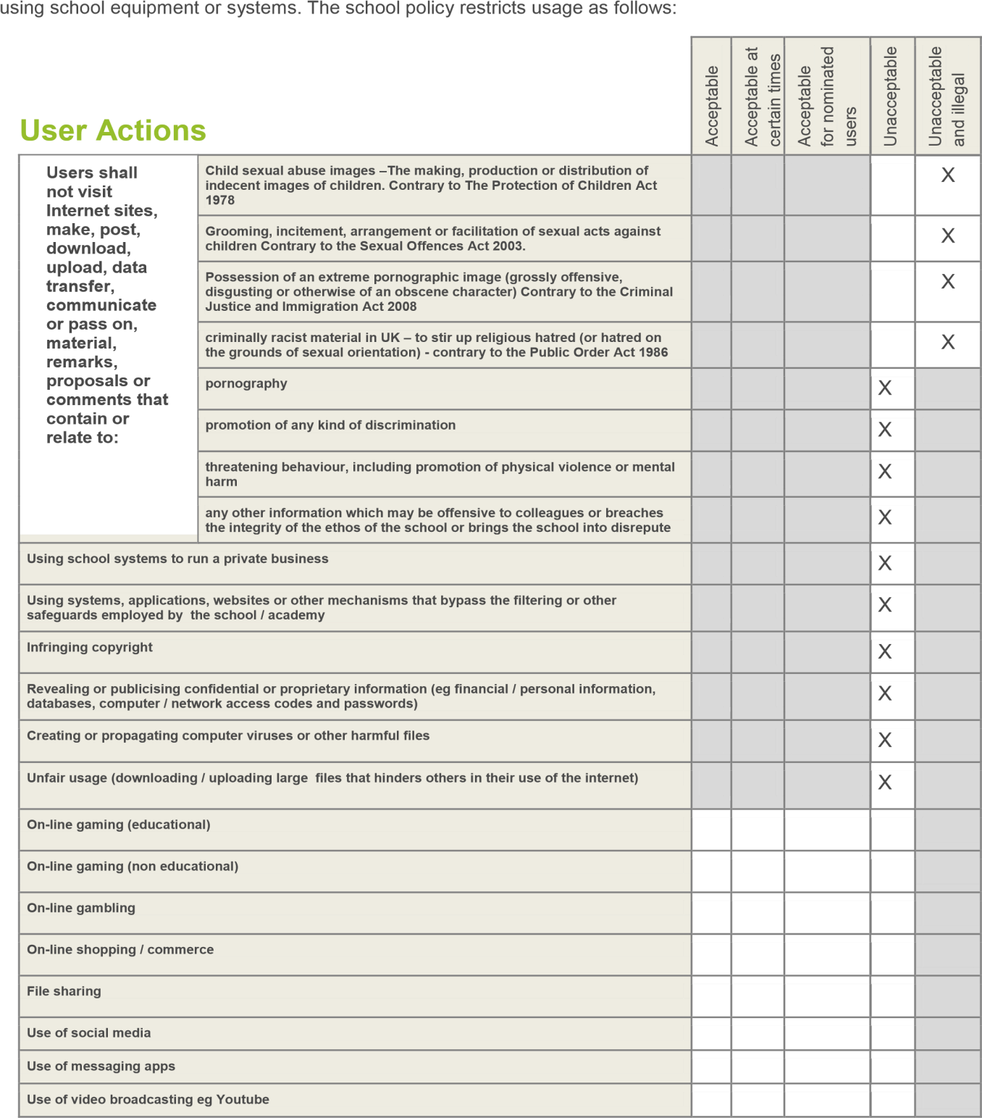

Responding to incidents of misuse
This guidance is intended for use when staff need to manage incidents that involve the use of online services. It encourages a safe and secure approach to the management of the incident. Incidents might involve illegal or inappropriate activities (see “User Actions” above).

Illegal Incidents
If there is any suspicion that the web site(s) concerned may contain child abuse images, or if there is any other suspected illegal activity, refer to the right hand side of the Flowchart (below and appendix) for responding to online safety incidents and report immediately to the police.
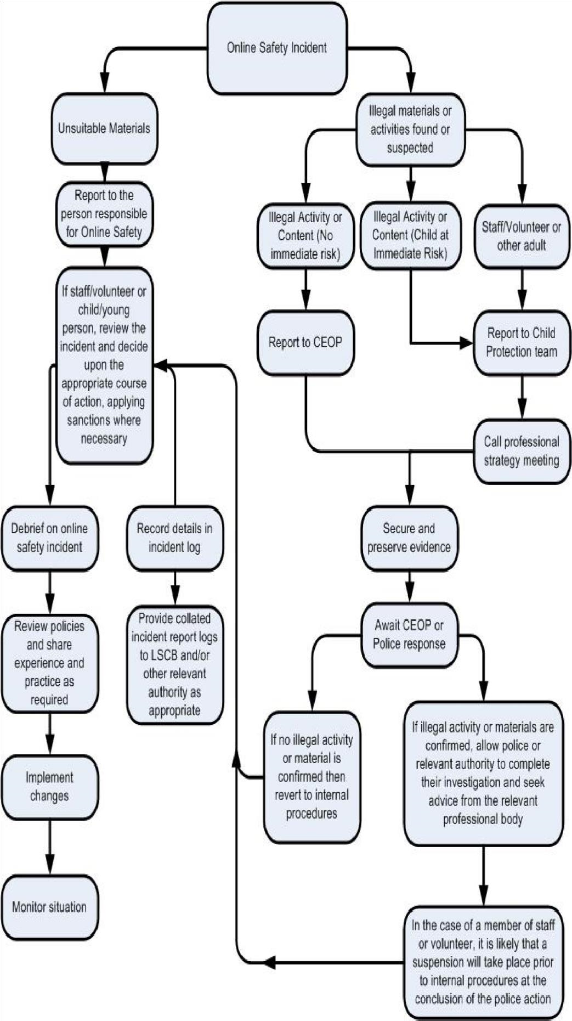

Other Incidents
It is hoped that all members of the school community will be responsible users of digital technologies, who understand and follow school policy. However, there may be times when infringements of the policy could take place, through careless or irresponsible or, very rarely, through deliberate misuse.
In the event of suspicion, all steps in this procedure should be followed:
- Have more than one senior member of staff / volunteer involved in this process. This is vital to protect individuals if accusations are subsequently reported.
- Conduct the procedure using a designated computer that will not be used by young people and if necessary can be taken off site by the police should the need arise. Use the same computer for the duration of the procedure.
- It is important to ensure that the relevant staff should have appropriate internet access to conduct the procedure, but also that the sites and content visited are closely monitored and recorded (to provide further protection).
- Record the url of any site containing the alleged misuse and describe the nature of the content causing concern. It may also be necessary to record and store screenshots of the content on the machine being used for investigation. These may be printed, signed and attached to the form
(except in the case of images of child sexual abuse – see below)
- Once this has been completed and fully investigated the group will need to judge whether this concern has substance or not. If it does then appropriate action will be required and could include the following:
- Internal response or discipline procedures
- Involvement by Local Authority or national / local organisation (as relevant).
- Police involvement and/or action
- If content being reviewed includes images of Child abuse then the monitoring should be halted and referred to the Police immediately. Other instances to report to the police would include:
- incidents of ‘grooming’ behaviour
- the sending of obscene materials to a child
- adult material which potentially breaches the Obscene Publications Act • criminally racist material
- other criminal conduct, activity or materials
- Isolate the computer in question as best you can. Any change to its state may hinder a later police investigation.

It is important that all of the above steps are taken as they will provide an evidence trail for the school and possibly the police and demonstrate that visits to these sites were carried out for child protection purposes. The completed form should be retained by the group for evidence and reference purposes.

School Actions & Sanctions
It is more likely that the school will need to deal with incidents that involve inappropriate rather than illegal misuse. It is important that any incidents are dealt with as soon as possible in a proportionate manner, and that members of the school community are aware that incidents have been dealt with. It is intended that incidents of misuse will be dealt with through normal behaviour / disciplinary procedures see Behaviour Policy

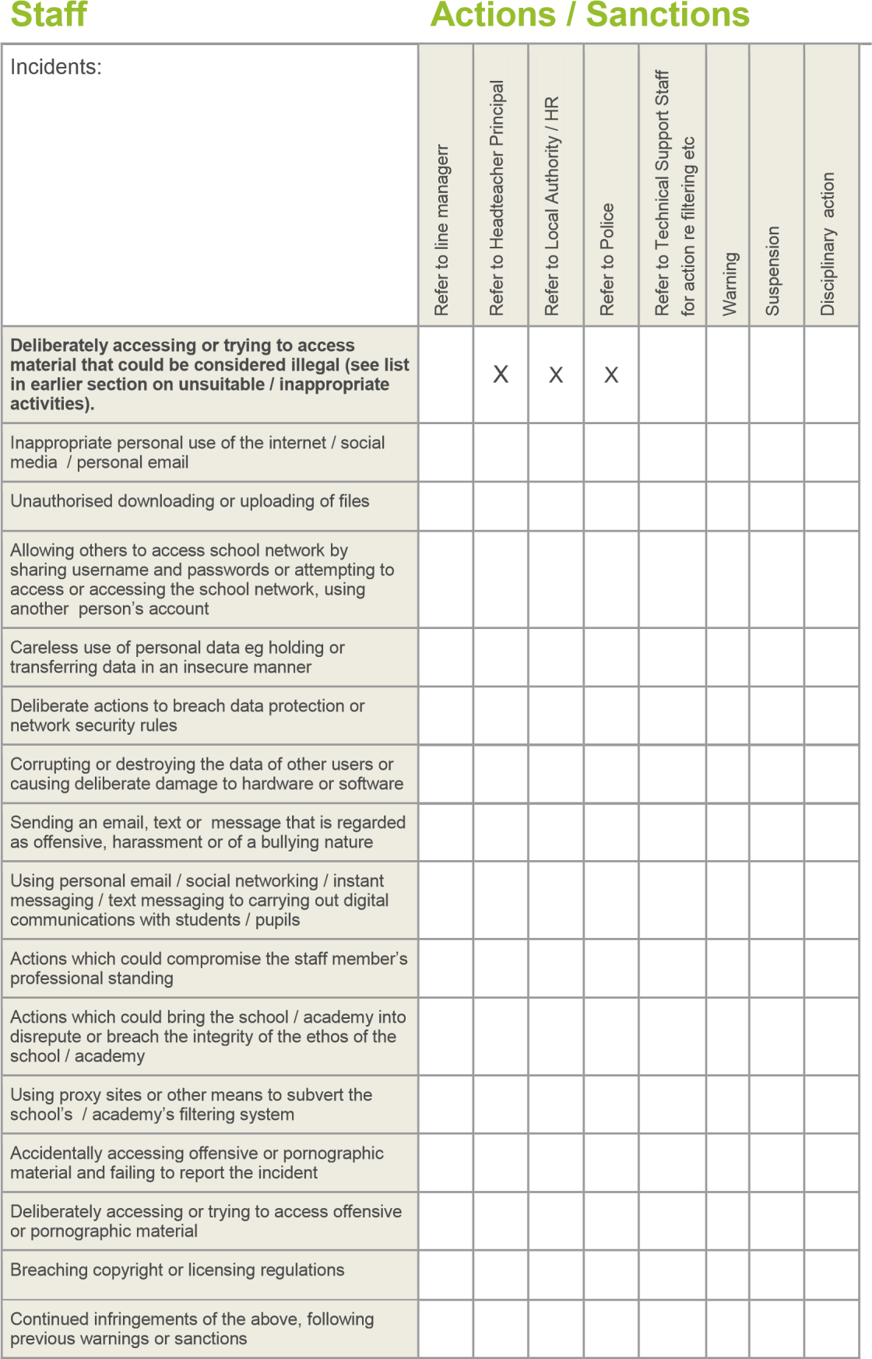

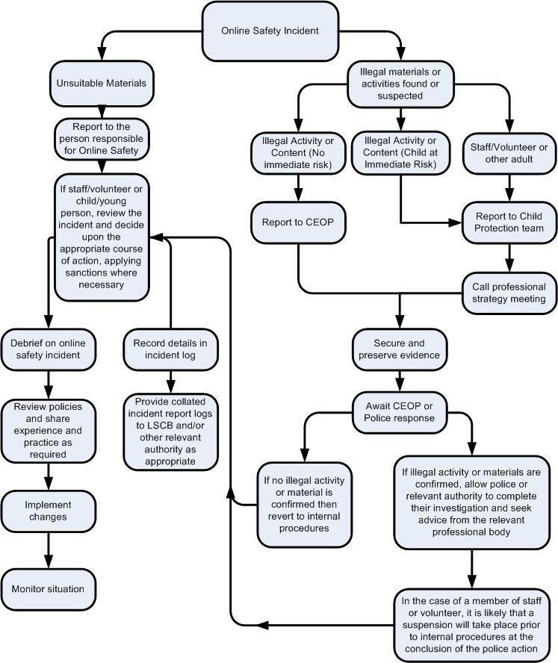

Training Needs Audit

Glossary of terms

AUP | Acceptable Use Policy – see templates earlier in this document
CEOP | Child Exploitation and Online Protection Centre (part of UK Police, dedicated to protecting children from sexual abuse, providers of the Think U Know programmes.
CPC | Child Protection Committee
CPD | Continuous Professional Development
CYPS | Children and Young Peoples Services (in Local Authorities)
FOSI | Family Online Safety Institute
EA | Education Authority
ES | Education Scotland
HWB | Health and Wellbeing
ICO | Information Commissioners Office
ICT | Information and Communications Technology
ICTMark | Quality standard for schools provided by NAACE
INSET | In Service Education and Training
IP address | The label that identifies each computer to other computers using the IP (internet protocol)
ISP | Internet Service Provider
ISPA | Internet Service Providers’ Association
IWF | Internet Watch Foundation
LA | Local Authority
LAN | Local Area Network
MIS | Management Information System
NEN | National Education Network – works with the Regional Broadband Consortia (e.g. SWGfL) to provide the safe broadband provision to schools across Britain.
Ofcom | Office of Communications (Independent communications sector regulator)
SWGfL | South West Grid for Learning Trust – the Regional Broadband Consortium of SW Local Authorities – is the provider of broadband and other services for schools and other organisations in the SW
TUK | Think U Know – educational e-safety programmes for schools, young people and parents.
VLE | Virtual Learning Environment (a software system designed to support teaching and learning in an educational setting,
WAP | Wireless Application Protocol

