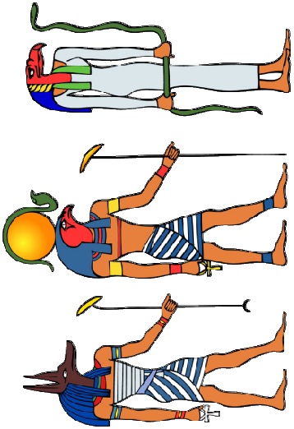
Unit: Who’s the Mummy?
Term: Spring 1
Year: 6
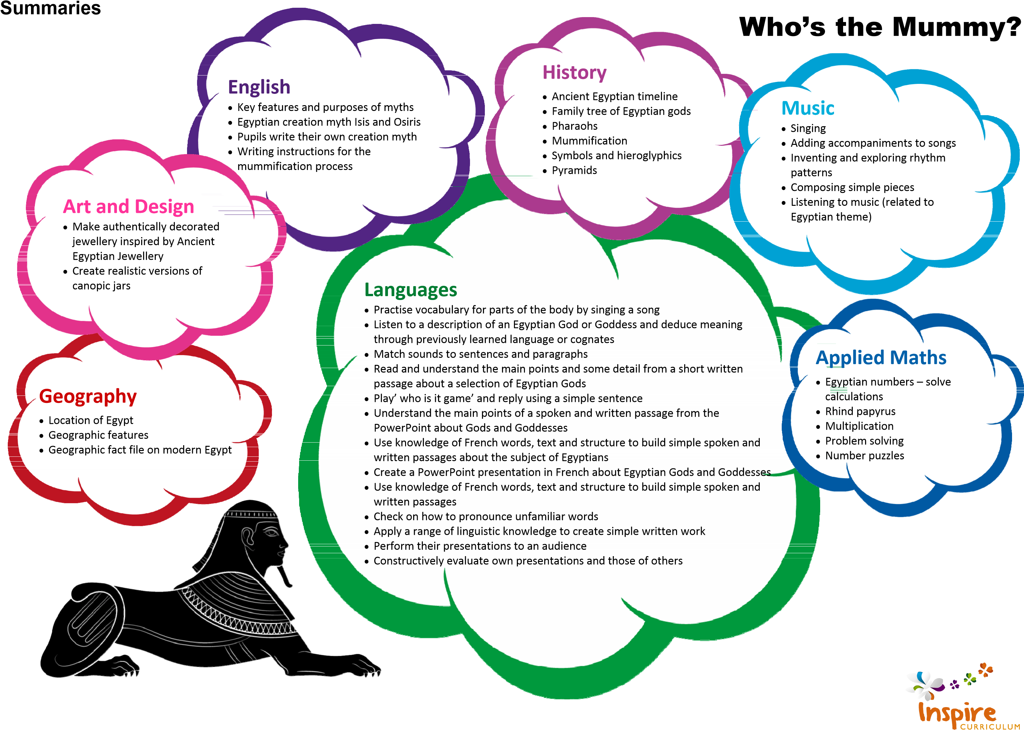
me of Study
Unit: Who’s the Mummy?  Year: 6  Term: Spring 1 |  |  | Key:  FT = First Teaching  OG = On Going  Please note that all appendices and guidelines referred to in the programme of study are available to download at:  https://www.gov.uk/government/collections/national-curriculum The POS codes replace the DfE bullets for ease of reference.
English | Spoken Language
 | SL1 | listen and respond appropriately to adults and their peers
 | SL2 | ask relevant questions to extend their understanding and knowledge
 | SL3 | use relevant strategies to build their vocabulary
 | SL4 | articulate and justify answers, arguments and opinions
 | SL5 | give well-structured descriptions, explanations and narratives for different purposes, including for expressing feelings
 | SL6 | maintain attention and participate actively in collaborative conversations, staying on topic and initiating and responding to comments
 | SL7 | use spoken language to develop understanding through speculating, hypothesising, imagining and exploring ideas
 | SL8 | speak audibly and fluently with an increasing command of Standard English
 | SL9 | participate in discussions, presentations, performances, role play, improvisations and debates
 | SL10 | gain, maintain and monitor the interest of the listener(s)
 | SL11 | consider and evaluate different viewpoints, attending to and building on the contributions of others
 | SL12 | select and use appropriate registers for effective communication
These statements apply to all Years. The content should be taught as a level appropriate to the age of the pupils (taken from notes and guidance [nonstatutory]).
Speaking and listening activities throughout the Unit have been designed with these POS statements in mind. Specific speaking and listening objectives are provided for some English lessons where appropriate.

English | Reading – word reading
 | WR1 | apply their growing knowledge of root words, prefixes and suffixes (morphology and etymology), as listed in English Appendix 1, both to read aloud and to understand the meaning of new words that they meet | OG
 | Reading – comprehension
 | RC1 | maintain positive attitudes to reading and understanding of what they read by:
 | RC1.1 | continuing to read and discuss an increasingly wide range of fiction, poetry, plays, non-fiction and reference books or textbooks | OG
 | RC1.2 | reading books that are structured in different ways and reading for a range of purposes | OG
 | RC1.3 | increasing their familiarity with a wide range of books, including myths, legends and traditional stories, modern fiction, fiction from our literary heritage, and books from other cultures and traditions | OG
 | RC1.4 | recommending books that they have read to their peers, giving reasons for their choices | OG
 | RC1.5 | identifying and discussing themes and conventions in and across a wide range of writing | OG
 | RC1.6 | making comparisons within and across books | OG
 | RC1.7 | learning a wider range of poetry by heart | OG
 | RC1.8 | preparing poems and plays to read aloud and to perform, showing understanding through intonation, tone and volume so that the meaning is clear to an audience | OG
 | RC2 | understand what they read by:
 | RC2.1 | checking that the book makes sense to them, discussing their understanding and exploring the meaning of words in context | OG
 | RC2.2 | asking questions to improve their understanding | OG
 | RC2.3 | drawing inferences such as inferring characters’ feelings, thoughts and motives from their actions and justifying inferences with evidence | OG
 | RC2.4 | predicting what might happen from details stated and implied | OG
 | RC2.5 | summarising the main ideas drawn from more than one paragraph, identifying key details that support the main ideas | OG
 | RC2.6 | identifying how language, structure and presentation contribute to meaning | OG
 | RC3 | discuss and evaluate how authors use language, including figurative language, considering the impact on the reader | OG
 | RC4 | distinguish between statements of fact and opinion | OG
 | RC5 | retrieve, record and present information from non-fiction | OG
 | RC6 | participate in discussions about books that are read to them and those they can read for themselves, building on their own and others’ ideas and challenging views courteously | OG
English | Reading – comprehension continued
 | RC7 | explain and discuss their understanding of what they have read, including through formal presentations and debates, maintaining a focus on the topic and using notes where necessary | OG
 | RC8 | provide reasoned justifications for their views | OG
 | Writing – transcription – spelling
 | WTS1 | use further prefixes and suffixes and understand the guidelines for adding them | OG
 | WTS2 | spell some words with ‘silent’ letters, e.g. knight, psalm, solemn | OG
 | WTS3 | continue to distinguish between homophones and other words which are often confused | OG
 | WTS4 | use knowledge of morphology and etymology in spelling and understand that the spelling of some words needs to be learnt specifically, as listed in English Appendix 1 | OG
 | WTS5 | use dictionaries to check the spelling and meaning of words | OG
 | WTS6 | use the first three or four letters of a word to check spelling, meaning or both of these in a dictionary | OG
 | WTS7 | use a thesaurus | OG
 | Writing – handwriting and presentation
 | WHP1 | write legibly, fluently and with increasing speed by:
 | WHP1.1 | choosing which shape of a letter to use when given choices and deciding whether or not to join specific letters | OG
 | WHP1.2 | choosing the writing implement that is best suited for a task | OG

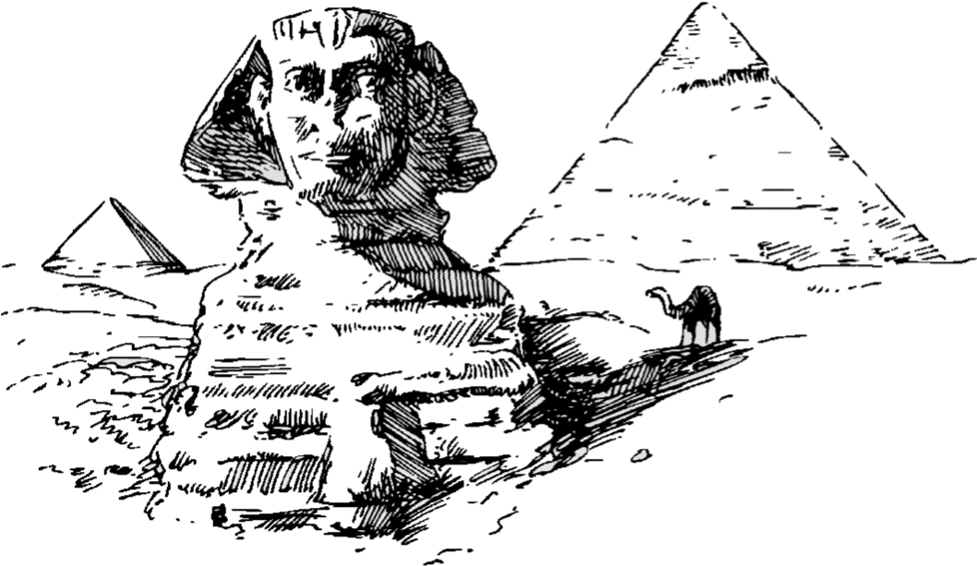
English | Writing – composition
 | WC1 | plan their writing by:
 | WC1.1 | identifying the audience for and purpose of the writing, selecting the appropriate form and using other similar writing as models for their own | OG
 | WC1.2 | noting and developing initial ideas, drawing on reading and research where necessary | OG
 | WC1.3 | in writing narratives, considering how authors have developed characters and settings in what pupils have read, listened to or seen performed | OG
 | WC2 | draft and write by:
 | WC2.1 | selecting appropriate vocabulary and grammar, understanding how such choices can change and enhance meaning | OG
 | WC2.2 | in narratives, describing settings, characters and atmosphere and integrating dialogue to convey character and advance the action | OG
 | WC2.3 | précising longer passages | OG
 | WC2.4 | using a wide range of devices to build cohesion within and across paragraphs | OG
 | WC3 | evaluate and edit by:
 | WC3.1 | assessing the effectiveness of their own and others’ writing | OG
 | WC3.2 | proposing changes to vocabulary, grammar and punctuation to enhance effects and clarify meaning | OG
 | WC3.3 | ensuring the consistent and correct use of tense throughout a piece of writing | OG
 | WC3.4 | ensuring correct subject and verb agreement when using singular and plural, distinguishing between the language of speech and writing and choosing the appropriate register | OG
 | WC4 | proof-read for spelling and punctuation errors | OG
 | WC5 | perform their own compositions, using appropriate intonation, volume, and movement so that meaning is clear | OG

English | Writing – vocabulary, grammar and punctuation
 | WVGP1 | develop their understanding of the concepts set out in English Appendix 2 by:
 | WVGP1.2 | using passive verbs to affect the presentation of information in a sentence | OG
 | WVGP1.3 | using the perfect form of verbs to mark relationships of time and cause | OG
 | WVGP1.4 | using expanded noun phrases to convey complicated information concisely | OG
 | WVGP1.5 | using modal verbs or adverbs to indicate degrees of possibility | OG
 | WVGP1.6 | using relative clauses beginning with who, which, where, when, whose, that or with an implied (i.e. omitted) relative pronoun | OG
 | WVGP1.7 | learning the grammar for Years 5 & 6 in English Appendix 2 | OG
 | WVGP2 | indicate grammatical and other features by:
 | WVGP2.1 | using commas to clarify meaning or avoid ambiguity in writing | OG
 | WVGP2.2 | using hyphens to avoid ambiguity | OG
 | WVGP2.3 | using brackets, dashes or commas to indicate parenthesis | OG
 | WVGP3 | use and understand the grammatical terminology in English Appendix 2 accurately and appropriately in discussing their writing and reading | OG

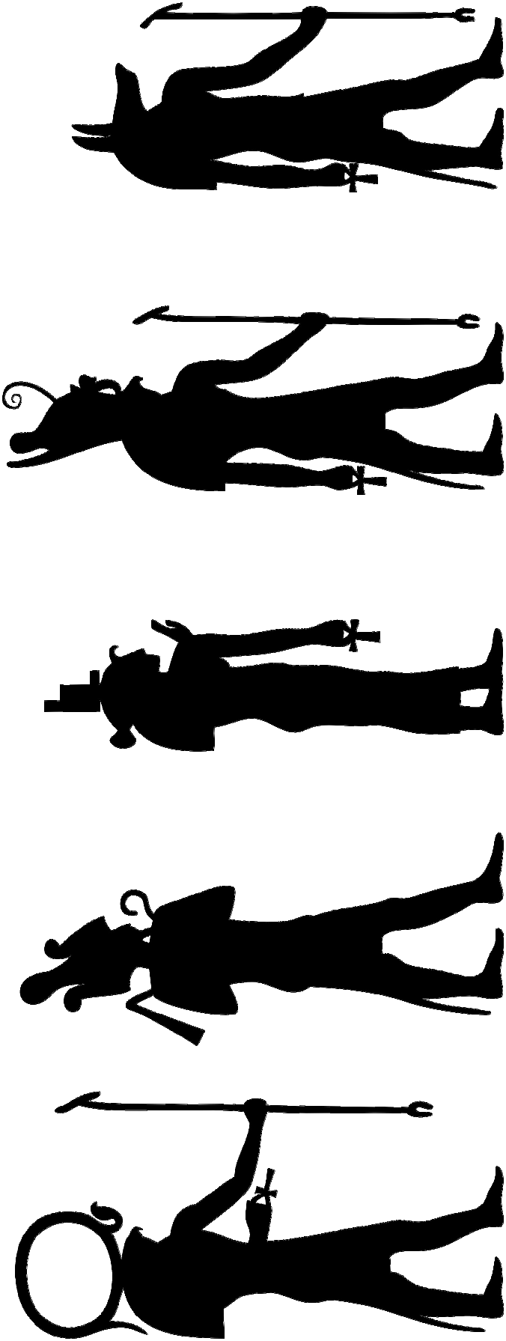
Maths | Number – number and place value
 | 1 | read, write, order and compare numbers up to 10 000 000 and determine the value of each digit
 | 2 | round any whole number to a required degree of accuracy
 | 3 | use negative numbers in context, and calculate intervals across zero
 | 4 | solve number problems and practical problems that involve all of the above
 | Number – addition, subtraction, multiplication and division
 | 4 | perform mental calculations, including with mixed operations and large numbers
 | 7 | solve addition and subtraction multi-step problems in contexts, deciding which operations and methods to use and why
 | 9 | use estimation to check answers to calculations and determine, in the context of a problem, levels of accuracy
 | Fractions (including decimals and percentages)
 | 7 | identify the value of each digit to three decimal places and multiply and divide numbers by 10, 100 and 1000 where the answers are up to three decimal places
 | 8 | multiply one-digit numbers with up to two decimal places by whole numbers
 | 9 | use written division methods in cases where the answer has up to two decimal places
 | 10 | solve problems which require answers to be rounded to specified degrees of accuracy
 | Ratio and proportion
 | 2 | solve problems involving the calculation of percentages (e.g. of measures) such as 15% of 360 and the use of percentages for comparison
 | Algebra
 | 1 | use simple formulae
 | 2 | generate and describe linear number sequences
 | 3 | express missing number problems algebraically
 | 4 | find pairs of numbers that satisfy an equation involving two unknowns
 | 5 | enumerate all possibilities of combinations of two variables

Geography | Location knowledge
 | 1 | locate the world’s countries, using maps to focus on Europe (including the location of Russia) and North and South America and concentrating on their environmental regions, key physical and human characteristics, countries, and major cities

History | 7 | the achievements of the earliest civilizations – an overview of where and when the first civilizations appeared and a depth study of one of the following: Ancient Sumer; The Indus Valley; Ancient Egypt; The Shang Dynasty of Ancient China

Music | 1 | play and perform in solo and ensemble contexts, using their voice and playing musical instruments with increasing accuracy, control and expression
 | 3 | listen with attention to detail and recall sounds with increasing aural memory
 | 4 | use and understand staff and other musical notations
 | 5 | appreciate and understand a wide range of high-quality live and recorded music drawn from different traditions and from great musicians and composers
 | 6 | develop an understanding of the history of music

Art & Design | 2 | to improve their mastery of art and design techniques, such as drawing, painting and sculpture with a range of materials (e.g. pencil, charcoal, paint, clay)
 | 3 | about the greatest artists, architects and designers in history

Languages | 1 | listen attentively to spoken language and show understanding by joining in and responding
 | 2 | explore the patterns and sounds of language through songs and rhymes and link the spelling, sound and meaning of words
 | 3 | engage in conversations; ask and answer questions; express opinions and respond to those of others; seek clarification and help*
 | 4 | speak in sentences, using familiar vocabulary, phrases and basic language structures
 | 5 | develop accurate pronunciation and intonation so that others understand when they are reading aloud or using familiar words and phrases*
 | 6 | present ideas and information orally to a range of audiences*
 | 7 | read carefully and show understanding of words, phrases and simple writing
 | 9 | broaden their vocabulary and develop their ability to understand new words that are introduced into familiar written material, including through using a dictionary
 | 10 | write phrases from memory, and adapt these to create new sentences, to express ideas clearly
 | 11 | describe people, places, things and actions orally* and in writing
 | 12 | understand basic grammar appropriate to the language being studied, such as (where relevant): feminine, masculine and neuter forms and the conjugation of high-frequency verbs; key features and patterns of the language; how to apply these, for instance, to build sentences; and how these differ from or are similar to English.
 | The starred (*) content above will not be applicable to ancient languages.

Applied Computing | 4 | understand computer networks including the internet; how they can provide multiple services, such as the world-wide web; and the opportunities they offer for communication and collaboration
 | 5 | use search technologies effectively, appreciate how results are selected and ranked, and be discerning in evaluating digital content
 | 6 | select, use and combine a variety of software (including internet services) on a range of digital devices to design and create a range of programs, systems and content that accomplish given goals, including collecting, analysing, evaluating and presenting data and information
 | 7 | use technology safely, respectfully and responsibly; recognise acceptable/unacceptable behaviour; identify a range of ways to report concerns about content and contact
Unit Overview
This Unit is based on a study of ancient Egypt. It would be impossible to cover all aspects of ancient Egyptian civilisation in such a short space of time so the main focus is on mummification. You will need the first two lessons of history early in the first week to get the mummification process underway.

The pupils begin the Unit by becoming tomb explorers that find a series of mysterious objects that they need to identify and mysterious riddles that they need to solve.

To do this over the four weeks they will discover how mummies were created by embalming a fish. They will recreate authentic Egyptian jewellery and make canopic jars to ‘store’ the body parts of mummies.

Pupils will write their own versions of ancient Egyptian myths and discover why Egypt’s position in the world made it such a powerful country. The Unit concludes with the pupils carrying out a ‘burial ceremony’ for their fish, which will help them to identify the mystery objects and answer the curious riddles.

