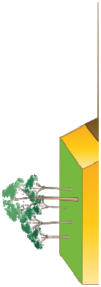
Unit: Shake, Rock and Roll
Term: Spring 2
Year: 3

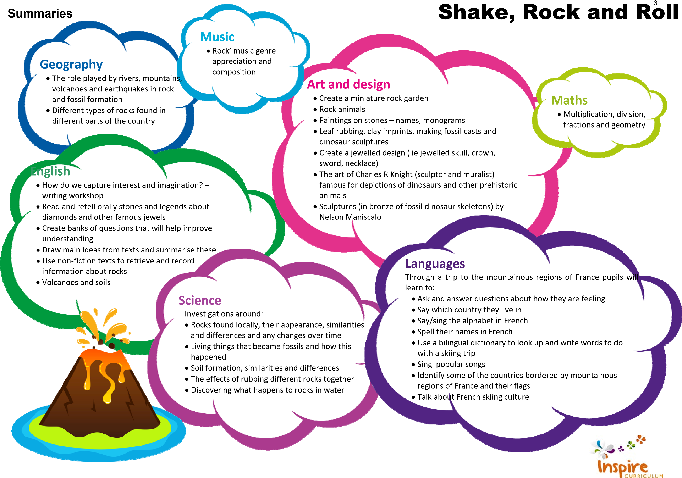

Programme of Study
Unit: Shake, Rock and Roll  Year: 3  Term: Spring 2 |  |  | Key:  FT = First Teaching  OG = On Going  Please note that all appendices and guidelines referred to in the programme of study are available to download at:  https://www.gov.uk/government/collections/national-curriculum The POS codes replace the DfE bullets for ease of reference.
English | Spoken Language
 | SL1 | listen and respond appropriately to adults and their peers
 | SL2 | ask relevant questions to extend their understanding and knowledge
 | SL3 | use relevant strategies to build their vocabulary
 | SL4 | articulate and justify answers, arguments and opinions
 | SL5 | give well-structured descriptions, explanations and narratives for different purposes, including for expressing feelings
 | SL6 | maintain attention and participate actively in collaborative conversations, staying on topic and initiating and responding to comments
 | SL7 | use spoken language to develop understanding through speculating, hypothesising, imagining and exploring ideas
 | SL8 | speak audibly and fluently with an increasing command of Standard English
 | SL9 | participate in discussions, presentations, performances, role play, improvisations and debates
 | SL10 | gain, maintain and monitor the interest of the listener(s)
 | SL11 | consider and evaluate different viewpoints, attending to and building on the contributions of others
 | SL12 | select and use appropriate registers for effective communication
 | These statements apply to all Years. The content should be taught as a level appropriate to the age of the pupils (taken from notes and guidance [nonstatutory]). Speaking and listening activities throughout the Unit have been designed with these POS statements in mind. Specific speaking and listening objectives are provided for some English lessons where appropriate.

English | Reading – word reading
 | WR1 | apply their growing knowledge of root words, prefixes and suffixes (etymology and morphology) as listed in English Appendix 1, both to read aloud and to understand the meaning of new words they meet | OG
 | WR2 | read further exception words, noting the unusual correspondences between spelling and sound, and where these occur in the word | OG
 | Reading – comprehension
 | RC1 | develop positive attitudes to reading and understanding of what they read by:
 | RC1.1 | listening to and discussing a wide range of fiction, poetry, plays, non-fiction and reference books or textbooks | OG
 | RC1.2 | reading books that are structured in different ways and reading for a range of purposes | OG
 | RC1.3 | using dictionaries to check the meaning of words that they have read | OG
 | RC1.4 | increasing their familiarity with a wide range of books, including fairy stories, myths and legends, and retelling some of these orally | OG
 | RC1.5 | identifying themes and conventions in a wide range of books | OG
 | RC1.7 | discussing words and phrases that capture the reader’s interest and imagination | OG
 | RC2 | understand what they read, in books they can read independently, by:
 | RC2.1 | checking that the text makes sense to them, discussing their understanding and explaining the meaning of words in context | OG
 | RC2.2 | asking questions to improve their understanding of a text | OG
 | RC2.4 | predicting what might happen from details stated and implied | OG
 | RC2.5 | identifying main ideas drawn from more than one paragraph and summarising these | FT
 | RC2.6 | identifying how language, structure, and presentation contribute to meaning | OG
 | RC3 | retrieve and record information from non-fiction | OG

English | Writing – transcription – spelling - SCHOOLS TO USE SPELLING PROGRAMME
 | WTS1 | use further prefixes and suffixes and understand how to add them (English Appendix 1) |  | OG
 | WTS2 | spell further homophones |  | OG
 | WTS3 | spell words that are often misspelt |  | OG
 | WTS4 | place the possessive apostrophe accurately in words with regular plurals (for example, girls’, boys’) and in words with irregular plurals (for example, pupils’) |  | OG
 | WTS5 | use the first two or three letters of a word to check its spelling in a dictionary |  | OG
 | WTS6 | write from memory simple sentences, dictated by the teacher, that include words and punctuation taught so far |  | OG
 | Writing – handwriting
 | WH1 | use the diagonal and horizontal strokes that are needed to join letters and understand which letters, when adjacent to one another, are best left unjoined |  | OG
 | WH2 | increase the legibility, consistency and quality of their handwriting, e.g. by ensuring that the downstrokes of letters are parallel and equidistant; that lines of writing are spaced sufficiently so that the ascenders and descenders of letters do not touch |  | OG
 | Writing – composition
 | WC1 | plan their writing by:
 | WC1.1 | discussing writing similar to that which they are planning to write in order to understand and learn from its structure, vocabulary and grammar |  | OG
 | WC1.2 | discussing and recording ideas |  | OG
 | WC2 | draft and write by:
 | WC2.1 | composing and rehearsing sentences orally (including dialogue), progressively building a varied and rich vocabulary and an increasing range of sentence structures (See English Appendix 2) |  | OG
 | WC2.2 | organising paragraphs around a theme |  | OG
 | WC2.3 | in narratives, creating settings, characters and plot |  | OG
 | WC2.4 | in non-narrative material, using simple organisational devices (for example as headings and sub-headings |  | OG
 | WC3 | evaluate and edit by:
 | WC3.1 | assessing the effectiveness of their own and others’ writing and suggesting improvements |  | OG
 | WC4 | proof-read for spelling and punctuation errors |  | OG
 | WC5 | read aloud their own writing, to a group or the whole class, using appropriate intonation and controlling the tone and volume so that the meaning is clear |  | OG
English | Writing – vocabulary, grammar and punctuation
 | WVGP1 |  | develop their understanding of the concepts set out in Appendix 2 by:
 | WVGP1.1 |  | extending the range of sentences with more than one clause by using a wider range of conjunctions, e.g. when, if, because, although | OG
 | WVGP1.2 |  | using the present perfect form of verbs in contrast to the past tense | OG
 | WVGP1.4 |  | using conjunctions, adverbs and prepositions to express time and cause | OG
 | WVGP1.5 |  | using fronted adverbials | FT
 | WVGP1.6 |  | learning the grammar for years 3 and 4 in English Appendix 2 | OG
 | WVGP2 |  | indicate grammatical and other features by:
 | WVGP2.3 |  | using and punctuating direct speech THROUGH NARRATIVE | OG
 | WVGP3 |  | use and understand the grammatical terminology in English Appendix 2 accurately and appropriately when discussing their writing and reading | OG

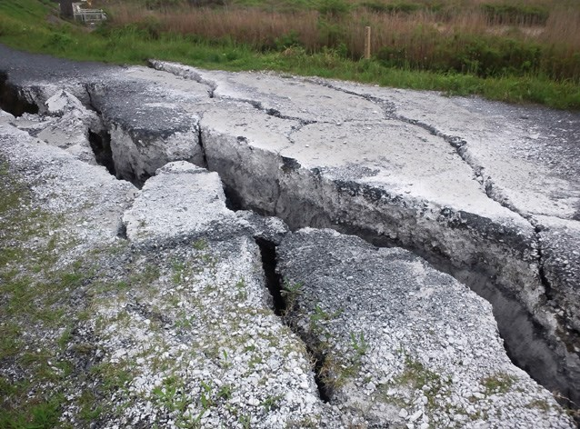
Maths | Number – multiplication and division
 | 1 | recall and use multiplication and division facts for the 3, 4 and 8 multiplication tables
 | 2 | write and calculate mathematical statements for multiplication and division using the multiplication tables that they know, including for two-digit numbers times one-digit numbers, using mental, and progressing to formal written, methods
 | 3 | solve problems, including missing number problems, involving multiplication and division, including positive integer scaling problems and correspondence problems in which n objects are connected to m objects
 | Number – fractions
 | 1 | count up and down in tenths; recognise that tenths arise from dividing an object into 10 equal parts and in dividing one-digit numbers or quantities by 10
 | 2 | recognise, find and write fractions of a discrete set of objects: unit fractions and non-unit fractions with small denominators
 | 3 | recognise and use fractions as numbers: unit fractions and non-unit fractions with small denominators
 | 4 | recognise and show, using diagrams, equivalent fractions with small denominators
 | 5 | add and subtract fractions with the same denominators within one whole (e.g. 5/7 + 1/7 = 6/7)
 | 6 | compare and order unit fractions, and fractions with the same denominators
 | 7 | solve problems that involve all of the above
 | Geometry: properties of shapes
 | 1 | draw 2-D shapes and make 3-D shapes using modelling materials; recognise 3-D shapes in different orientations; and describe them
 | 2 | recognise angles as a property of shape or a description of a turn
 | 3 | identify right angles, recognise that two right angles make a half-turn, three make three quarters of a turn and four a complete turn; identify whether angles are greater than or less than a right angle
 | 4 | identify horizontal and vertical lines and pairs of perpendicular and parallel lines

Science | Working scientifically (Y3 + Y4)
 | 1 | asking relevant questions and using different types of scientific enquiries to answer them
 | 2 | setting up simple practical enquiries, comparative and fair tests
 | 3 | making systematic and careful observations and, where appropriate, taking accurate measurements using standard units, using a range of equipment thermometers and data loggers
 | 4 | gathering, recording, classifying and presenting data in a variety of ways to help in answering questions
 | 5 | recording findings using simple scientific language, drawings, labelled diagrams, bar charts, and tables
 | 6 | reporting on findings from enquiries, including oral and written explanations, displays or presentations of results and conclusions
 | 7 | using results to draw simple conclusions, make predictions for new values, suggest improvements and raise further questions
 | 8 | identifying differences, similarities or changes related to simple scientific ideas and processes
 | 9 | using straightforward scientific evidence to answer questions or to support their findings
 | Rocks
 | 1 | compare and group together different kinds of rocks on the basis of their simple physical properties
 | 2 | describe in simple terms how fossils are formed when things that have lived are trapped within rock
 | 3 | Recognise that soils are made from rocks and organic matter

Geography | Place Knowledge
 | 5 | describe and understand key aspects of:
 | 5.1 | physical geography, including: climate zones, biomes and vegetation belts, rivers, mountains, volcanoes and earthquakes, and the water cycle

Music | 1 | play and perform in solo and ensemble contexts, using their voice and playing musical instruments with increasing accuracy, control and expression
 | 3 | listen with attention to detail and recall sounds with increasing aural memory
 | 4 | use and understand staff and other musical notations
 | 5 | appreciate and understand a wide range of high-quality live and recorded music drawn from different traditions and from great musicians and composers
 | 6 | develop an understanding of the history of music

Art & Design | 1 | to create sketch books to record their observations and use them to review and revisit ideas

Applied Computing | 4 | understand computer networks including the internet; how they can provide multiple services, such as the world-wide web; and the opportunities they offer for communication and collaboration
 | 7 | use technology safely, respectfully and responsibly; recognise acceptable/unacceptable behaviour; identify a range of ways to report concerns about content and contact

Languages | 1 | listen attentively to spoken language and show understanding by joining in and responding
 | 2 | explore the patterns and sounds of language through songs and rhymes and link the spelling, sound and meaning of words
 | 3 | engage in conversations; ask and answer questions; express opinions and respond to those of others; seek clarification and help*
 | 4 | speak in sentences, using familiar vocabulary, phrases and basic language structures
 | 5 | develop accurate pronunciation and intonation so that others understand when they are reading aloud or using familiar words and phrases*
 | 6 | present ideas and information orally to a range of audiences*
 | 7 | read carefully and show understanding of words, phrases and simple writing
 | 8 | appreciate stories, songs, poems and rhymes in the language
 | 9 | broaden their vocabulary and develop their ability to understand new words that are introduced into familiar written material, including through using a dictionary
 | 12 | understand basic grammar appropriate to the language being studied, such as (where relevant): feminine, masculine and neuter forms and the conjugation of high-frequency verbs; key features and patterns of the language; how to apply these, for instance, to build sentences; and how these differ from or are similar to English.
 | The starred (*) content above will not be applicable to ancient languages.

