Unit: To the Rescue
Term: Spring 2
Year: 1

Unit Overview
This Unit helps pupils to develop an understanding of the rescue services, with particular reference to rescue at sea and how modern services have been developed from their early beginnings. The famous rescue by Grace Darling and her father will be considered and compared with modern systems. Pupils will make a role-play lifeboat station in their classroom to enhance their learning.

Pupils will talk about accessing rescue services and learn how to make emergency calls.

The Unit also focuses strongly on poetry and art based on the sea and seashore, and will conclude with an art exhibition to which parents are invited, perhaps raising a little money for the work of the RNLI or another rescue charity. Within this part of the Unit there is plenty of scope for following the pupils’ interests and engaging their problem solving skills in organising various aspects of the exhibition.

English | Reading – word reading
 | WR1 | apply phonic knowledge and skills as the route to decode words | OG
 | WR2 | respond speedily with the correct sound to graphemes (letters or groups of letters) for all 40+ phonemes, including, where applicable, alternative sounds for graphemes | OG
 | WR3 | read accurately by blending sounds in unfamiliar words containing GPCs that have been taught | OG
 | WR4 | read common exception words, noting unusual correspondences between spelling and sound and where these occur in the word | OG
 | WR6 | read other words of more than one syllable that contain taught GPCs | OG
 | WR8 | read aloud accurately books that are consistent with their developing phonic knowledge and that do not require them to use other strategies to work out words | OG
 | WR9 | re-read these books to build up their fluency and confidence in word reading | OG
 | Reading –comprehension
 | RC1 | develop pleasure in reading, motivation to read, and understanding by:
 | RC1.1 | listening to and discussing a wide range of poems, stories and non-fiction at a level beyond that at which they can read independently | OG
 | RC1.2 | being encouraged to link what they read or hear read to their own experiences | OG
 | RC1.3 | becoming very familiar with key stories, fairy stories and traditional tales, retelling them and considering their particular characteristics   | OG
 | RC1.4 | recognising and joining in with predictable phrases | OG
 | RC1.5 | learning to appreciate rhymes and poems, and to recite some by heart | OG
 | RC1.6 | discussing word meanings, linking new meanings to those already known | OG
 | RC2 | understand both the books they can already read accurately and fluently and those they listen to by:
 | RC2.1 | drawing on what they already know or on background information and vocabulary provided by the teacher | OG
 | RC2.2 | checking that the text makes sense to them as they read and correcting inaccurate reading | OG
 | RC3 | participate in discussion about what is read to them, taking turns and listening to what others say | OG
 | RC4 | explain clearly their understanding of what is read to them | OG

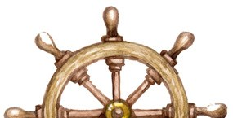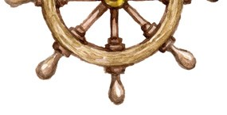

English | Writing – transcription - spelling
 | WTS1 | spell: See English Appendix 1
 | WTS1.1 | words containing each of the 40+ phonemes already taught | OG
 | WTS1.2 | common exception words | OG
 | WTS1.3 | The days of the week | OG
 | WTS2 | name the letters of the alphabet | OG
 | WTS2.1 | naming the letters of the alphabet in order | OG
 | WTS2.2 | using letter names to distinguish between alternative spellings of the same sound | OG
 | WTS4 | apply simple spelling rules and guidance, as listed in English appendix 1 | OG
 | WTS5 | write from memory simple sentences dictated by the teacher that include words using the GPCs and common exception words taught so far | OG
 | Writing – handwriting
 | WH1 | sit correctly at a table, holding a pencil comfortably and correctly | OG
 | WH2 | begin to form lower-case letters in the correct direction, starting and finishing in the right place | OG
 | WH3 | form capital letters | OG
 | WH4 | form digits 0-9 | OG
 | WH5 | understand which letters belong to which handwriting ‘families’ (i.e. letters that are formed in similar ways) and to practise these | OG
 | Writing – composition
 | WC1 | write sentences by:
 | WC1.1 | saying out loud what they are going to write about | OG
 | WC1.2 | composing a sentence orally before writing it | OG
 | WC1.4 | re-reading what they have written to check that it makes sense | OG
 | WC2 | discuss what they have written with the teacher or other pupils | OG
 | WC3 | read aloud their writing clearly enough to be heard by their peers and the teacher | OG

English | Writing – vocabulary, grammar and punctuation
 | WVGP1 | develop their understanding of the concepts set out in English Appendix 2 by:
 | WVGP1.1 | leaving spaces between words | OG
 | WVGP1.2 | joining words and joining clauses using and | OG
 | WVGP1.3 | beginning to punctuate sentences using a capital letter and a full stop, question mark or exclamation mark | OG
 | WVGP1.4 | using a capital letter for names of people, places, the days of the week and the personal pronoun ‘I’ | OG
 | WVGP1.6 | use the grammatical terminology in English Appendix 2 in discussing their writing | OG

Maths | Multiplication and division
 | 1 | solve simple one-step problems involving multiplication and division, calculating the answer using concrete objects, pictorial representations and arrays with the support of the teacher
 | Fractions
 | 1 | recognise, find and name a half as one of two equal parts of an object, shape or quantity
 | 2 | recognise, find and name a quarter as one of four equal parts of an object, shape or quantity
 | Geometry - properties of shapes
 | 1 | recognise and name common 2-D and 3-D shapes, including:
 | 1.1 | 2-D shapes (for example rectangles (including squares), circles and triangles)
 | 1.2 | 3-D shapes (for example cuboids (including cubes), pyramids and spheres).
 | Position and direction
 | 1 | describe position, direction and movement, including whole, half, quarter and three-quarter turns

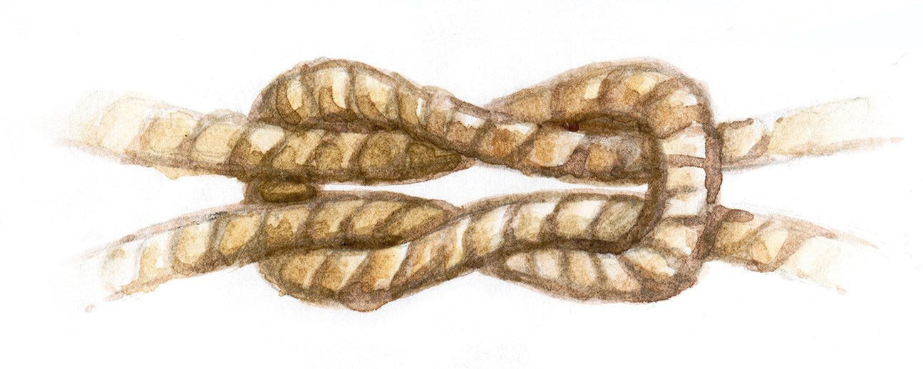

History | 2 | events beyond living memory that are significant nationally or globally (e.g. the Great Fire of London, the first aeroplane flight or events commemorated through festivals or anniversaries)
 | 3 | the lives of significant individuals in the past who have contributed to national and international achievements. Some should be used to compare aspects of life in different periods (e.g. Elizabeth I and Queen Victoria, Christopher Columbus and Neil Armstrong, William Caxton and Tim Berners-Lee, Pieter Bruegel the Elder and LS Lowry, Rosa Parks and Emily Davison, Mary Seacole and/or Florence  Nightingale and Edith Cavell)

Music | 1 | use their voices expressively by singing songs and speaking chants and rhymes

Art & Design | 2 | to use drawing, painting and sculpture to develop and share their ideas, experiences and imagination
 | 4 | about the work of a range of artists, craftsmen and designers, describing the differences and similarities between different practices and disciplines, and making links to their own work

Computing | 4 | use technology purposefully to create, organise, store, manipulate and retrieve digital content
 | 5 | recognise common uses of information technology beyond school
 | 6 | use technology safely and respectfully, keeping personal information private; identify where to go for help and support when they have concerns about content or contact on the internet or other online technologies

