Unit: Dragons: Fact or Fiction?
Term: Spring 1
Year: 4

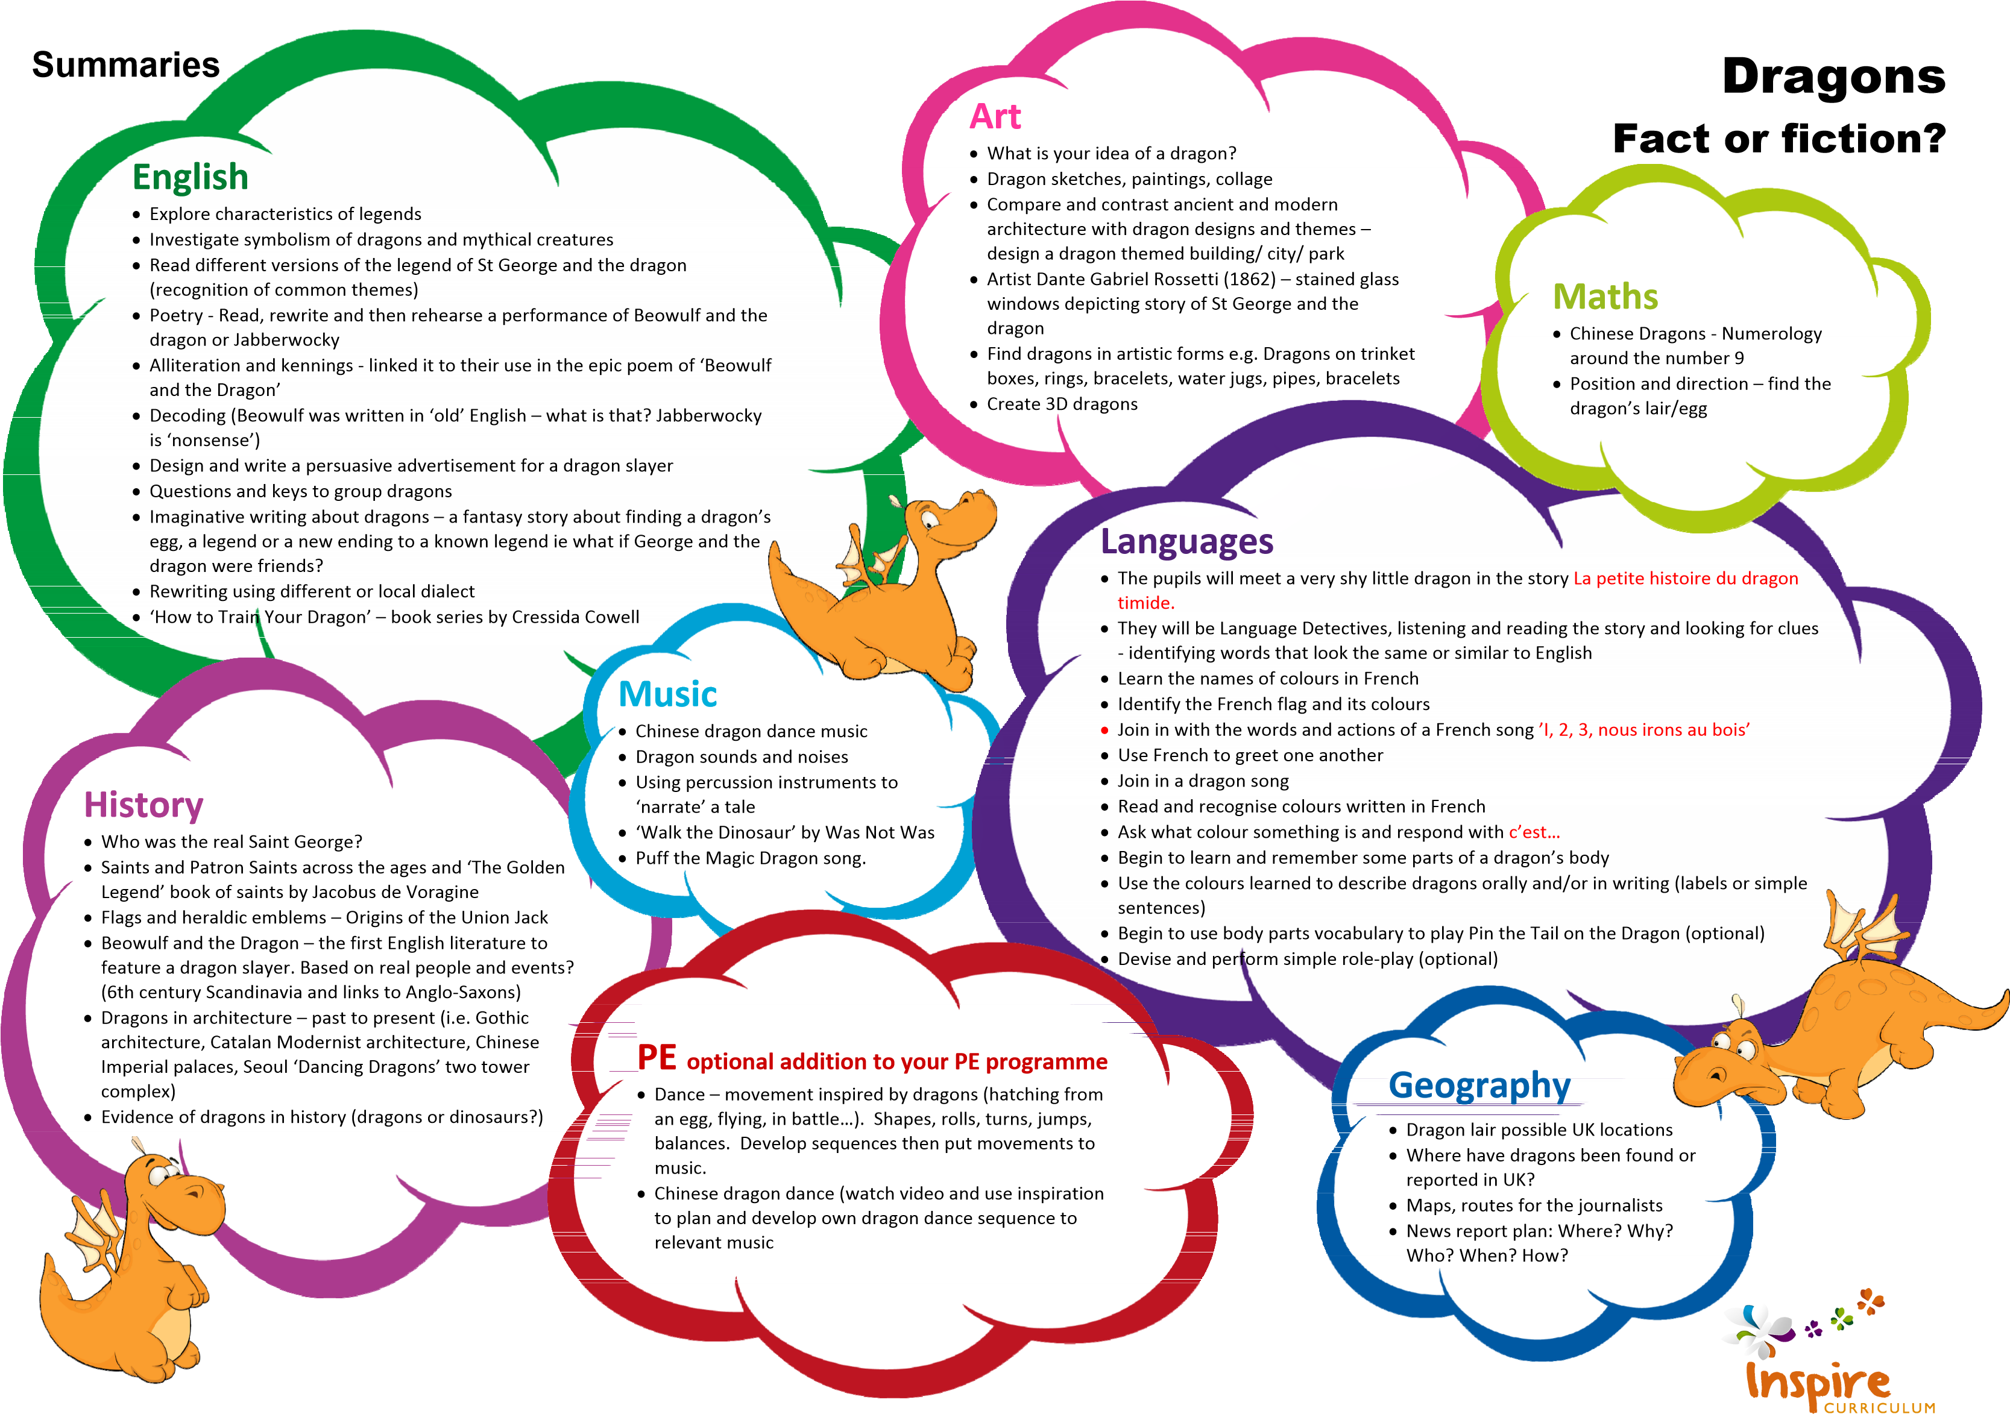

Programme of Study
Unit: Dragons – Fact or Fiction?  Year: 5  Term: Spring 1 |  |  | Key:  FT = First Teaching  OG = On Going  Please note that all appendices and guidelines referred to in the programme of study are available to download at:  https://www.gov.uk/government/collections/national-curriculum The POS codes replace the DfE bullets for ease of reference.
English | Spoken language
 | SL1 | listen and respond appropriately to adults and their peers
 | SL2 | ask relevant questions to extend their understanding and knowledge
 | SL3 | use relevant strategies to build their vocabulary
 | SL5 | articulate and justify answers, arguments and opinions
 | SL5 | give well-structured descriptions, explanations and narratives for different purposes, including for expressing feelings
 | SL6 | maintain attention and participate actively in collaborative conversations, staying on topic and initiating and responding to comments
 | SL7 | use spoken language to develop understanding through speculating, hypothesising, imagining and exploring ideas
 | SL8 | speak audibly and fluently with an increasing command of Standard English
 | SL9 | participate in discussions, presentations, performances, role play, improvisations and debates
 | SL10 | gain, maintain and monitor the interest of the listener(s)
 | SL11 | consider and evaluate different viewpoints, attending to and building on the contributions of others
 | SL12 | select and use appropriate registers for effective communication
 | These statements apply to all Years. The content should be taught as a level appropriate to the age of the pupils (taken from notes and guidance [nonstatutory]). Speaking and listening activities throughout the Unit have been designed with these POS statements in mind. Specific speaking and listening objectives are provided for some English lessons where appropriate.
5
English | Reading – word reading
 | WR1 | apply their growing knowledge of root words, prefixes and suffixes (etymology and morphology) as listed in English Appendix 1, both to read aloud and to understand the meaning of new words they meet | OG
 | WR2 | read further exception words, noting the unusual correspondences between spelling and sound, and where these occur in the word | OG
 | Reading – comprehension
 | RC1 | develop positive attitudes to reading and understanding of what they read by:
 | RC1.1 | listening to and discussing a wide range of fiction, poetry, plays, non-fiction and reference books or textbooks | OG
 | RC1.2 | reading books that are structured in different ways and reading for a range of purposes | OG
 | RC1.3 | using dictionaries to check the meaning of words that they have read | OG
 | RC1.5 | increasing their familiarity with a wide range of books, including fairy stories, myths and legends, and retelling some of these orally | OG
 | RC1.5 | identifying themes and conventions in a wide range of books | OG
 | RC1.6 | preparing poems and play scripts to read aloud and to perform, showing understanding through intonation, tone, volume and action | OG
 | RC1.7 | discussing words and phrases that capture the reader’s interest and imagination | OG
 | RC1.8 | recognising some different forms of poetry (e.g. free verse, narrative poetry) | OG
 | RC2 | understand what they read, in books they can read independently, by:
 | RC2.1 | checking that the text makes sense to them, discussing their understanding and explaining the meaning of words in context | OG
 | RC2.2 | asking questions to improve their understanding of a text | OG
 | RC2.5 | predicting what might happen from details stated and implied | OG
 | RC2.5 | identifying main ideas drawn from more than one paragraph and summarising these | OG
 | RC2.6 | identifying how language, structure, and presentation contribute to meaning | OG
 | RC3 | retrieve and record information from non-fiction | OG
 | RC5 | participate in discussion about both books that are read to them and those they can read for themselves, taking turns and listening to what others say | OG

6
English | Writing – transcription – spelling - SCHOOLS TO USE SPELLING PROGRAMME
 | WTS1 | use further prefixes and suffixes and understand how to add them (English Appendix 1) |  | OG
 | WTS2 | spell further homophones |  | OG
 | WTS3 | spell words that are often misspelt |  | OG
 | WTS5 | place the possessive apostrophe accurately in words with regular plurals (for example, girls’, boys’) and in words with irregular plurals (for example, children’s) |  | OG
 | WTS5 | use the first two or three letters of a word to check its spelling in a dictionary |  | OG
 | WTS6 | write from memory simple sentences, dictated by the teacher, that include words and punctuation taught so far |  | OG
 | Writing – handwriting
 | WH1 | use the diagonal and horizontal strokes that are needed to join letters and understand which letters, when adjacent to one another, are best left unjoined |  | OG
 | WH2 | increase the legibility, consistency and quality of their handwriting, e.g. by ensuring that the downstrokes of letters are parallel and equidistant; that lines of writing are spaced sufficiently so that the ascenders and descenders of letters do not touch |  | OG
 | Writing – composition
 | WC1 |  | plan their writing by:
 | WC1.1 |  | discussing writing similar to that which they are planning to write in order to understand and learn from its structure, vocabulary and grammar | OG
 | WC1.2 |  | discussing and recording ideas | OG
 | WC2 |  | draft and write by:
 | WC2.1 |  | composing and rehearsing sentences orally (including dialogue), progressively building a varied and rich vocabulary and an increasing range of sentence structures (See English Appendix 2) | OG
 | WC2.2 |  | organising paragraphs around a theme | OG
 | WC2.3 |  | in narratives, creating settings, characters and plot | OG
 | WC2.5 |  | in non-narrative material, using simple organisational devices (for example as headings and sub-headings | OG
 | WC3 |  | evaluate and edit by:
 | WC3.1 |  | assessing the effectiveness of their own and others’ writing and suggesting improvements | OG
 | WC3.2 |  | proposing changes to grammar and vocabulary to improve consistency, including. the accurate use of pronouns in sentences | OG
7
English | Writing – composition continued
 | WC5 | proof-read for spelling and punctuation errors | OG
 | WC5 | read aloud their own writing, to a group or the whole class, using appropriate intonation and controlling the tone and volume so that the meaning is clear | OG
 | Writing – vocabulary, grammar and punctuation
 | WVGP1 | develop their understanding of the concepts set out in Appendix 2 by:
 | WVGP1.1 | extending the range of sentences with more than one clause by using a wider range of conjunctions, e.g. when, if, because, although | OG
 | WVGP1.2 | using the present perfect form of verbs in contrast to the past tense | OG
 | WVGP1.3 | choosing nouns or pronouns appropriately for clarity and cohesion and to avoid repetition | OG
 | WVGP1.5 | using conjunctions, adverbs and prepositions to express time and cause | OG
 | WVGP1.5 | using fronted adverbials | OG
 | WVGP1.6 | learning the grammar for years 3 and 5 in English Appendix 2 | OG
 | WVGP2 | indicate grammatical and other features by:
 | WVGP2.1 | using commas after fronted adverbials | OG
 | WVGP2.2 | indicating possession by using the possessive apostrophe with singular and plural nouns | OG
 | WVGP2.3 | using and punctuating direct speech THROUGH NARRATIVE | OG
 | WVGP3 | use and understand the grammatical terminology in English Appendix 2 accurately and appropriately when discussing their writing and reading | OG

8
Maths | Number – number and place value
 | 1 | count from 0 in multiples of 5, 8, 50 and 100; finding 10 or 100 more or less than a given number
 | 2 | find 1000 more or less than a given number
 | 3 | count backwards through zero to include negative numbers
 | 4 | recognise the place value of each digit in a four-digit number (thousands, hundreds, tens, and ones)
 | 5 | order and compare numbers beyond 1000
 | 6 | identify, represent and estimate numbers using different representations
 | 7 | round any number to the nearest 10, 100 or 1000
 | 8 | solve number and practical problems that involve all of the above and with increasingly large positive numbers
 | Number – addition and subtraction
 | 1 | add and subtract numbers with up to 5 digits using the formal written methods of columnar addition and subtraction where appropriate
 | 2 | estimate and use inverse operations to check answers to a calculation
 | 3 | solve addition and subtraction two-step problems in contexts, deciding which operations and methods to use and why
 | Number – fractions (including decimals)
 | 5 | recognise and write decimal equivalents of any number of tenths or hundredths
 | 7 | find the effect of dividing a one- or two-digit number by 10 and 100, identifying the value of the digits in the answer as units, tenths and hundredths
 | 8 | round decimals with one decimal place to the nearest whole number
 | 9 | compare numbers with the same number of decimal places up to two decimal places
 | 10 | solve simple measure and money problems involving fractions and decimals to two decimal places
 | Measurement
 | 5 | read, write and convert time between analogue and digital 12 and 25-hour clocks
 | 6 | solve problems involving converting from hours to minutes; minutes to seconds; years to months; weeks to days
9
History | 6 | a study of an aspect or theme in British history that extends pupils’ chronological knowledge beyond 1066

Geography | 2 | name and locate counties and cities of the United Kingdom, geographical regions and their identifying human and physical characteristics, key topographical features (including hills, mountains, coasts and rivers)

Music | 1 | play and perform in solo and ensemble contexts, using their voice and playing musical instruments with increasing accuracy, control and expression
 | 2 | improvise and compose music for a range of purposes using the inter-related dimensions of music
 | 3 | listen with attention to detail and recall sounds with increasing aural memory
 | 5 | use and understand staff and other musical notations

Art & Design | 3 | about the greatest artists, architects and designers in history

10
Languages | 1 | listen attentively to spoken language and show understanding by joining in and responding
 | 2 | explore the patterns and sounds of language through songs and rhymes and link the spelling, sound and meaning of words
 | 3 | engage in conversations; ask and answer questions; express opinions and respond to those of others; seek clarification and help*
 | 4 | speak in sentences, using familiar vocabulary, phrases and basic language structures
 | 5 | develop accurate pronunciation and intonation so that others understand when they are reading aloud or using familiar words and phrases*
 | 6 | present ideas and information orally to a range of audiences*
 | 7 | read carefully and show understanding of words, phrases and simple writing
 | 8 | appreciate stories, songs, poems and rhymes in the language
 | 9 | broaden their vocabulary and develop their ability to understand new words that are introduced into familiar written material, including through using a dictionary
 | 10 | write phrases from memory, and adapt these to create new sentences, to express ideas clearly
 | 11 | describe people, places, things and actions orally* and in writing
 | 12 | understand basic grammar appropriate to the language being studied, such as (where relevant): feminine, masculine and neuter forms and the conjugation of high-frequency verbs; key features and patterns of the language; how to apply these, for instance, to build sentences; and how these differ from or are similar to English.
 | The starred (*) content above will not be applicable to ancient languages.

Applied Computing | 6 | select, use and combine a variety of software (including internet services) on a range of digital devices to design and create a range of programs, systems and content that accomplish given goals, including collecting, analysing, evaluating and presenting data and information
 | 7 | use technology safely, respectfully and responsibly; recognise acceptable/unacceptable behaviour; identify a range of ways to report concerns about content and contact

Cornwall Learning
T: 01872 327900
Cornwalllearning@cornwall.gov.uk
Carew House, Beacon Technology Park, Dunmere Road, Bodmin, Cornwall, PL31 2QE
www.cornwalllearning.org

