Perimedr ac Arwynebedd
Tasg 1
Yn gyntaf, mae rhaid ymarfer y strategaeth. Cofiwch taw mesur tu allan y siâp yw’r perimedr a’r tu fewn yw’r arwynebedd. Dewiswch lefel yr her wrth edrych ar nifer y tsilis.

a.
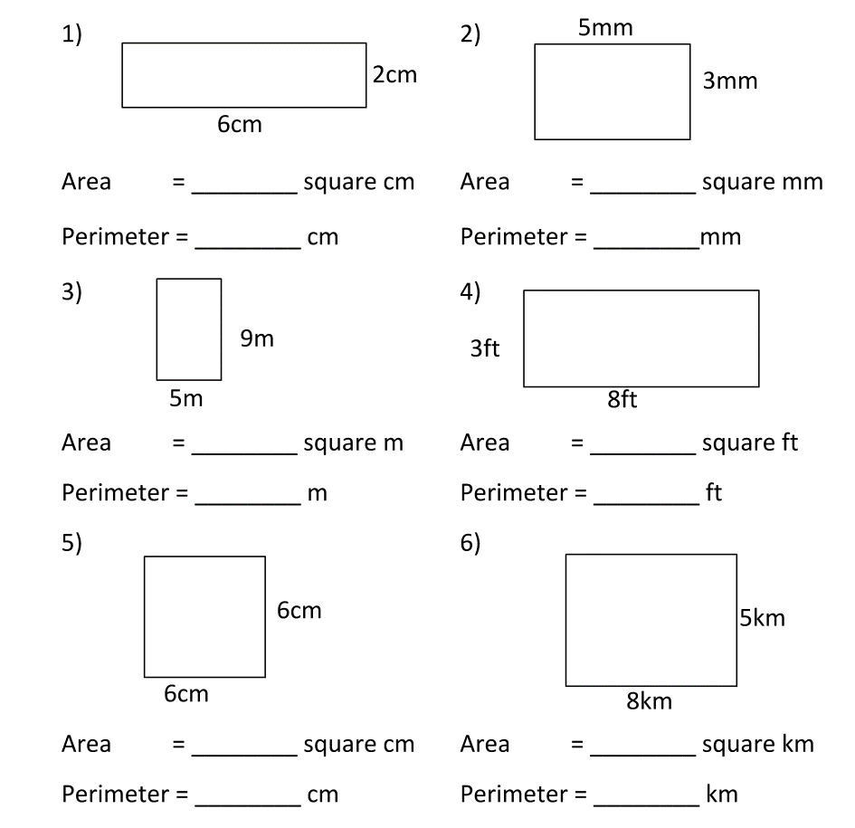

b.

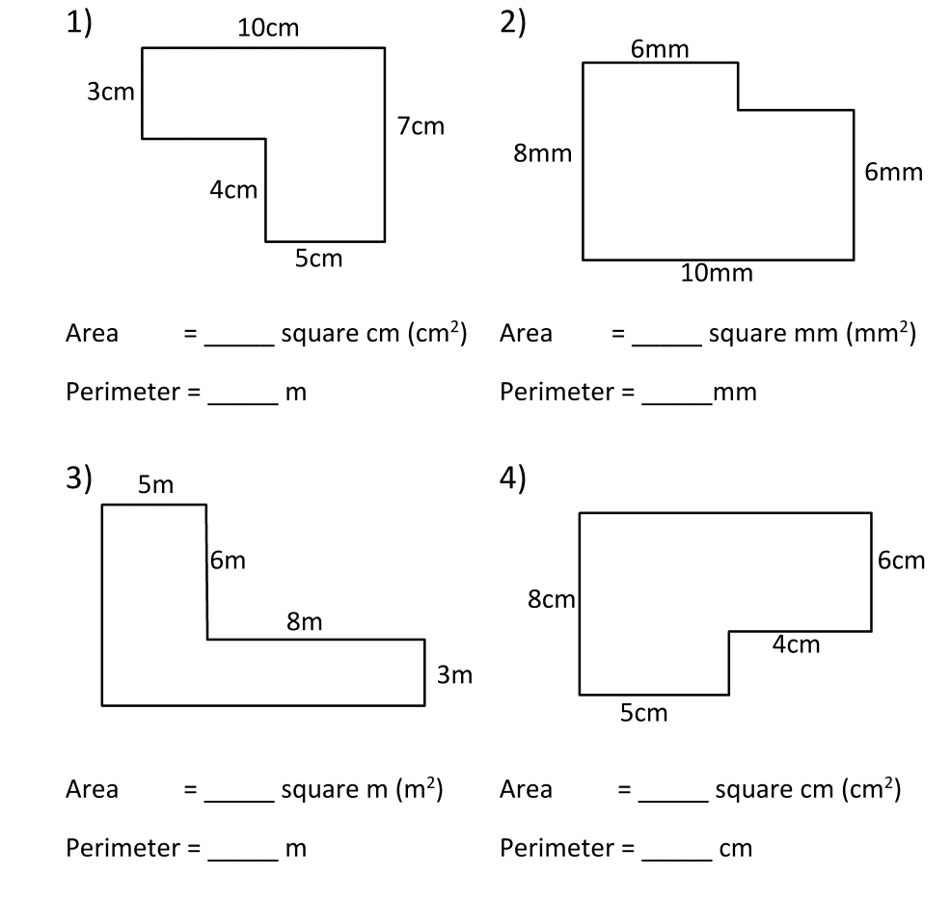

Tasg 2
Mae’r sgil o fesur arwynebedd a pherimedr yn hollol bwysig yn fywyd go iawn, meddyliwch am 2 esiampl.

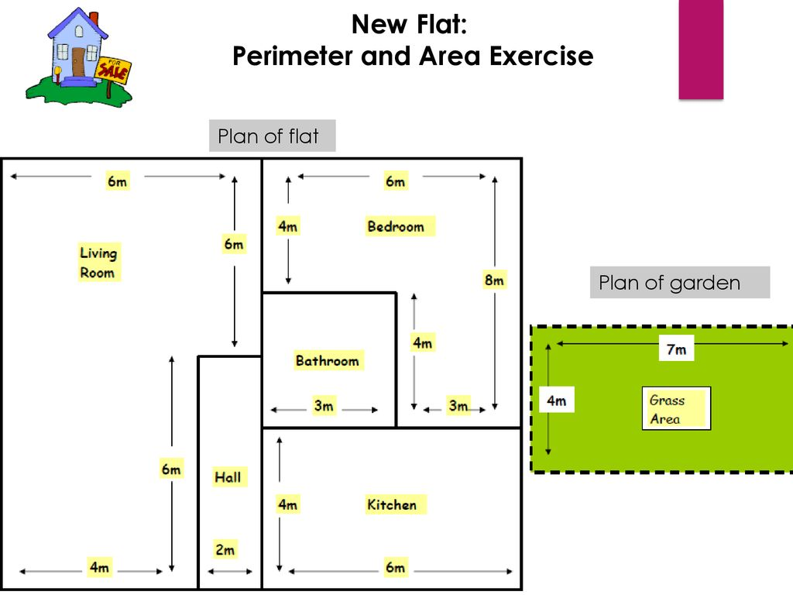
Mae’r teulu Harris yn edrych am loriau newydd. Cofnodwch arwynebedd a pherimedr pob ystafell, gan gyflwyno’r data yn glir i dabl.
Neuadd
Cegin
Ystafell wely
Ystafell ymolchi
Ystafell fyw

Gardd

Ystafell | Perimedr | Arwynebedd

Tasg 3
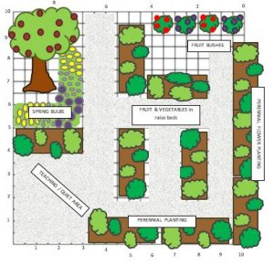
Roedd y teulu Harris braidd yn siomedig ar faint a symlrwydd yr ardd. Ewch ati i gynllunio gardd newydd i’r teulu Harris. Edrychwch ar y lluniau yma am syniadau. Ystyriwch ardal llysiau, perlysiau, blodau, chwarae, eistedd a llwybrau.
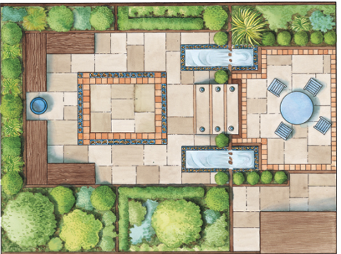

Gallwch gynllunio eich gardd chi ar bapur, neu ar ddogfen ddigidol. Beth am arbed grid i Jit o dan, ‘Design Garden?’
Meini Prawf Llwyddiant
• Defnyddio symbolau i gynrychioli ardaloedd.
• Nodi perimedr pob ardal
• Nodi arwynebedd pob ardal

Perimeter ac Area
Task 1
Firstly, you must review the strategy. Remember that the perimeter is the measurement outside of the shape and the area is within. Choose the level of challenge according to the number of chillies.

b.

Task 2
The skill of measuring the area and perimeter is very important in real life to solve many problems, think of 2 examples.

The Harris family is looking for new flooring. Note the perimeter and area of each room and present the data in a clear table.

Room | Perimeter | Area

Task 3
The Harris family is slightly disappointed with the simplicity and size of the garden. Design a new garden for the Harris family. Look at the pictures for ideas. Consider a vegetable patch, herbs, flower beds, playing area, sitting area and paths.

You could design your garden on paper, or on a digital document. Could you save a grid to Jit under ‘Garden Design?’
Success Criteria
• Use symbols to represent areas
• Note the perimeter of each zone
• Note the area of each zone

