Elw a cholled y parc adloniant

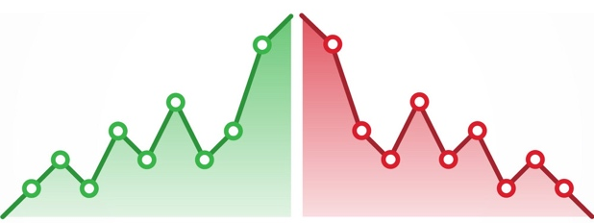

Yn y gweithgaredd hwn, byddwch yn cyfrifo cyfanswm eich elw o'r pris mynediad (giât), caffis a siopau. Nesaf, byddwch yn cymryd i ffwrdd cyfanswm eich costau rhedeg o ddydd i ddydd yr ydych eisoes wedi gweithio allan, a dod o hyd i eich elw neu golled ar gyfer pob diwrnod.

Bydd pob ymwelydd i eich parc thema yn gwario:
£ 4 ym mhob caffi sydd gennych
£ 3 ym mhob siop sydd gennych
£ 1 ym mhob stondin hufen iâ sydd gennych chi

Peidiwch ag anghofio eich bod eisoes wedi cyfrifo eich costau rhedeg o ddydd i ddydd yn y dasg olaf. Gallwch ysgrifennu'r swm yma yn y golofn ' Cyfanswm y costau bob dydd (b)'

Diwrnod | Nifer yr ymwelwyr | Incwm |  |  |  |  | Cyfanswm y costau bob dydd (b) | Elw  (a - b)
Diwrnod | Nifer yr ymwelwyr | Pris Mynediad (£15) | Caffi a Siop goffi | Siopau a byrbrydau | Hufen iâ | Cyfanswm (a) | Cyfanswm y costau bob dydd (b) | Elw  (a - b)
1 | 50
2 | 75
3 | 66
4 | 49
5 | 61
6 | 67
7 | 102
8 | 110
9 | 87
10 | 21
11 | 89
12 | 111
13 | 453
14 | 367
 |  |  |  |  |  |  | Total

Pa elw neu golled ydych chi wedi'i wneud yn ystod y pythefnos cyntaf o agor eich parc adloniant?

____________________________________
Profit and loss of your amusement park

In this activity, you will work out your total profit from the admission price (gate), cafes and shops. Next you will take away your total daily running cost that you have already worked out and find your profit or loss for each day.

Each visitor to your theme park will spend:
£4 at each café you have
£3 at each shop you have
£1 at every ice cream stand you have

Don't forget that you've already calculated your daily running cost in the last task so you can write than amount in the column 'Total running cost per day (b)'.

Day | Number of visitors | Income |  |  |  |  | Total running cost per day (b) | Profit  (a - b)
Day | Number of visitors | Admission Price  (£15) | Café and coffee shop | Shop and snacks | Ice-cream | Total (a) | Total running cost per day (b) | Profit  (a - b)
1 | 50
2 | 75
3 | 66
4 | 49
5 | 61
6 | 67
7 | 102
8 | 110
9 | 87
10 | 21
11 | 89
12 | 111
13 | 453
14 | 367
 |  |  |  |  |  |  | Total

What profit or loss have you made in the first two weeks of opening your amusement park?

____________________________________

