Task 1: listening skills
Map of Wales
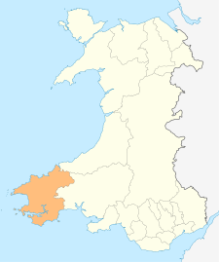
- Where did Deio go? Listen carefully and use the map of Pembrokeshire to mark the places Deio has visited.

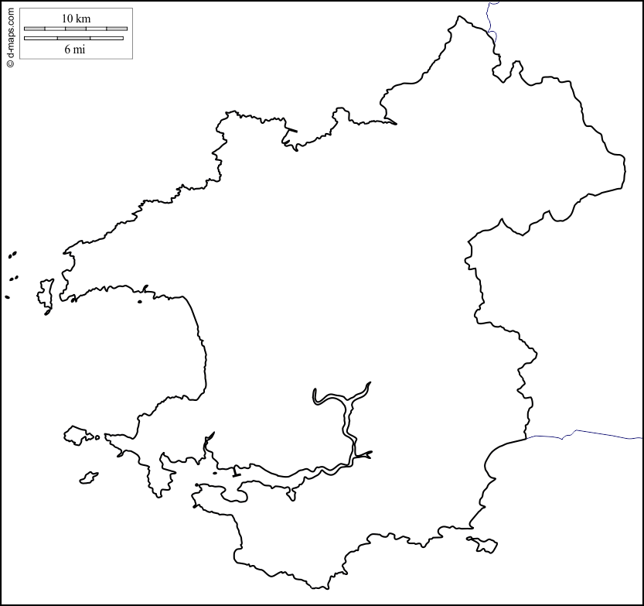
Pembrokeshire
Cardigan
Crymych
Abereiddy
Skomer Island
Pembroke
Saundersfoot
Fishguard
St. Davids
Newgale
Milford Haven
Tenby
Caldey Island
Manorbier
Narbeth
Haverfordwest

Tasg Wrando
Map o Gymru
- Ble aeth Deio? Gwrandewch yn ofalus a marciwch ble aeth Deio’r Ddraig ar y map o Sir Benfro.
