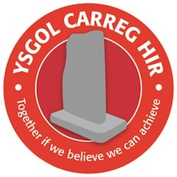
YSGOL CARREG HIR
Old Road, Briton Ferry
Neath SA11 2ET
Tel: (01639) 502892
Head Teacher: Mrs Lesley Hynes B.Ed.(Hons) NPQH
Deputy Head Teacher: Mrs Sam Evans

...
.

November, 2020.

Dear Parents

Can I once again thank you for your continued support in these anxious times. At school we continue
to do all we can to keep your children and staff safe. I would like to reassure you that we continue to
act promptly to any new positive results, this includes working over the weekend and during holidays.
However there can be a lag between someone becoming ill, having a test and then having a positive
result. Can I remind you to email carreghir@npt.school if your child has a positive result.

Can I once again ask you not to send your child to school if they have any of the symptoms or if a
member of the household is symptomatic and waiting on results.

Parents evenings
There will be no formal parents evening this term due to Covid restrictions. However, if you have
any concerns/issues or would like a progress update please discuss with your child’s class teacher at the
end of the day.

Christmas concerts
Due to Covid restrictions unfortunately there will be no Christmas concerts this year. However, we are planning whole school/class activities to make Christmas as special as we can.

Please help your child to make a Christmas decoration for outdoors and bring into school on the first
Week of December. These will be displayed around the school.

We have also organised a virtual panto online.

Each class will also be planning lots of celebrations within their class bubbles. Each year group will send
out their Christmas planned schedule on December 1st.

Many thanks

L Hynes
Headteacher

