8 Yoga Poses for Stress Relief For Kids
October 30, 2018 by Ashleigh Saponare
https://gozen.com/8-yoga-poses-for-stress-relief-for-kids/

Do you ever feel like you have the world on your shoulders – between being a parent, an employee, a partner, a friend, a pet-owner – and then notice a shoulder muscle that won’t relax? Or a pain in your hip, foot, head, or back? Surely, we’ve all noticed the connection between busy and stressful times in our lives and the aches and pains we feel in our bodies.
We can surmise that our children experience this, too. Has your son ever complained of a tummy-ache, but was just nervous about going to school? How about the general complaint from your daughter that “I just don’t feel good,” but she can’t pinpoint what hurts, or why? We don’t have to look far to see examples of the mind-body connection. So what can we do in these moments, when we’re getting the message that we’re in a place of “dis-ease”? We can move our bodies! We can breathe, stretch and shake loose our discomfort.
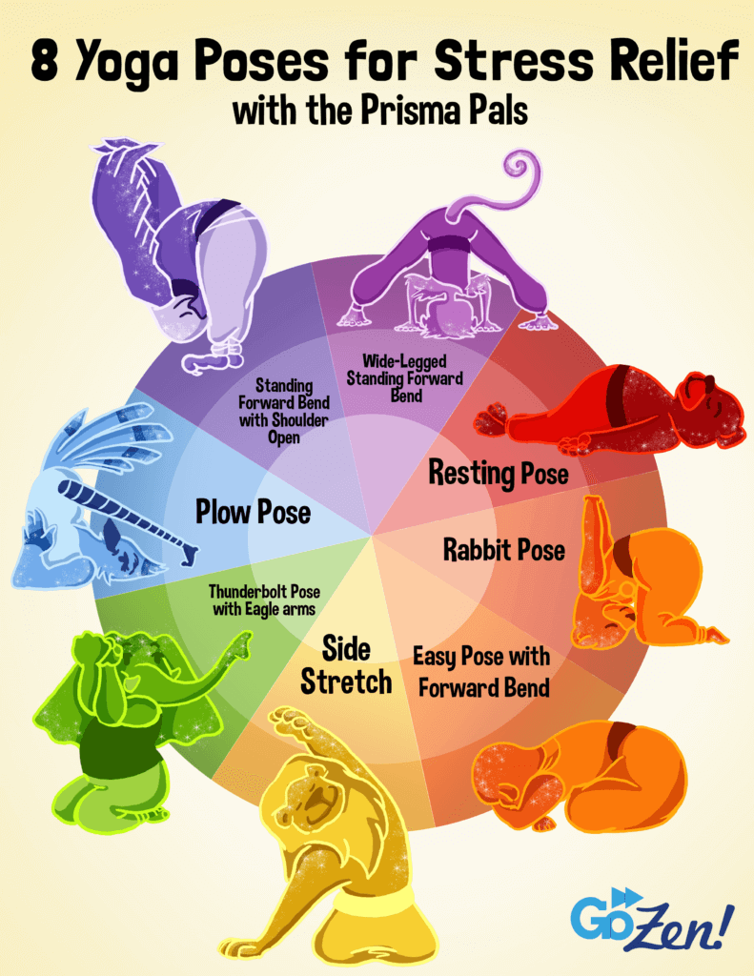
Introducing the “Prisma Pals,” a new set of GoZen! characters that offer a series of yoga postures targeting the upper back, neck, and shoulders – the places we most often carry stress. We encourage you to do these poses with your child; take this time-out together, now, to breathe and relax as the Prisma Pals guide you into ease and peace in both mind and body.
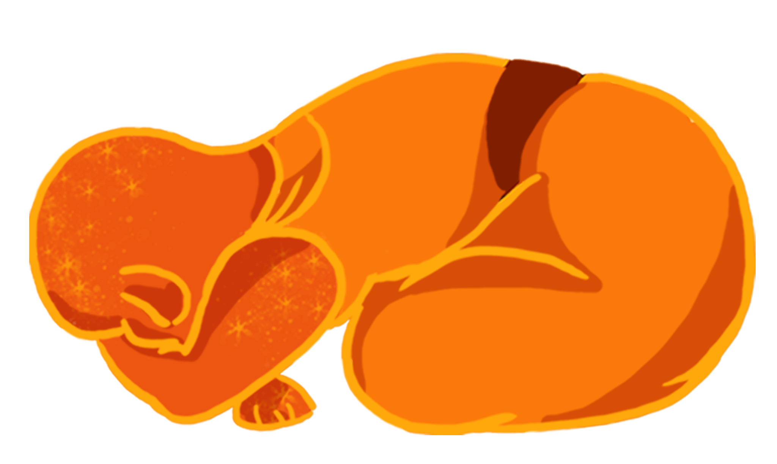

1. Easy Pose with Forward Bend
The next time your child needs to find calm, try helping them into this pose. Sit down with legs in “criss-cross applesauce,” or in “pretzel-style,” or simply sit cross-legged. Then, take a nice big inhale, and on the exhale bend forward. Rest your head on your forearms (like the orange otter), or even on the floor. Stay here and breathe. Take a few slow inhales and exhales, and then sit up. Straighten your legs and shake them out. Notice how you feel.
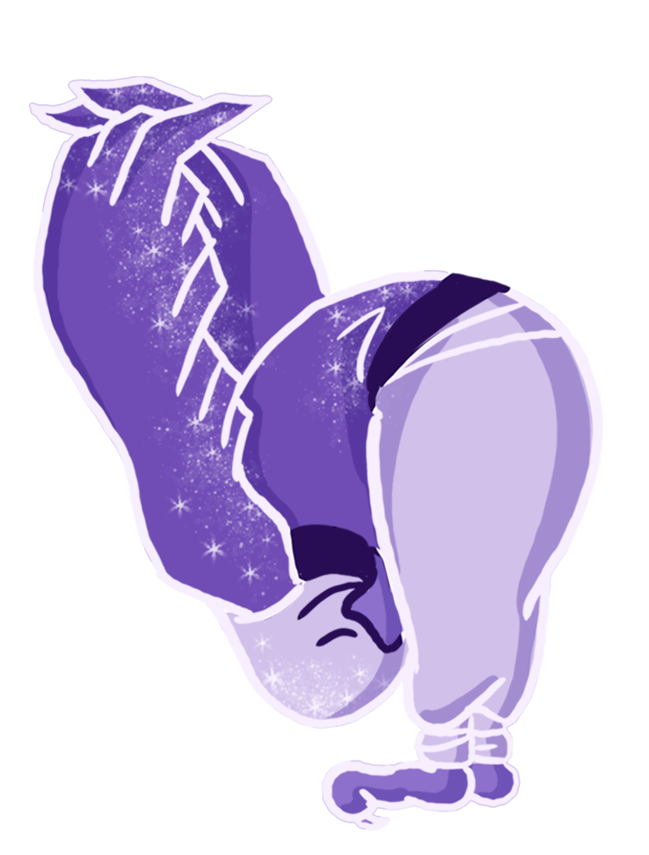

2. Standing Forward Bend
Is your child stuck in worrisome thoughts? Do you have any tension in your shoulders? This will address both by flipping you upside down and allowing your head and arms to hang heavy. Stand tall, slightly bend your knees, and clasp your hands (or wings!) behind your back. Breathe in, and as you breathe out, bend forward and bring your arms over your head. Feel the stretch between your shoulder blades and at the back of your thighs. Stay here and breathe – a few calm inhales and exhales – and then with hands on hips, slowly come back up and stand. Notice how you feel.
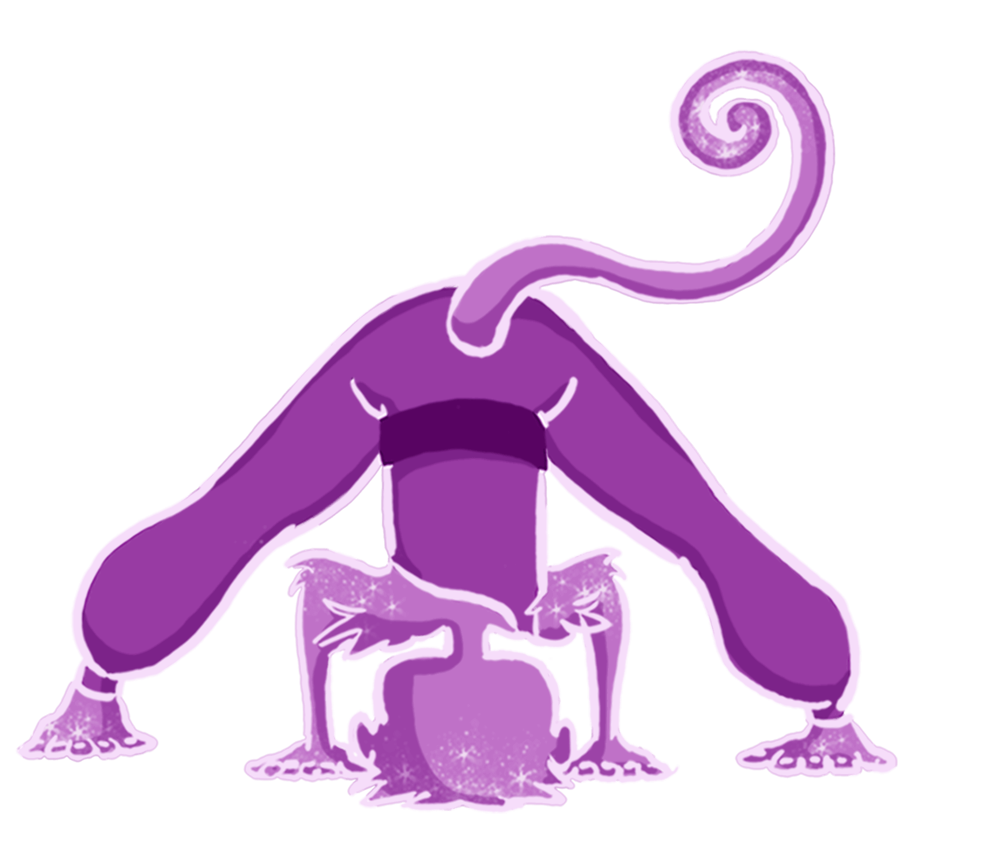

3. Wide-Legged Standing Forward Bend
For this pose, you’ll want a yoga block or a puffy pillow. Does your child have a busy monkey brain that won’t slow down or turn off? Have you been sitting all day and want to stretch your legs? Try this! Stand with your feet wide apart, hands on your hips. Take a big breath in, and as you exhale, bend forward and bring your hands to the floor or to blocks. You can bend your knees slightly or walk your hands forward if that helps. Let your forehead rest on a pillow to help calm your mind. Stay here and breathe – a few calm inhales and exhales – and then with hands on hips, slowly come back up and stand.
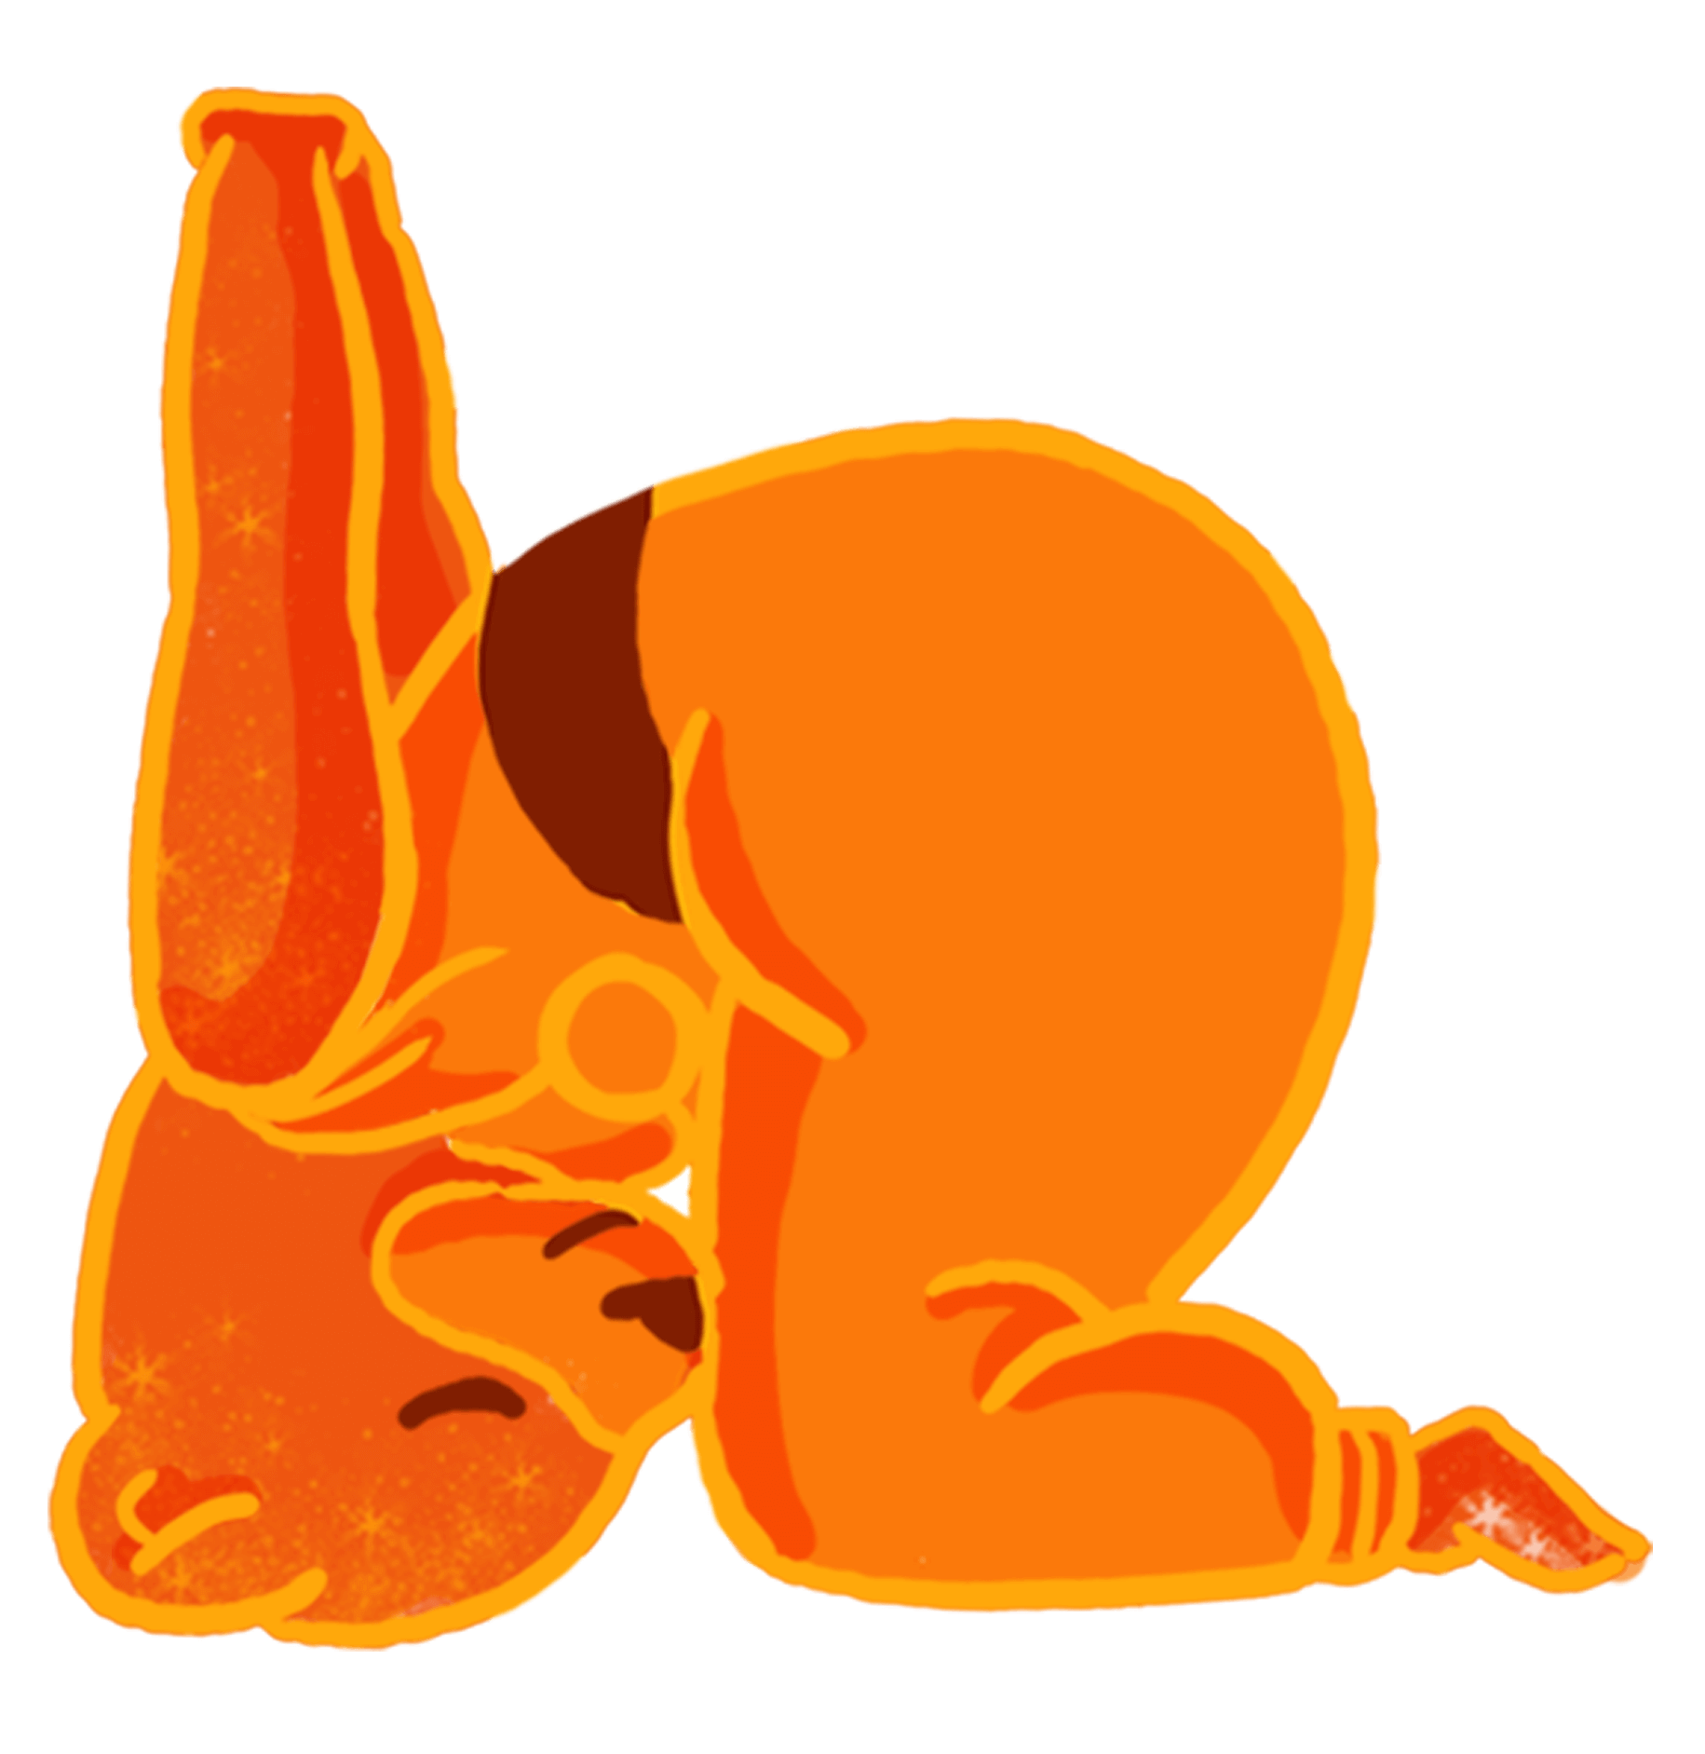

4. Rabbit Pose
If you are tired, stressed, or your child is on the verge of a meltdown, let it all go in rabbit pose. With your child, together you’ll be imitating the shape of our orange otter friend. Start in child’s pose. Now, clasp your hands behind your back, lift your hips and carefully roll forward onto the crown of your head. Notice where you feel the stretch, and back off if it’s too much. Stay here and take a few breaths in and out. When you’re ready, lower your hips back down and release your arms. Relax in child’s pose until you’re ready to sit up.
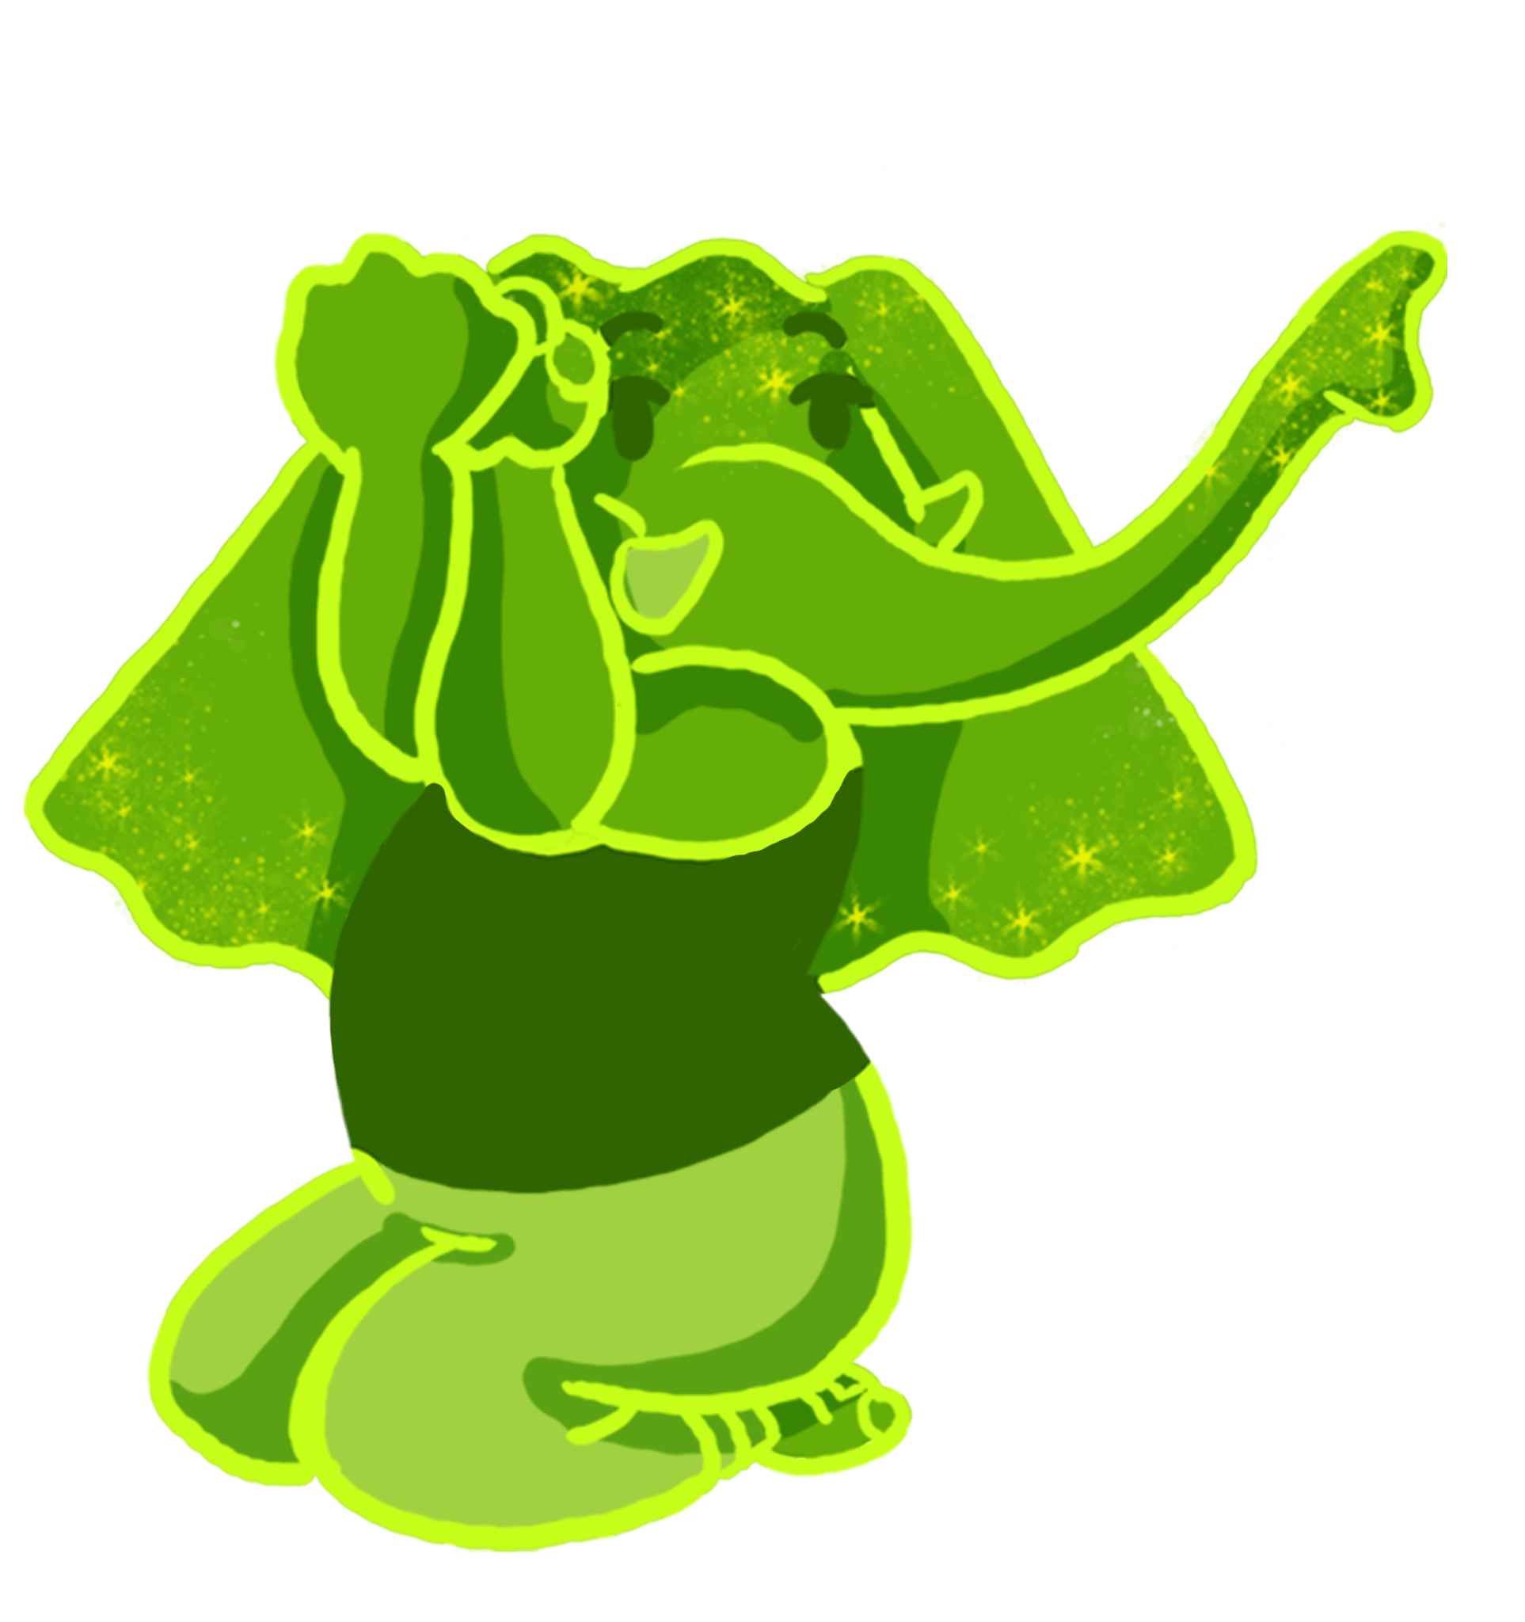

5. Thunderbolt Pose
Will “a little fun” be the cure for the current mood? Let’s give this one a try with Esme the Green Elephant! Kneel down and sit back on your feet. Extend your arms straight in front of you and then bend them so your palms face you and your fingers point straight up. Place your left elbow into your right – pass your right hand in front of your left – bring palms together, or even just a few fingers on to the left palm. Did you get it? This is a great place to laugh at the pretzel knot you’ve created with your arms! Hold your pose and breathe in and out. Feel the stretch between the shoulder blades. Now, switch arms, breathe, and release.
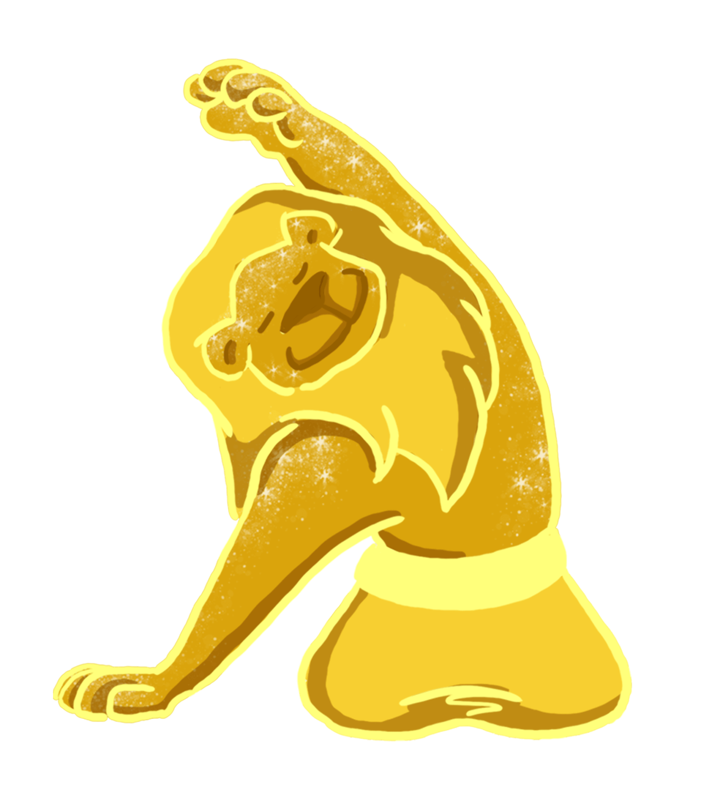

6. Side Stretch
“Head, shoulders, knees and toes, knees and toes!” Yes, let’s give the head and shoulders a rest in this yummy side stretch. Sit on the floor in a comfortable position. Walk your right hand away from you and drop your head toward your right shoulder. Inhale, stretch your left arm over your head and notice where you feel a stretch. Keep your head and shoulders relaxed as you breathe in and out. When ready, switch sides, breathe, and release.
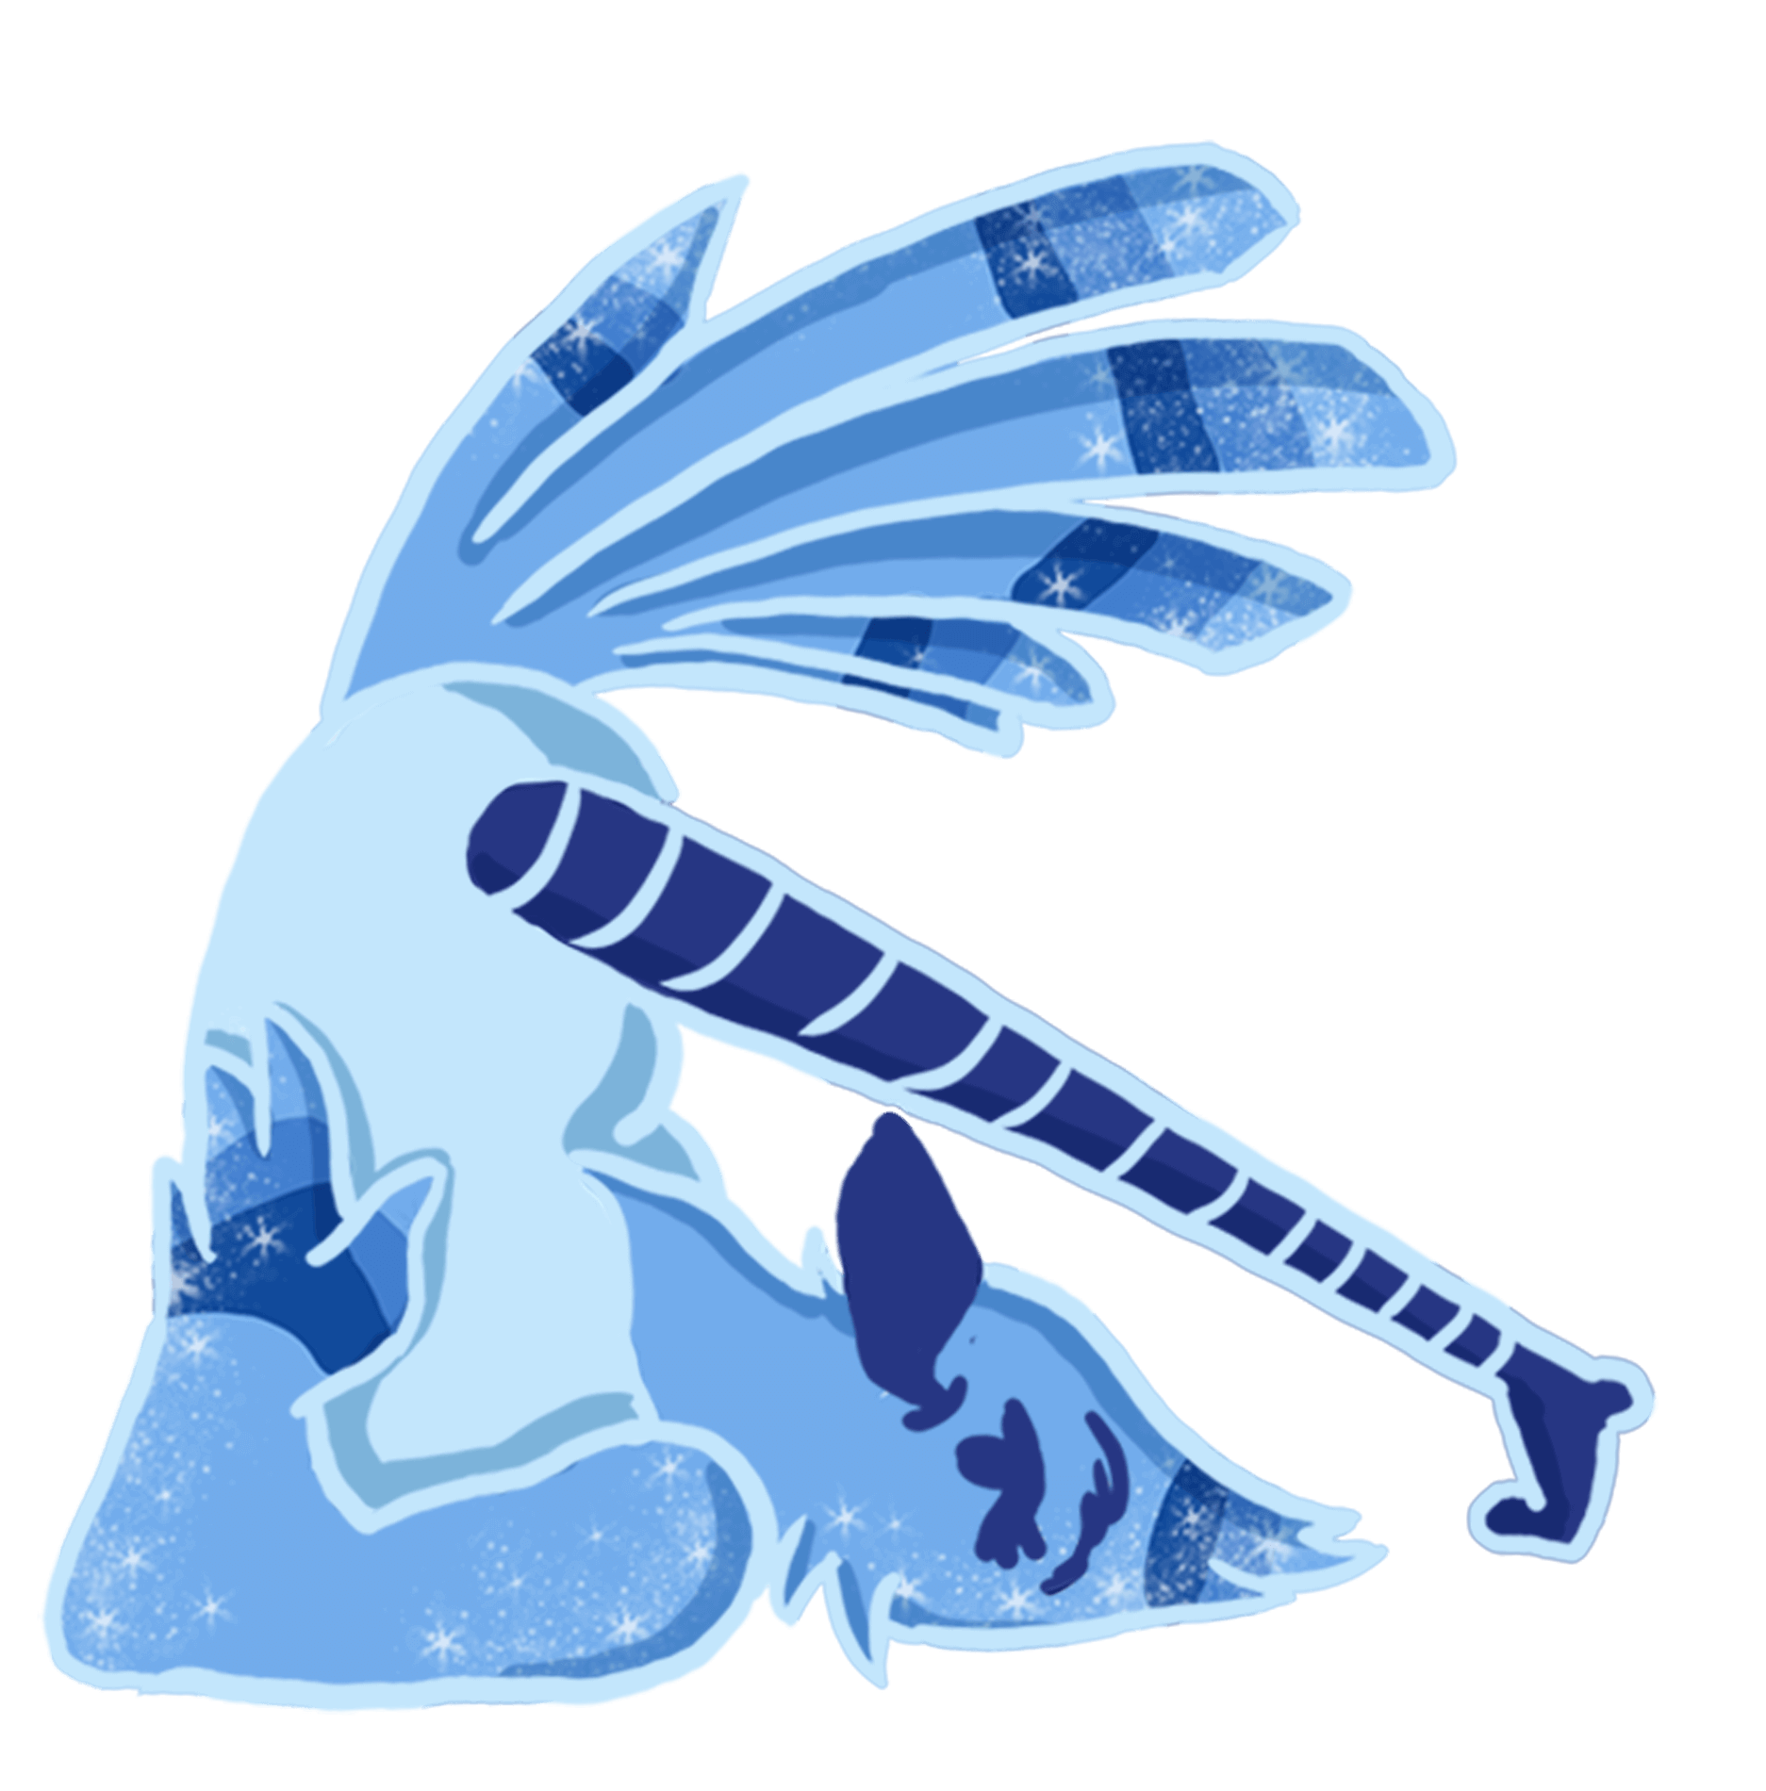

7. Plow Pose
Has it been a long, busy day for you and your kids, and you’re eager to get off your feet? If so, you’ll surely appreciate this pose, which starts with lying on your back. From here, pull your knees into your chest and start rocking forward and back until you can safely swing your legs up over your head. Be careful with the weight on your neck – bring your hands to your back to support yourself. Your legs can stay vertical, with toes pointing to the sky, or your toes can touch the floor behind your head. Stay here and breathe, at least 3 – 5 breaths, and then slowly roll out of plow pose.
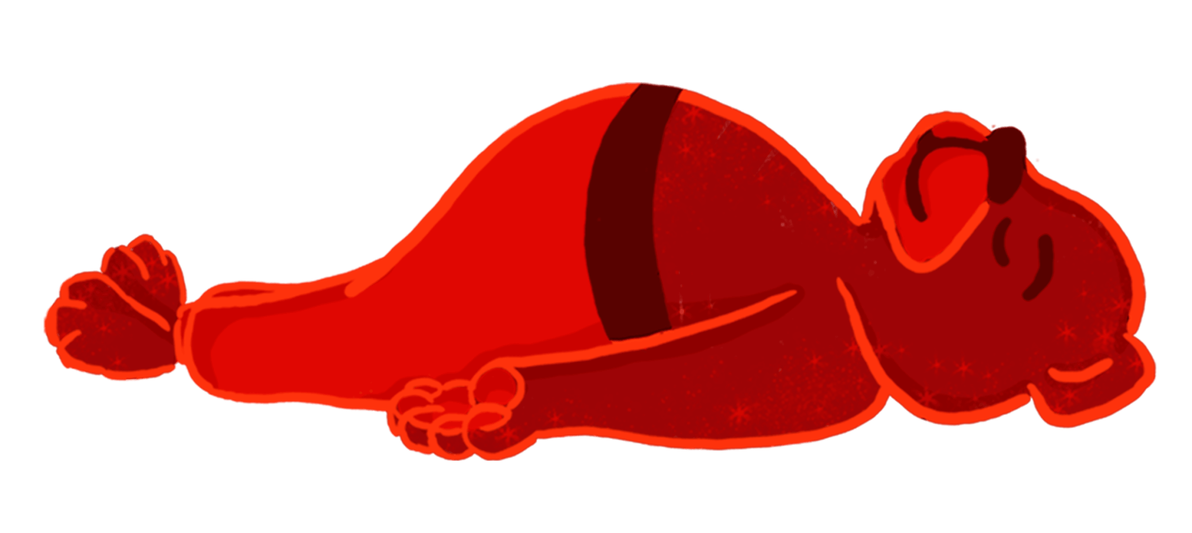

8. Resting Pose
It’s a contest – who can be still for the longest period of time? Let’s find out. Just like our red bear prisma pal (is he in hibernation?), lie down on your back, eyes opened or closed. Take a big breath in, open your mouth and let it all go. Feel your arms and legs rest heavy on the floor. Inhale and exhale loudly, even sighing perhaps, two more times. Then, stay here and breathe easily until you’re sure you’ve stayed still the longest.

