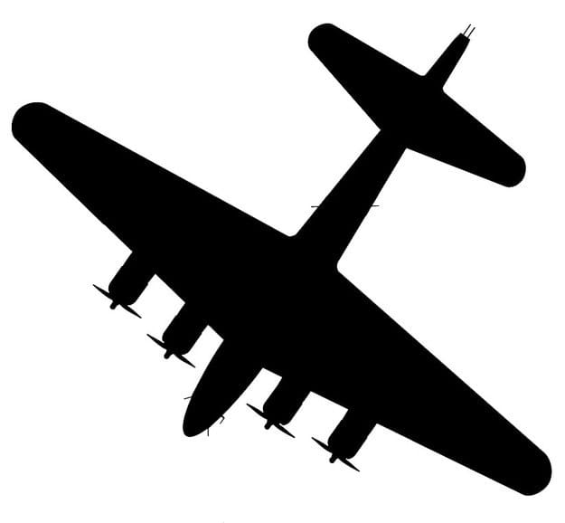

**P.E/Games**

While the weather is still warm, all PE and Games will be taking place outside. On a Wednesday the children will have an opportunity to do golf and athletics. On Fridays the children will try netball, hockey and football. Please can all children come to school on Wednesdays and Fridays dressed in trainers, PE kit of shorts and T shirt,with a sweatshirt and jogging bottoms over the top

**Music**

We will listen to songs from WW2.

**Art and Computing**

We will be scripting and performing our own WW2

Radio broadcasts giving advice to people during the war.

In art we will be inspired by Henry Moore’s London underground pictures and also look at the Blitz skyline and create our own, using the Acle buildings as a silhouette. In D&T we will be making our own gas mask boxes. We will also be designing and making our own cuddly toy in the style of ‘Make do and mend’.

Donations of spare fabric remnants would be very welcome. Thank you.

In computing we will be exploring how to keep ourselves safe online.

**RE**

We will discuss these two questions.

How does religion explain suffering in the world?

Does religion bring peace, conflict or both?

**Maths**

During this term our Maths will have a strong emphasis on Number and place value, moving on to different efficient calculation methods. We will then look at Fractions, Decimals and percentages.

This term we will be focusing on learning clear mental maths strategies to support the children in maths, knowing times tables will also be emphasised. As last year, there will be an opportunity for children to continue their Bronze, Silver, Gold and Platinum timetables awards.

**Topic**

This term we will be finding out about life during WW2. We will discover what it was like to live during this period of time.

We will make comparisons to today’s society and highlight differences and similarities. We will begin to understand which countries took part in the allied forces and why. We will also consider what life was like from the German point of view.

We will be watching the BBC Spywatch programme and reading Goodnight Mister Tom to support our knowledge of life in WW2.

We will read a variety of book extracts from the WW2 time period.

**Science**

In Science we will be focusing on Materials.

We will be learning about famous Chemists in history as well as using lots of different scientific equipment to carry out different investigations.

We will be learning about thermal conductors & insulators, Electrical insulators and conductors, separating solutions, evaporation and condensation.

Year 6 Autumn Term 2020 Curriculum Newsletter