Space Theme: Monday 13th July-Friday 17th July.

**Challenge 3:** Can you use the sheet in your pack or click this link and design your own alien? Can you draw it, label it and write about it?

<https://www.twinkl.co.uk/resource/t-l-5677-design-an-alien-activity-sheet>.

**Challenge 1:** Play the ‘aliens love under pants’ matching game. Please see the resource in your pack or click the link provided.<https://www.twinkl.co.uk/resource/t-t-3564-aliens-love-underpants-matching-pants-activity>

**Challenge 2:** Read these space themed sentences. Can you sound them out and blend them? Please find these attached within your pack or click the link below. <https://www.twinkl.co.uk/resource/esl-space-simple-sentence-cards-t-t-26654>. Please do not feel you need to print all of these.

**Challenge 4:** Can you make an alien using an old sock? Use your design to help you. You could use buttons, pom-poms or anything that you have in your house. Can you send me a picture of what you have made?

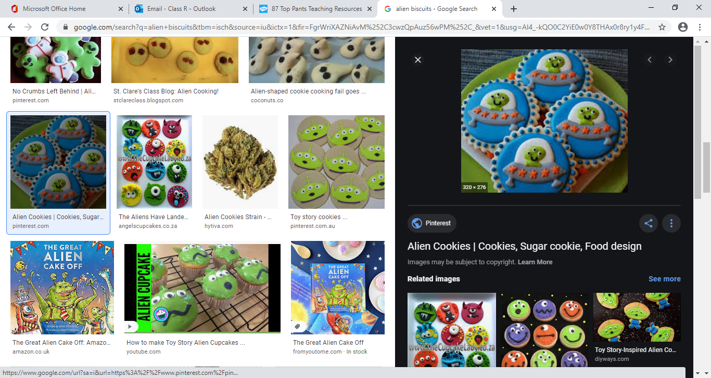

**Challenge 5:** Can you make some alien, planet or astronaut cookies/biscuits?

