Maths Reasoning and Problem Solving

Explain to your child the difference between seconds, minutes and hours and talk about how these are used to measure some activities.

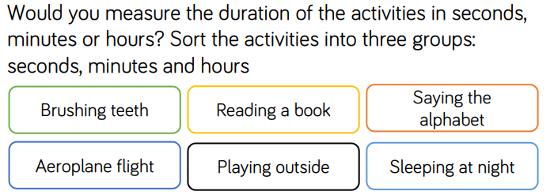

|  |  |  |
| --- | --- | --- |
| seconds | minutes | hours |
|  |  |  |

Have a look at the way the following things have been measured. Are they sensible choices? Explain your answers.



