KS2 The Circulatory system

The purpose of the circulatory system is to transport___________________ around the body.

Blood consists of:

1.___________________________

2.___________________________

3.___________________________

4.___________________________

The functions of the components of the blood are:
Component of the blood | Job or function
Red blood cells (erythrocytes)

White blood cells (leukocytes)

Platelets

Plasma

I can record my heartbeats.
You can either count how many beats in 1 minute (60 seconds), or count how many beats in half a minute (30 seconds) and multiply (times) by 2.
Heart rate | Number of beats per minute
Resting heart rate

Exercise heart rate (30 star jumps plus run on the spot for 30 seconds)

Heart rate after 1 minute recovery after exercise

Heart rate after 5 minutes recovery after exercise

Heart rate after 1 minute recovery after exercise

What happens to your heart rate (number of beats per minute) during exercise?

Why?

What happens to your heart rate (number of beats per minute) after rest and recovery after exercise?

Why?

Label the parts of the heart

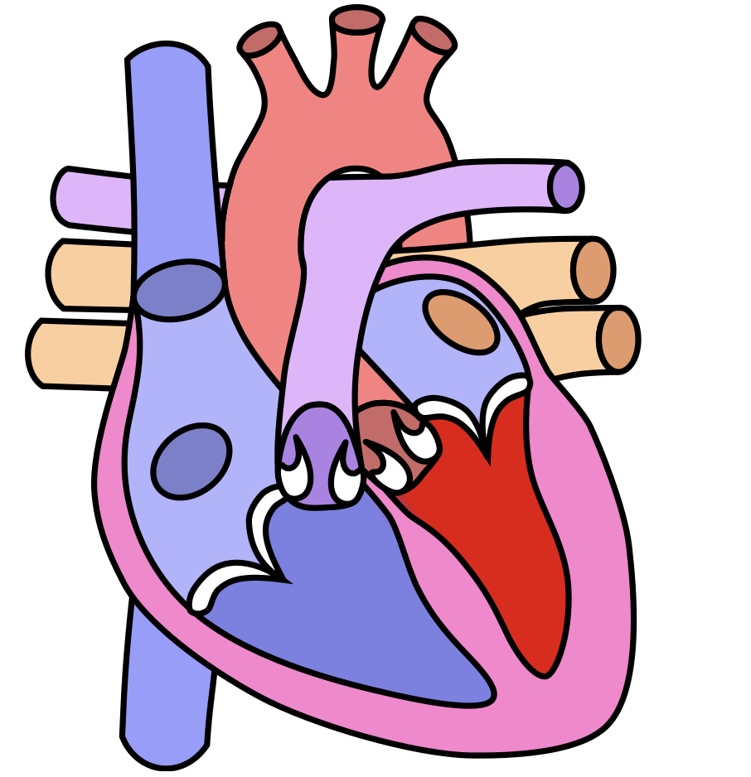
Wikimedia commons

Left ventricle | Left atrium | Blood vessels | Deoxygenated blood
Right ventricle | Right atrium | Oxygenated blood | Valves

Make a model of the components of the blood.
Can you remember (or find out) the relative proportions of each?
You could use beads or marbles, or ooballs, screwed up balls of coloured paper, or breakfast cereal! Be creative to make a model in a glass or tube to represent the different amounts of the blood cells found in the blood.

Watch the video of a white blood cell engulfing bacteria in the blood:
https://youtu.be/I_xh-bkiv_c

