Name:
Conjunctions
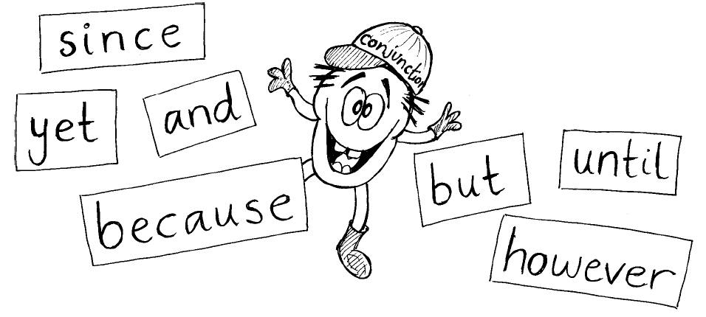
Can you spot the conjunctions in these sentences?
Underline them:
1. I put on my shoes and I went out to play.
2. I can’t eat my sweets until after dinner.
3. I can’t go out tonight because I have to stay in and do my homework.
4. It had been a long time since I had last played football.
5. I was going to eat the sweets but I saved them for my sister.
6. She was nice to me although she wouldn’t let me play with the lego.

Use conjunctions to make these sentences more interesting.
7. I can’t go swimming. I have forgotten my swimming trunks.

8. I’d like to go to the park. My mum won’t let me.

9. The old woman wanted to feed her dog. There was nothing in the cupboard.

10. I bought some sweets. I ate them on the way home.

11. The teacher was cross. She was late.

12. I went to the pictures. I really wanted to stay at home.

13. I couldn’t go out. My dad came home.

