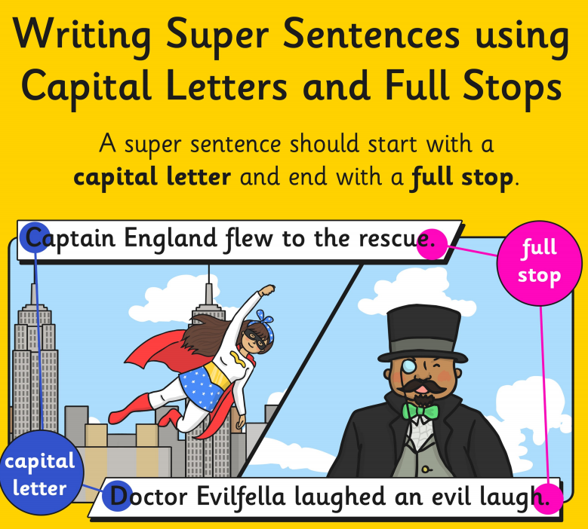

GREEN
Read these sentences and correct the capital letters and full stops.

- i am playing in the garden

- the man sat on the bench in the park

- we went to the cinema to see a film

- today it is raining

- i am good at skipping

- they like to go swimming

BLUE
Read this paragraph and find were you think there should be a capital letter or a full stops.

A lovely Surprise
last night when i went home from school my mummy said she had a surprise for me. as soon as we got into the house she told me to wait next to the door. she ran into the kitchen and i could hear funny scratching noises I took my coat off and sat on the stairs waiting patiently soon mummy came back and had something hiding under her coat the thing was moving and wriggling about she took her coat off and underneath there was a little puppy she said happy birthday to me and put the puppy in my arms i was so happy
RED
