GREEN IAITH
We have been looking at the sh sound (shout, sheep)

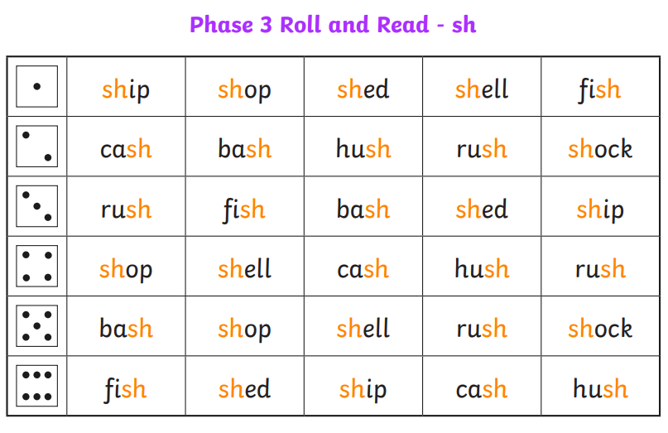
Roll a dice or get an adult to pick a number. Read the words and suond them out. Write two sentences using one of the words from the table.

BLUE AND RED IAITH
This week we have been learning the ee sound. We have found that there are different ways of making the ee sound.
ee – feet
ea – meat
e- he (usually smaller words)
BLUE IAITH
Pick a letter from each box to make words. Write the word in a sentece. Complete 5 sentences remembering your capital letters and full stops.
Can you then think of words that have ea as the same sound. Write these in a list.
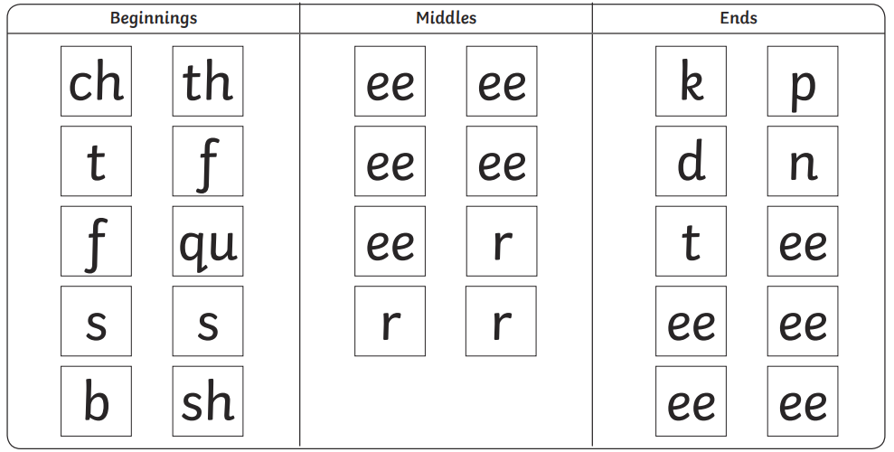

RED IAITH
Create a list of words containing the ee, ea or e sound. Write four sentences using the ee words and another four using the ea words. Remember to include a capital letter and full stop. Can you make your sentences interesting be adding a connective (but, because, although, also, so).

