Monday
WALT; choose to use a suitable written method to solve particular subtractions

Based on the numbers, use either:
Column subtraction
OR
Jumping on using a number line

Tuesday
G-WALT; understand and the use the place-value of 4-digit numbers

Steps to success
Use place-value cards to create 4-digit numbers
Describe the number for your partner to guess it
Partition into some of the thousands, one more thousand then the hundreds

Wednesday
WALT; use column subtraction to subtract 4-digit numbers

Steps to success
Use column subtraction to solve the calculations
Start on the right
Decompose the columns if needed
Choose a strategy to check your answers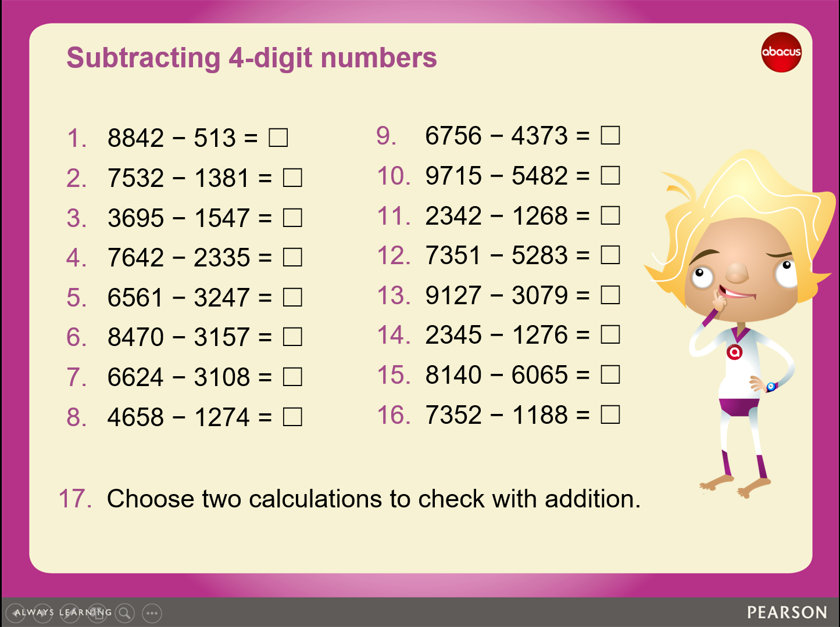

Friday
WALT; use column subtraction to subtract 4-digit numbers

Steps to success
Use column subtraction to solve the calculations
Start on the right
Decompose the columns if needed
Choose a strategy to check your answers

Answers

