WALT; choose to use a suitable written method to solve particular subtractions

Based on the numbers, use either:
Column subtraction
OR
Jumping on using a number line

Tuesday
B-WALT; understand and the use the place-value of 4-digit numbers

Steps to success
Write a number according to the instructions
Solve the place-value additions

Wednesday
WALT; use column subtraction to subtract 4-digit numbers
Steps to success
Use column subtraction to solve the calculations
Start on the right
Decompose the columns if needed
Choose a strategy to check your answers
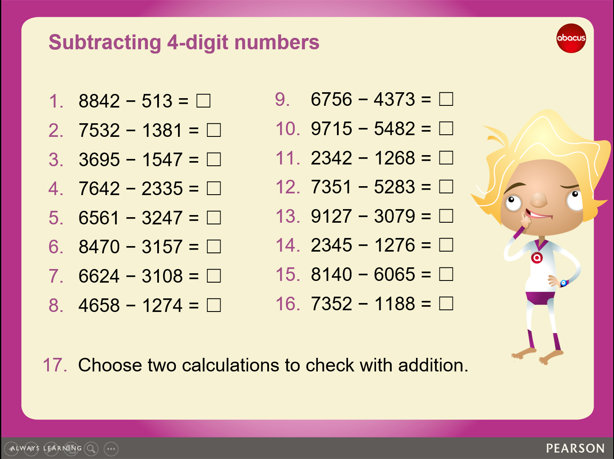

Friday
WALT; use column subtraction to subtract 4-digit numbers

Steps to success
Use column subtraction to solve the calculations
Start on the right
Decompose the columns if needed
Choose a strategy to check your answers

Answers

