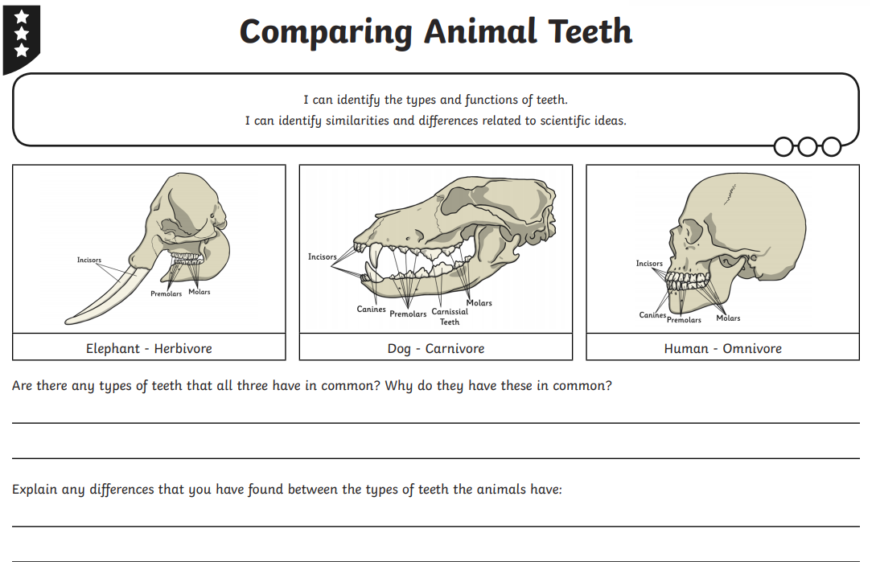

**RED SCIENCE TASK SHEET 3**