Smoking Car Puzzle Game
Aim
Create a car that travels round a roadway emitting smoke as it goes. Can the user keep the smoke trail on the roadway?
Learning Focus
decomposition, debugging
Steps
ONE – Decomposing Smoking Car
https://scratch.mit.edu/projects/editor/43651270/ Press i for instructions
Show pupils in full screen the game without the coding blocks. Explain that before we make a game like this, we are going to use our decomposing skills and take the game apart. As a class list all the elements on the board. You will need to play the game lots of times and describe what keys you are pressing.
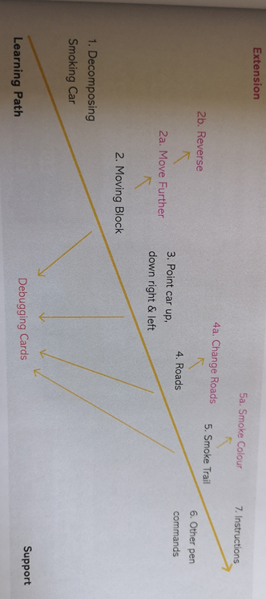
TWO- Create a Moving Block
Pupils to first add a car sprite to the stage. Link each stage to the decomposition done in step 1. As a group come up with what then need the car to do and how it moves. Discuss that when the number 1 is pressed the car moves forwards 10 steps. Pupils to test their code before moving on.
EXTENSION: Can you create a move block that when 2 is pressed the car moves 20 and the 3 key moves. These should be separate blocks and not attached to the first block. Can you make another block that moves the car backwards?
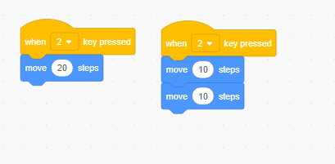
Show pupils these blocks and discuss what they do. Explain that both blocks are correct but if we are looking at which is the best and most efficient solution we may need to look at which used the least amount of blocks.

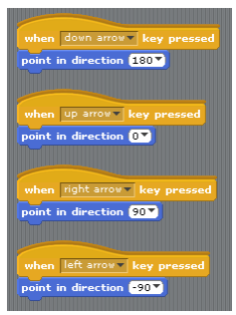
THREE – Point Car Up, Down Right & Left
Drag out four keyboard input starting blocks. Click on the menu triangle at the point direction block. Read the movement blocks with children. Which should we choose? Pupils to experiment and come back with the answer.
Pupils to test their car by taking it for a drive.
EXTENSION: Is there any limitation with our steering method? We can only travel in four directions are there any blocks that could change that.

FOUR – Road Creation
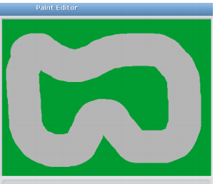
Click backdrop
Click paint
Pupils to then create their own road using the fill tool and the paint brush.

EXTENSION: Can you link a keyboard input to change the background in the stage area? Can you make a more challenging road? Use the line tool to draw right angle turns.
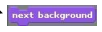

FIVE – Smoke Trail
Drag out three more keyboard input blocks and show pupils where the pen blocks are. Link pen up, pen down and clear. Pupils to try this and come back and share what happens when they press the keyboard.
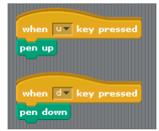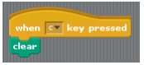
EXTENSION: Can you link keyboard inputs to change the colour of your line? Can you make the Y key draw in yellow and the G key draw a green line?
SIX – Other Pen Commands
Give pupils time to explore the other pen commands and link them to other keys. What have you notices? Stress that exploration needs to be on separate blocks making it easy to debug.
Hint: Explain to pupils that they always need to select the correct sprite or stage they want to code before placing any blocks.
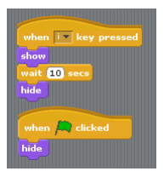
SEVEN – Instructions
Can pupils write a key for their game?
Paint a sprite
Draw and colour a star
Use the arrow to draw a box around the start and make it smaller
Move to the top left corner
Press text
Write instructions
Can you now find a way that the instructions pop up when the I key is pressed and then hide after 10 seconds? After a while drag out the show, hide and wait blocks. Pupils to decide on the order of the blocks.

