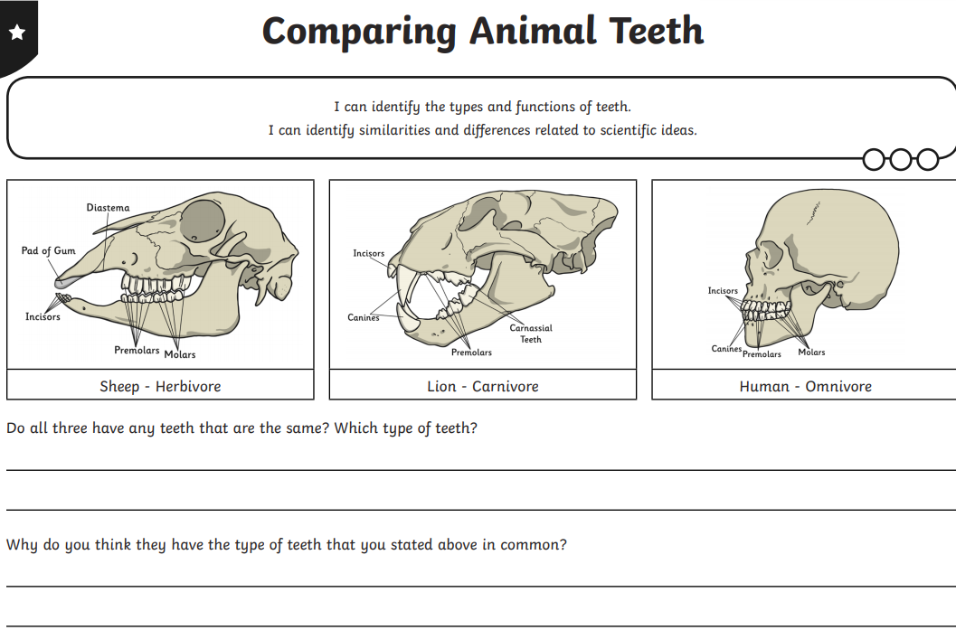

**GREEN SCIENCE TASK SHEET 3**