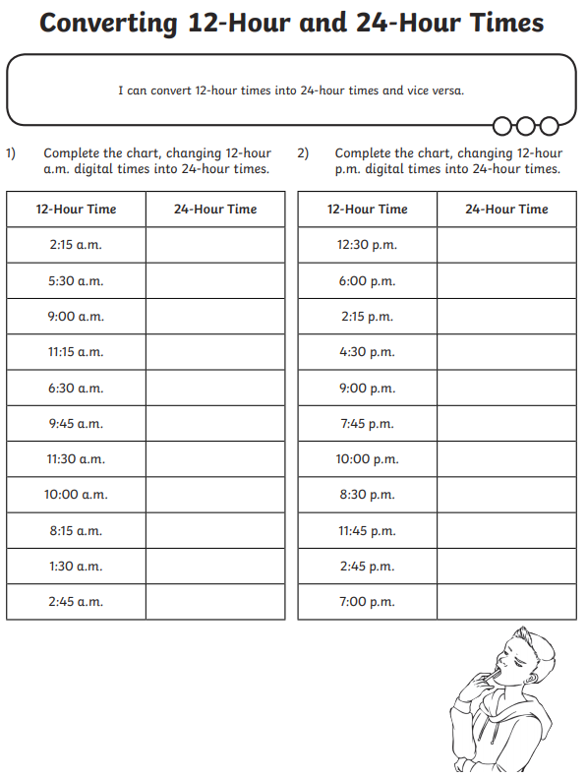

**BLUE TASK SHEET 1**

**24 hour time**