Thema
To celebrate World Book Day choose your favourite book and create a book mark featuring your favourite character. Here are some examples to help you.
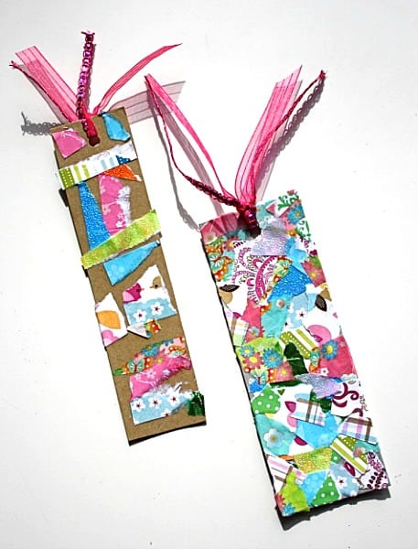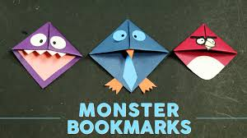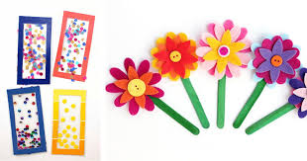

Iaith
Using the same book as you did for thema complete a story map/mountain to tell a friend about the book. Your plan will need to describe the character/setting and plot (beginning, problem, end). There are some examples on the website for you to use. Pick the one you think will work the best with your story.
Remember, this is a plan so no need for full sentences. Use words, phrases and pictures.

