Monday

R-WALT; identify decimals to one decimal place on a number line and count to the next whole number

Steps to success
Add the missing decimal numbers to the number line
Identify the marked point on a number line
Calculate how much is needed to get the next whole number

Tuesday
R-WALT; identify one-decimal numbers that would round to specific numbers

Steps to success
Choose a number from 0-10
Identify which one-place decimal numbers that would round to it
If you make a mistake, identify why it is wrong and what number it would round to
Do this for 3 numbers

Wednesday

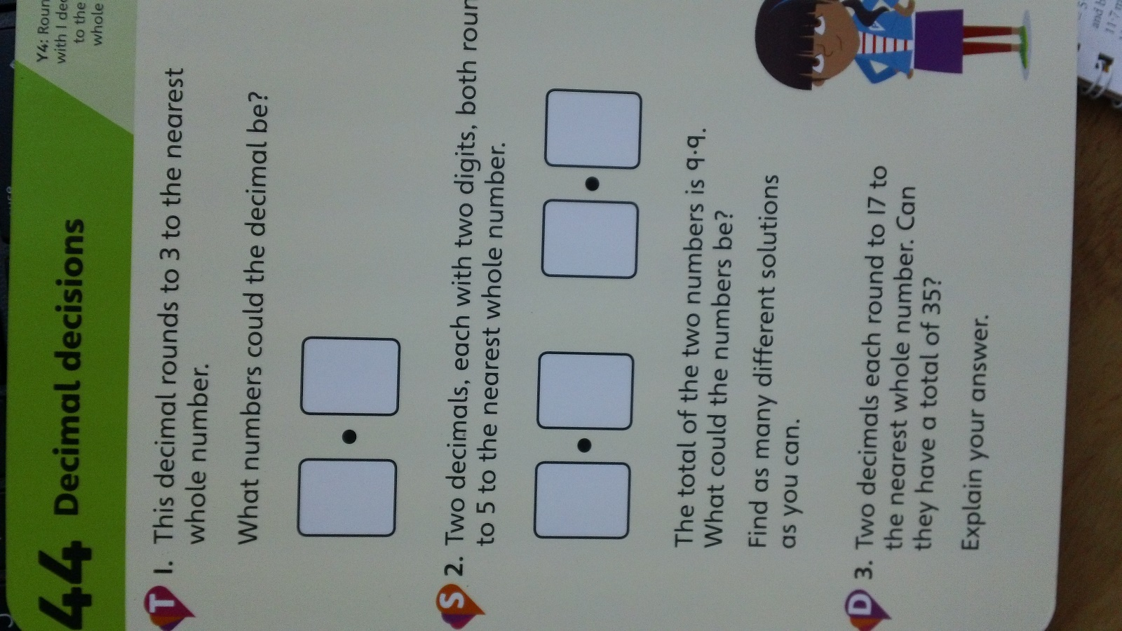

Answers
