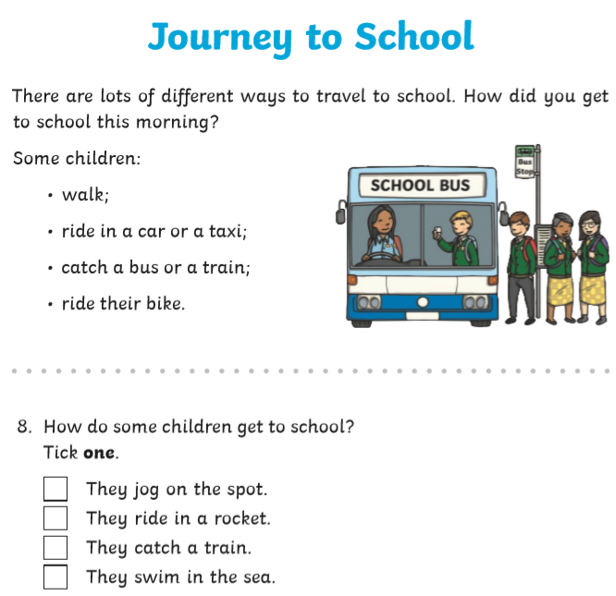
Green Galaxies 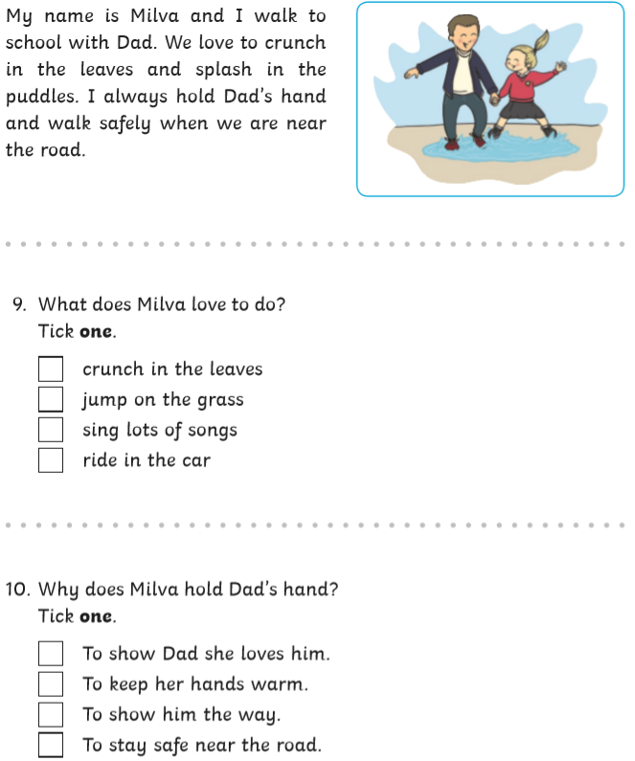
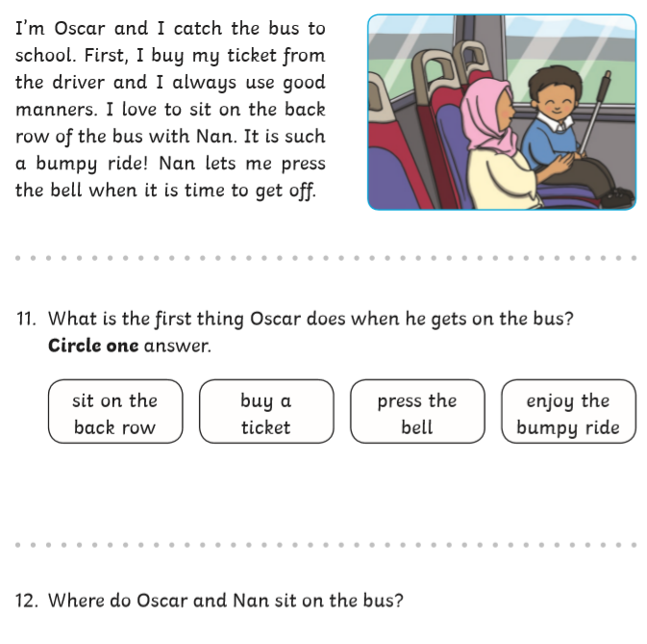

Green Godivas
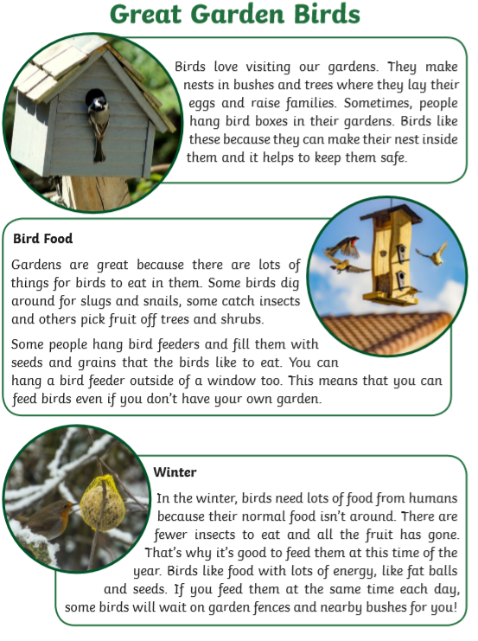
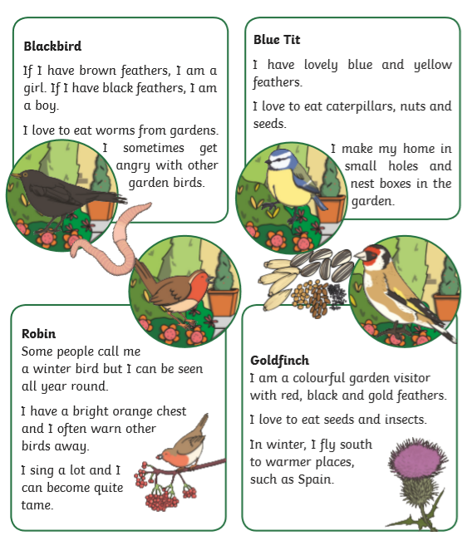
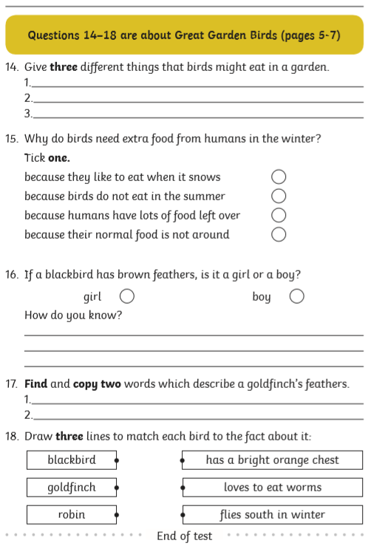
Turquise Twirls 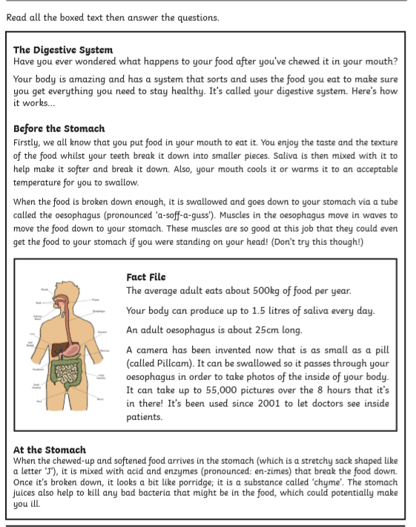
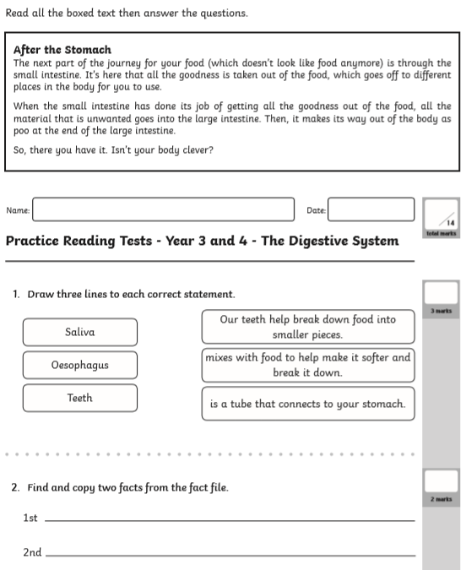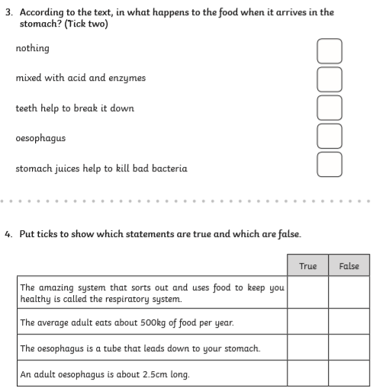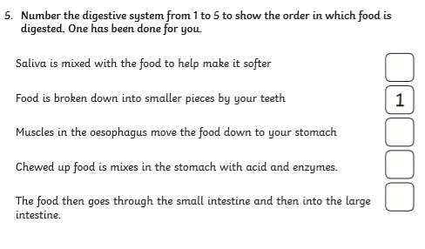

Purple Picnics
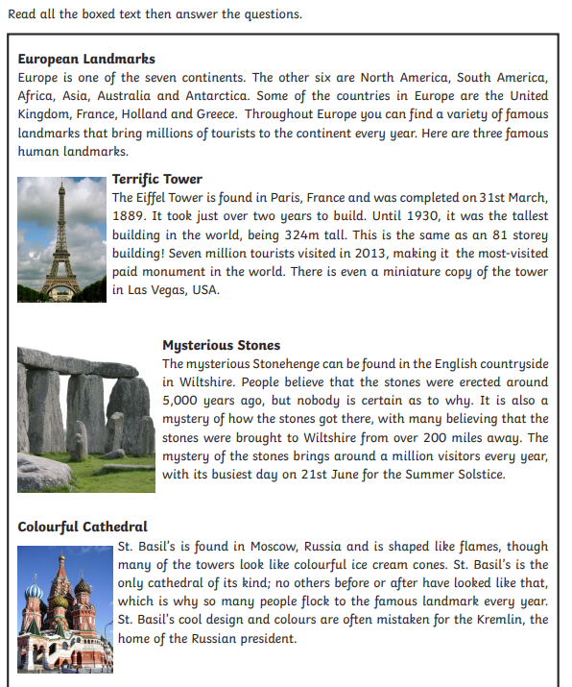
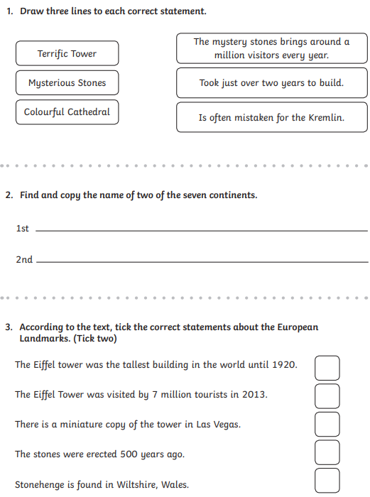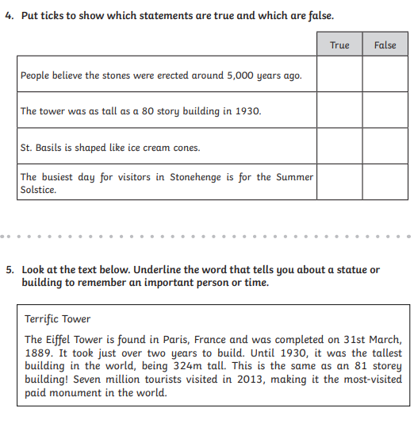
Lesson 2
Look at the PowerPoint on Kennings.
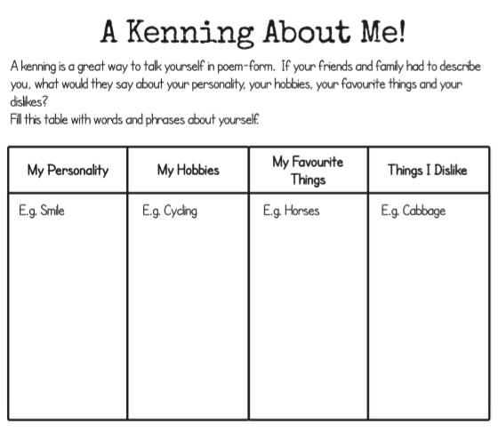
Once you have filled this table with words you now need to think of verbs and nouns to go with the words.
Verbs are doing words such as drinking, eating and jumping. It would help if your verb end in -ing
Nouns are names of people, places or objects. It would help if these ended in -er.
Now write a list of phrases using a word from the table and a verb/noun. For example,
Horse-grooming
Cabbage-hater
Cycle-racing

Lesson 3
Today we are going to plan our Kenning poem on an organ. Remember they work as a riddle and you have to find out what it is about.
- Write the organ in the middle of the page
- Add lots of words about the organ (words only)
- Underline the nouns (things) in blue
- Underline the verbs (doing words) in orange
- Join words that go well together with a hyphen e.g, muscle-pumping
- Write your Kenning using the rules below.
- Read your poem to a family member. Can they guess what your poem is about?
