Wednesday
WALT; divide 2-digit numbers by 10 and 3-digit multiples of 10 by 10

Steps to success
Use a place-value grid
Divide 2-digit numbers by 10
Divide 3-digit multiples of ten numbers by 100
Explain the rules and patterns

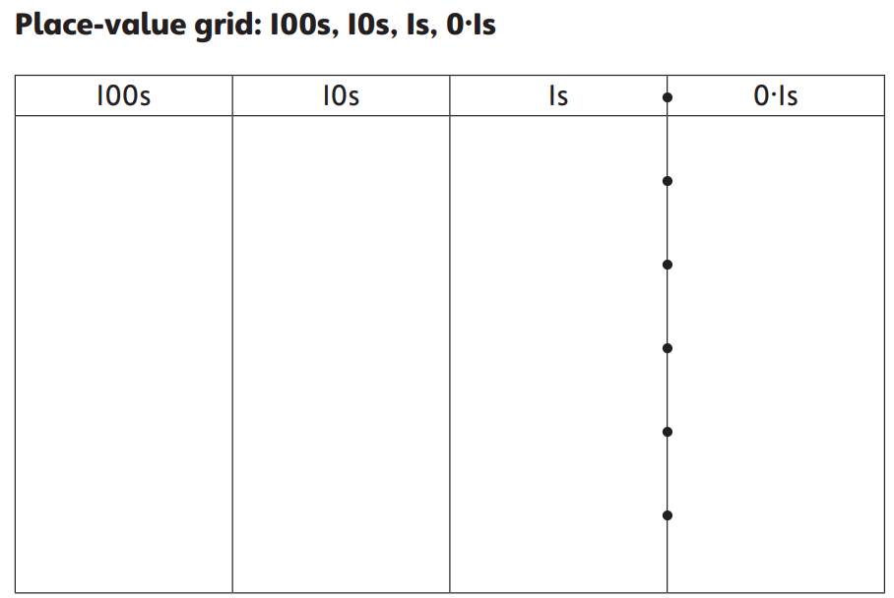

Friday
B-WALT; add 4-digit numbers

Steps to success
Copy the calculations carefully
Complete the calculations
Solve the word problems

