GREEN /BLUE
INFORMATION SHEET

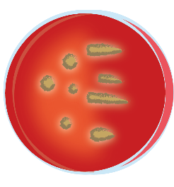
Bacteria
Bacteria are some of the smallest living things on the planet!
A single bacteria (called a bacterium) is made of just one cell.
Bacteria live everywhere. Some bacteria live inside plants and animals, including humans.
Your skin, nose, mouth and gut all contain bacteria.
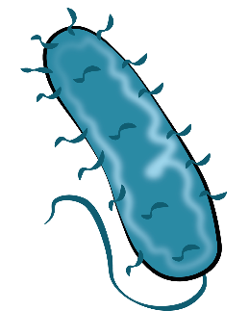
A lot of your body’s bacteria are harmless, and can actually help you fight off illnesses. However, not all bacteria are good for us. Some bacteria can be harmful.
If you cut your finger, bad bacteria can enter your body through the cut and cause an infection. People who get infections from bad bacteria are given anti-biotics by their doctors. Anti-biotics don’t work on diseases that are caused by viruses.
Viruses
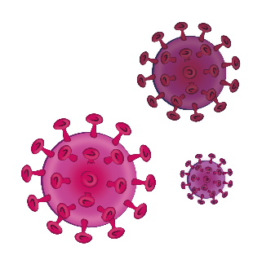
A virus is a kind of germ. Germs and viruses are tiny living things which invade our bodies and make us sick. A virus can’t survive on its own for very long – it needs to live inside another living thing.
Viruses get inside the body and can then be passed on to other people. Viruses are usually spread from person to person in little drops (called droplets) from sneezes or coughs.

What can I do to avoid catching a virus?
There are several things you can do to reduce your risk of catching a virus.
- wash your hands regularly with soap and water.
- try not to touch your face, especially your eyes, nose and mouth.
- protect your immune system by eating foods like strawberries, raspberries, kale and other foods which are high in antioxidants.
- Get enough sleep

What should I do if I think I’ve got a virus?
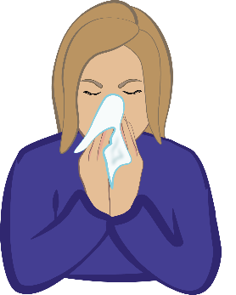
If you have got a mild virus, for example a cold, you should make sure to get a lot of rest and stay away from other people as much as you can

