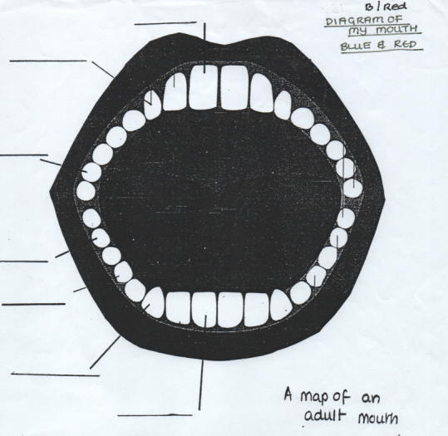

Identify the different teeth in the adult mouth and label them. Then count how many of each type of tooth there should be.

* __________ Incisors
* __________ Canines
* __________ Premolars
* __________Molars

Adults should have a complete set of _____ teeth

**MAP OF AN ADULT MOUTH**

**BLUE/RED SCIENCE**

**TASK 2**