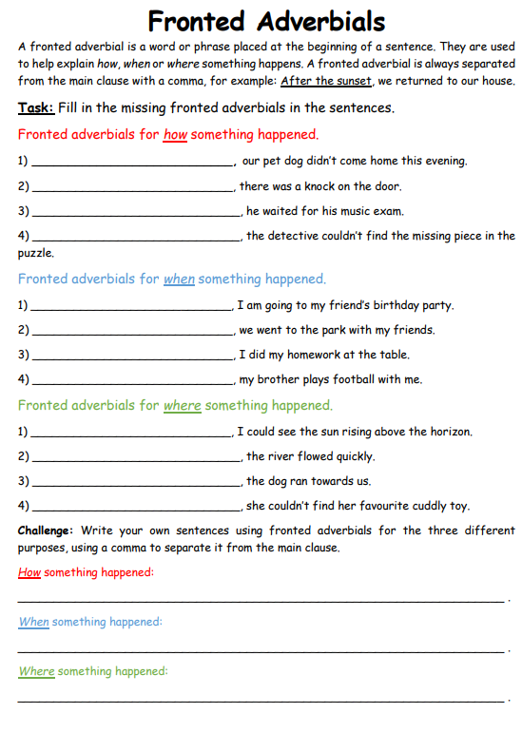

**RED IAITH TASK**

**Fronted Adverbials**