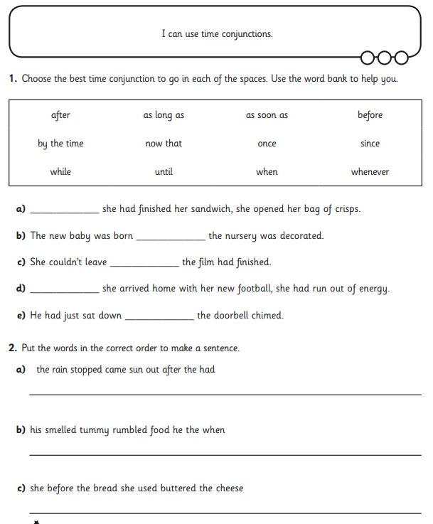

**RED IAITH TASK SHEET 2 - missing time conjunctions**